CHUKA | 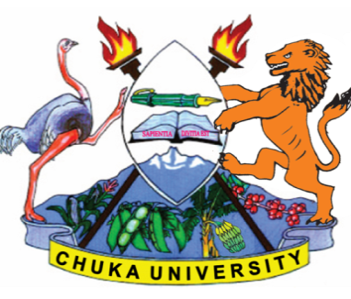 | UNIVERSITY
SUPPLEMENTARY/ SPECIAL EXAMINATIONS

THIRD YEAR EXAMINATION FOR THE AWARD OF DEGREE OF
BACHELOR OF CATERING AND HOTEL MANAGEMENT

BCHM 411: HOTEL ECONOMICS

STREAMS: BCHM TIME: 2 HOURS

DAY/DATE: WEDNESDAY03/02/2021 8.30 AM – 10.30 AM
INSTRUCTIONS:

Answer Questions One and Any Other Two Questions
SECTION ONE: COMPULSORY (30 marks)
QUESTION ONE.
(a) By use of a diagram explain how market prices restore equilibrium in a buyer
market and in a seller market. (10mks)
Consider a project maximizing form operating under conditions of perfect competition. Suppose the market price is Ksh.50 and the firm faces a total cost fraction given by
TC= 10 + 5Q²
- Calculate the maximum profit that this firm can make. (7marks)

(b) By use of a diagram explain the bandwagon effect on demand of Pizza from Helen’s restaurant. (7marks)
(c) Explain 3 uses of price elasticity of demand (6marks)

QUESTION TWO.
- Explain the causes of vertical integration. (8marks)
- With examples, explain how diversification aid in growth of a firm. (6marks)
- Differentiate Economies of scale and economies of scope. (6marks)

QUESTION THREE.
- With a diagram, explain the effects of advertising. (4marks)
- Research and development results in technical change. Discuss four barriers that hinder enjoyment of such change. Give examples. (8marks)
- Draw and explain a diagram of project maximizing firm. (8marks)

QUESTION FOUR.
- The Kenyan labour market is characterized by frequent incidents of strike by workers agitating for a higher pay. Explain four bases on which to base their claim. (8marks)
- Discuss the sources of economies of scale from a static view. (6marks)

- Explain how dynamic economies can improve the profitability of affirm. (6marks)

QUESTION FIVE.
- Explain using a diagram, explain the kinked demand curve.
Examine why a monopolist is a price marker.
Consider a monopolist who faces the following demand and TC
functions
P = 140 - 2Q tc = 5 + 5Q²
- Calculate Pе and Qе (6marks)
- Maximum profit (4marks)
- Explain five determinants of innovation in an industry. (5marks)
- Discuss four ways in which government can assist to improve quality of products.
(5marks)
----------------------------------------------------------------------------------------------------------------------------------------

