CHUKA | 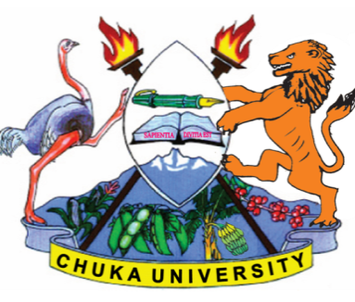 | UNIVERSITY
UNIVERSITY EXAMINATIONS
EXAMINATION FOR THE AWARD OF DIPLOMA IN BUSINESS MANAGEMENT/HUMAN RESOURCE MANAGEMENT AND DIPLOMA IN ACCOUNTING
DIBM 0112 : PRINCIPLES OF MANAGEMENT
STREAMS: DIBM TIME: 2 HOURS
DAY/DATE: THURSDAY 04/11/2021 11.30 A.M. – 1.30 P.M.
INSTRUCTIONS:
- Answer Question ONE and any other TWO Questions

QUESTION ONE
(a) Management is defined as „getting things done through people‟. To what extent is
management a profession? [5 Marks]

(b) Citing examples where appropriate, discuss measures that management should take to
improve the ethical behavior of employees. [5 Marks]

(c) Illustrate the factors that affect organization structure. [8 Marks]

(d) Discuss some of the skills a manager should have so as to manage effectively and efficiently.
[12 Marks]
QUESTION TWO
(a) Identify any 5 external environment forces and explain how they influence managerial
decisions of a company. [10 Marks]

(b) Describe three leadership styles that managers can embrace while managing resources.
[10Marks]
QUESTION THREE
(a) Fredrick Taylor is referred to as the father of “Scientific Management Theory”. Critically
analyze the contributions of shortcoming of the theory in management thought. [12 Marks]

(b) Identify and explain the factors that affect span of control in an organization. [8 Marks]

QUESTION FOUR
(a) Define the term Management By Objectives (MBO) and explain its benefits and limitations
to an organization. [12Marks]
(b) Identify and explain the steps in employee selection. [8 Marks]
---------------------------------------------------------------------------------------------------------------------

