CHUKA | 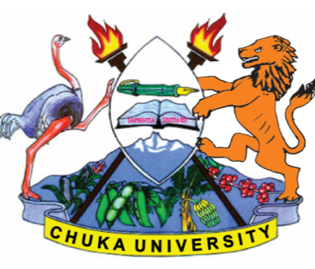 | UNIVERSITY
UNIVERSITY EXAMINATIONS
EXAMINATION FOR THE AWARD OF DOCTOR OF PHILOSOPHY IN
AGRI BUSINESS MANAGEMENT
AGBM 922: AGRIBUSINESS MANAGEMENT THEORY

STREAMS:
TIME: 3 HOURS

DAY/DATE: TUESDAY 13 /07/ 2021 2.30 PM – 4.30 PM
INSTRUCTIONS:
- Answer Question ONE and Two other questions
- Do not write on the question paper

The importance of corporate governance in firm performance has been the subject of debate and empirical analysis among managers, researchers and policy makers in the last two decades due to among other factors, the rise in corporate financial fraud/scandals, fraudulent financial reporting and corporate collapses. According to the principal-agent theory, executives of firms often fail to act in the interest of investors as they pursue personal interests. Investors have limited ability to monitor mangers who often times have superior information concerning the performance of their firms. Consequently, shareholders employ several corporate governance mechanisms to incentivize managers to act in their interest. These include ownership structure, appointing boards of directors, contingent compensation schemes, and the market for corporate control. External mechanisms include protecting the interest of minority shareholders and enforcing effective auditing and reporting standards.
An effective board of directors is expected to facilitate establishment of key organs such as audit, finance, marketing and personnel committees with adequate members to undertake various supervisory and monitoring tasks. This leads to improved risk mitigation and prevention of fraud cases, especially when the board is independent. Additionally, a board composed of members with adequate skills, knowledge and experience can improve firm financial performance by advising the management on the best strategies to employ to overcome competition or expand a business. Doctors with business connections can enhance access to external capital and business opportunities, thereby improving firm profits and market share. Nevertheless, a large board often suffers from a free rider problem and increases the cost of monitoring managers’ professional conduct. Additionally, board members often lack technical skills in key areas such as accounting and their knowledge of the operations of their companies is usually limited due to information asymmetry. In this regard, a board of directors can hardly improve firm performance since the board merely endorses decisions of the management. In the absence of strong corporate ethics, board members can sometimes be the chief architects of scandals and fraud cases that eventually lead to firm failure.
a) Discuss any 5 principles of good corporate governance. [10 Marks]
b) Based on the above scenario, identify the common problems facing corporate management today. [15 Marks]
c) Briefly discuss agency problem in corporate governance. [5 Marks]
QUESTION TWO
Discuss the following theories as explained in management
a) Scientific management theory by Fredrick Taylor. [10 Marks]
b) Henry Fayol’s classical organization theory [10 Marks]

QUESTION THREE
It is the desire of every manager to have proper quality of goods and services delivered by the organization at all levels. Many a times though, managers experience difficulties in maintaining proper quality of service delivery in organizations.
a) Using ISO 9001 - 2015, explain any 5 principles that can guide managers in quality management. [10 Marks]
b) Describe process approach to delivering quality. [10 Marks]
QUESTION FOUR
a) Management is viewed as profession. Discuss. [10 Marks]
b) There are times when managers are faced with ethical dilemma yet they must make decisions. What would you advise them to do in such a scenario? [10 Marks]
………………………………………………………………………………………………………

