CHUKA |  | UNIVERSITY
UNIVERSITY EXAMINATIONS
FIFTH YEAR SECOND SEMESTER EXAMINATION FOR THE AWARD OF DEGREE OF BACHELOR OF SCIENCE IN ELECTRICAL AND ELECTRONIC ENGINEERING
EPHY 251: ELECTRICAL NETWORKS I
STREAMS: TIME:2 HOURS
DAY/DATE: THURSDAY 13/04/2023 11.30 A.M. –1.30 P.M.
INSTRUCTIONS
• Answer question one and any other two questions
• Do not write on the question paper

QUESTION ONE (30 MARKS)
- Define Kirchhoff’s Current Law (KCL) (1 Mark)
- Give two advantages of circuit analysis in the frequency domain (2 Marks)
- Distinguish between the following terms in electrical circuit and network analysis
(2 Marks)
- Loop
- Mesh
- Describe what you understand by the term a port and briefly discuss some of the reasons why we should study two-ports and the parameters that describe them. (3 Marks)
- Using phasors, determine i(t) in the following integro-differential equation. Also, find the average and the r.m.s values of i(t). (6 Marks)
- Find the current i(t) flowing into the network in Figure Q1(f) using phasors. (6 Marks)
Figure Q1(f)
- For the following voltage and current phasors below, calculate the complex power, apparent power, real power, and reactive power. Specify whether the power factor is leading or lagging. (10 Marks)

QUESTION TWO (20 MARKS)
- Find the Fourier transform of the switched on exponential function shown in figure Q2(a) below (4 Marks)
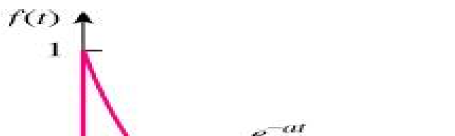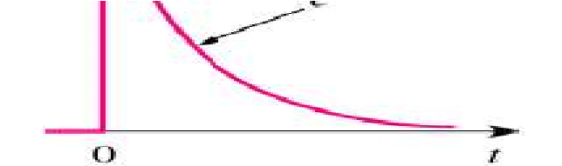
Figure Q2 (a)

- Find the value of the resistance between terminals a-b of the network shown in figure Q2 (b) below (4 Marks)
Figure Q 2(b)

- A 20μF capacitor is connected in series with a 50kΩ resistor and the circuit is connected to a 20V, dc supply. Determine (5 Marks)
  - Initial value of current flowing
  - The time constant of the circuit
  - The value of current one second after connection
  - Value of the capacitor two seconds after connection
  - Time after connection when resistor voltage is 15V.
- Find the y parameters for the resistive network shown in Figure Q2 (d) below (7 Marks)
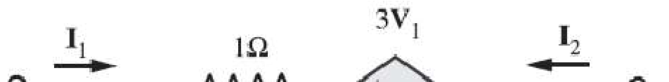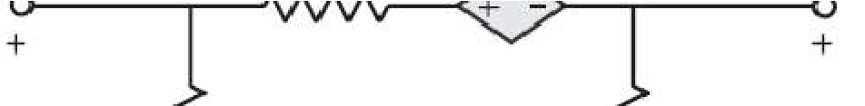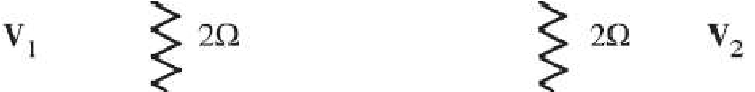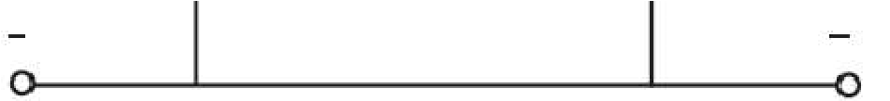
Figure Q 2(d)

QUESTION THREE (20 MARKS)
- Discuss two limitations of Ohm’s law (2 Marks)
- By inspection, determine: (3 Marks)
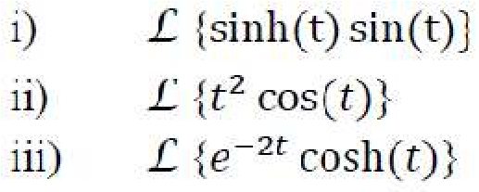
- A circuit, having a resistance of 4.0Ω with an inductance of 0.5H and a variable capacitance in series, is connected across a 100V, 50Hz supply.
Calculate: (5 Marks)
    - the capacitance required to attain resonance;
    - voltages across the inductance and the capacitance at resonance;
    - the Q factor of the circuit.
- A 208-V three-phase power system is shown in Figure Figure Q 3(d). It consists of an ideal 208-V, Y-connected three-phase generator connected through a three-phase transmission line to a Y-connected load. The transmission line has an impedance of (0.06 + j0.12) Ω per phase, and the load has an impedance of (12 + j9) Ω per phase. For this simple power system, find (10 Marks)
  - The magnitude of the line current IL
  - The magnitude of the load's line and phase voltages VLL and VΦL
  - The real, reactive, and apparent powers consumed by the load
  - The power factor of the load
  - The real, reactive, and apparent powers consumed by the
transmission line vi. The generator’s power factor.
Figure Q 3(d)

QUESTION FOUR (20 MARKS)
- Define a phasor (1 Mark)
- Briefly explain what you understand by the term mutual inductance (1 Mark)
- A coil of 5Ω resistance and inductance of 100mH is connected in series with a
capacitance of 2μF and a resistance of 5Ω across a 50V, variable frequency supply. Determine (5 Marks)
i) The resonant frequency
ii) The current at resonance
iii) Voltages across the coil and capacitor at resonance iv) The Q factor of the circuit
- Calculate the phasor currents I₁ and I₂ in the circuit of Figure Q4 (d) below (4 Marks)

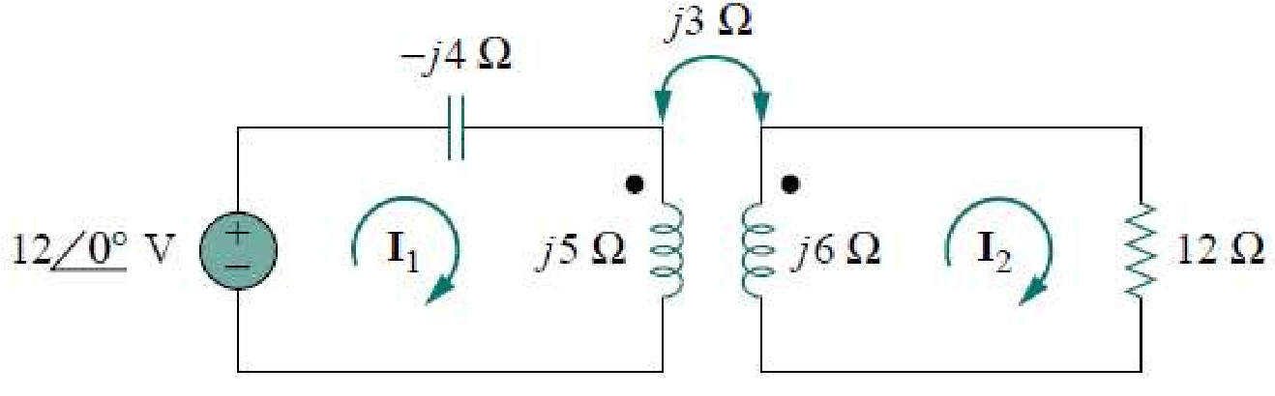
Figure Q 4(d)
- Applying Kirchhoff’s current law, determine the current i₂ for the network shown in figure 4 (e) below (4 Marks)
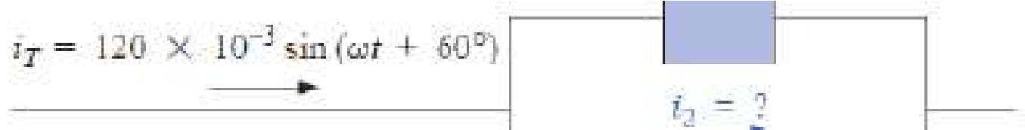
Figure Q 4(e)
- Determine the steady-state current i(t) in the RLC circuit shown in figure Q 4(f) using phasors and impedances (5 Marks)
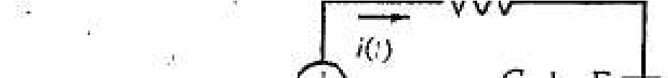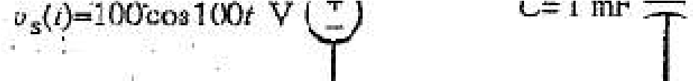
Figure Q 4(f)

---------------------------------------------------------------------------------------------------------------------

