CHUKA | 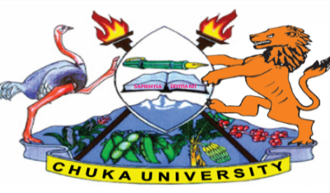 | UNIVERSITY
UNIVERSITY EXAMINATIONS

EXAMINATION FOR THE AWARD OF DEGREE OF BACHELOR OF SCIENCE
IN INDUSTIRAL CHEMISTRY

CHIN 452: INDUSTRIAL WASTE MANAGEMENT

STREAMS: BSC (INDUSTRIAL CHEM) BSC (CHEM) TIME: 2 HOURS

DAY/DATE: TUESDAY 11/04/2023 11.30 A.M. – 1.30 P.M.
INSTRUCTIONS: Answer ALL questions in section A and any TWO in section B

SECTION A (30 MARKS) (COMPULSORY)
a) Describe the meaning of the following terms (10 marks)
(i) Antagonism
(ii) Dissolved oxygen
(iii) Pollutant
(iv ) Contaminant
(v) Threshold limit value
(b) (i) What is industrial waste? (2 marks)
(c) Explain the meaning of the following statements with respect to industrial waste management
(i) Sustainable waste management (2 marks)
(ii) Toxic substance (2 marks)
(iii) Proportioning (2 marks)
(iv) Equalization (2 marks)
(d) Describe briefly the natural and artificial methods of industrial waste water disposal methods (4 marks)
(e) Explain neutralization as a method of waste reduction with reference to industrial wastes (6 marks)

SECTION B (ANSWER ANY TWO QUESTIONS)
QUESTION 2
(a) What is sludge? (2 marks)
(b) Explain each of the following methods as used in treatment and disposal of sludge solids
(8 marks)
(i) Anaerobic and aerobic digestion
(ii) Vacuum filtration
(iii) Sludge Lagooning
(iv) Centrifuging
(c) Compare lagooning in oxidation ponds and anaerobic digestion when mitigating organic dissolved solid in industrial effluents (4 marks)
(d) Briefly describe the objectives of the sustainable waste management Bill 2021 Kenya (6 marks)
QUESTION 3
(a) Explain the meaning of 4R in waste management (4 marks)
(b) Briefly discuss ‘industrial symbiosis “in reference to waste management (3 marks)
(c) Deep well injection and land -fills can ameliorate the effects of industrial waste, highlight some demerits of these methods (3 marks)
(d) Dairy industries are common in most parts of the world and locally
(i) Describe the characteristics of dairy wastes briefly (4 marks)
(ii) Explain methods of mitigating, control and removal of dairy wastes from dairy industries (6 marks)

QUESTION 4 (20 MARKS)
(a) Explain three and two major methods respectively for the treatment and disposal of Industrial solid waste and Industrial waste waters from a tanning industry respectively (10 marks)
(b) Explain the effect of waste waters and solids from a fertilizer to the following (4 marks)
(i) Sewage
(ii) Water bodies
(c) (i) Explain the major purpose of “The sustainable waste management Bill 2021 Kenya (2 marks)
(ii) Discuss the role of county governments in industrial waste management and challenges in waste management in Kenya (4 marks)
---------------------------------------------------------------------------------------------------------------------------

