CHUKA |  | UNIVERSITY
UNIVERSITY EXAMINATIONS

EXAMINATION FOR THE AWARD OF BACHELOR OF SCIENCE IN ELECTRICAL AND ELECTRONIC ENGINEERING

EENG 444: ROBOTICS I

STREAM: BSC (EENG) TIME: 2 HOURS

DAY/DATE: TUESDAY 11/04/2023 2.30 P.M. – 4.30 P.M.
INSTRUCTIONS:
- Answer question ONE and any other TWO questions
- Do not write on the question paper

QUESTION ONE (30 MARKS)
a) Distinguish between a transducer and a sensor. (4 marks)
b) What is a robot? (2 marks)
c) What is an actuator? (2 marks)
d) Outline five advantages of electric actuators. (5 marks)
e) List any three types of ac motors in robotics. (4 marks)
f) Why are dc motors preferred as servomotors? (2 marks)
g) Distinguish accuracy from repeatability. (4 marks)
h) Why are position sensors not preferred to obtain velocity and acceleration? (2 marks)
- Explain any five robotic languages. (5 marks)

QUESTION TWO (20 MARKS)
a). Discuss any 2 linear and non-linear control mechanisms used in robotics. (4 marks)
b). A vector ^{A}P is rotated about ${\hat{Z}}_{A}$ by $θ$ degrees and is subsequently rotated about ${\hat{X}}_{A}$ by
$ϕ$ degrees. Give the rotation matrix that accomplishes these rotations in the given order.
(3 marks)

c). Assign link frames to the RPR planar robot shown below, and give the linkage parameters.
(5 marks)

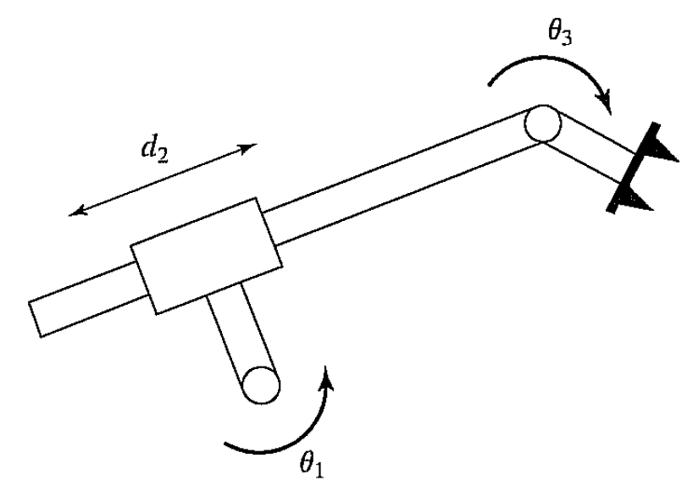

d). The arm with three degrees of freedom shown below has a twist of 90 degrees in magnitude between axes 1 and 2. Derive link parameters and the kinematic equations for ${}_{W}^{B}T$. Note that no $l_{3}$ need be defined. (8 marks)

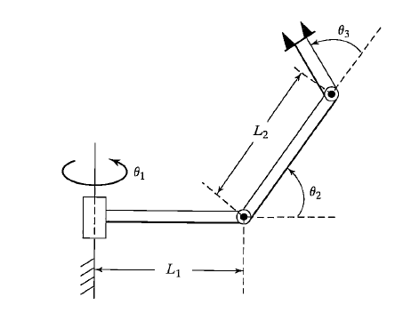

QUESTION THREE (20 MARKS)

a) Discuss briefly any three types of gripper mechanism. (6 marks)
b) A single cubic trajectory is given by (5 marks)
$θ\left(t\right)=10+90t^{2}-60t^{3}$
and is used over the time interval from t = 0 to t = 1. What are the starting and final positions, velocities, and accelerations?

c) The experimental surgical manipulator shown in Figure A.1, developed at the National University of Singapore, is a parallel mechanism with three identical legs, each with a prismatic joint and two universal joints (the joints are marked for one of the legs). Use Gr¨ubler’s formula to calculate the number of degrees of freedom of this mechanism. (4 marks)

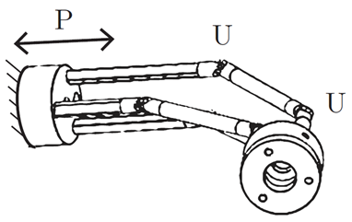
Fig A miniature parallel surgical manipulator with three PUU legs

d). Compute the motion of the system below if parameter values are in = 2, b = 6, and k = 4 and the block (initially at rest) is released from the position x =1. (5 marks)
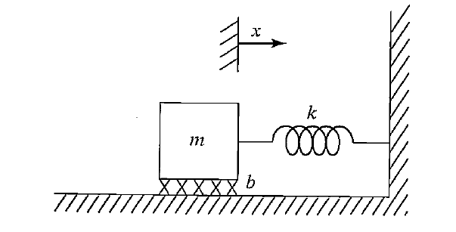

QUESTION FOUR (20 MARKS)
a) What does an ADC do in electronics? (2 marks)
b) Discuss any four the motion subsystems of a robot system. (4 marks)
c) Figure A.3 shows a screw axis in the (${\hat{y} }_{c}$, ${\hat{z} }_{c}$) plane, at a ${45}^{0}$ angle with respect to the ${\hat{y} }_{c}$-axis. (The ${\hat{x} }_{c}$-axis points out of the page.) The screw axis passes through the point (0, 3, 0).

(i) If the pitch of the screw is h = 10 linear units per radian, what is the screw axis $S_{c}$? Make sure you can also write this in its se(3) form [$S_{c}$], too. (5 marks)
(ii) Using your answer to (a), if the speed of rotation about the screw axis is $\dot{θ}$ = $\sqrt{2}$ rad/s, what is the twist $V_{c}$? (2 marks)
(iii) Using your answer to (a), if a frame initially at {c} rotates by $θ$ = $π$/2 about the screw axis, yielding a new frame {$c^{'}$}, what are the exponential coordinates describing the configuration of {$c^{'}$} relative to {c}? (2 marks)
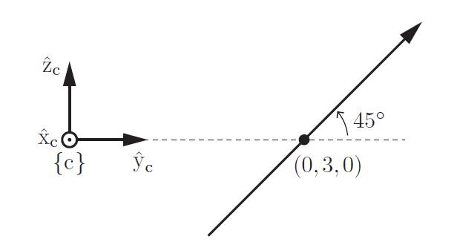
Fig. A.3 screw axis in the ((${\hat{y} }_{c}$, ${\hat{z} }_{c}$)) plane.

d). Referring to two Revolute-Prismatic (RP) planar arms below, where the revolute and prismatic joints are indicated as R and P, respectively, find the DH parameters (5 marks)




