THIRD YEAR EXAMINATION FOR THE DEGREE OF BACHELOR OF SCIENCE IN ELECTRICAL ENGINEERING
EENG 353: ELECTRONIC DEVICES AND CIRCUITS
Time: 2 hours
Instructions.
- This paper consist four questions
- Attempt Question one and any other two.
- The following constants may be of importance;
    - Silicon n_{i} = 1.4 × 10¹⁶m⁻³
    - k = 1.38 × 10⁻²³
    - e = 1.6 × 10⁻¹⁹ _{C}
QUESTION ONE (30 MARKS)
a). Discuss 2 limitations of an ordinary d.c. power supply (4 marks)
b). i). Define Voltage Regulation and explain its importance in the electronic world. (2 marks)
ii). Two power supplies A and B are available in the market. Power supply A has no-load and full-load voltages of 30V and 25V respectively whereas these values are 30V and 29V for power supply B. By calculation, identify the better power supply. (6 marks)

c). Determine the h parameters of the circuit fig. Q1 (c) (8 marks)
Fig. Q1 (c)
d). The Q of a tuned amplifier is 60. If the resonant frequency for the amplifier is 1200 kHz, find;
(i) Bandwidth
(ii) Cut-off frequencies. (6 marks)

e). Highlight four advantages of negative Feedback (4 marks)

QUESTION TWO (20 MARKS)
a). Discuss 2 Classification of Power Amplifiers (4 marks)

b). Prove that the power amplifiers collector efficiency η is given by (6 marks)
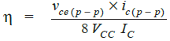

c). A power transistor working in class A operation is supplied from a 12-volt battery. If the maximum collector current change is 100 mA, find the power transferred to a 5Ω loudspeaker if it is:
(10 marks)
(i) Directly connected in the collector
(ii) Transformer-coupled for maximum power transference
iii). Design the two power amplifiers

QUESTION THREE (20 MARKS)
a). Discuss three advantages of electronic oscillators over mechanical alternators. (3 marks)

b). From the Colpitt's oscillator circuit of fig. Q 3 (b), determine the; (6 marks)
(i) Operating frequency
(ii) Feedback fraction

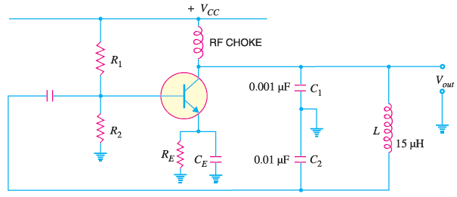
Fig. Q 3 (b)

c). Draw the frequency response of an ideal tuned amplifier and discuss its characteristics.
(6 marks)
d). Design the value of an inductor in a Hartley oscillator so that f = 1 MHz, mv = 0.2 and given that a 1 pF capacitor is available. (5 marks)

QUESTION FOUR (20 MARKS)
a). Define resonant frequency fr and give its mathematical expression (2 marks)

b). Prove that the ripple factor of a Single-phase half-wave Rectifier is given by ɤ = 1.21. (5 marks)

c). With the aid of an SCR circuit diagram/s, explain its working principle under the following conditions; (6 marks)
- When gate is open
- When gate is positive w.r.t. cathode
d). With the aid of circuit diagrams, explain the working of an Oscillatory Circuit. (7 marks)

