CHUKA | 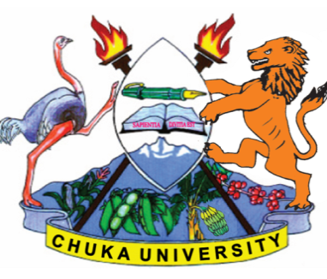 | UNIVERSITY
UNIVERSITY EXAMINATIONS
EXAMINATION FOR THE AWARD OF
DIPLOMA IN JOURNALISM AND MASS COMMUNICATION

DJMC 0125: COMMUNICATION RESEARCH

STREAMS: DJMC Y2S1 TIME: 2 HOURS

DAY/DATE: MONDAY 05/08/2019 8.30 AM – 10.30 AM
INSTRUCTIONS:

SECTION A: 30 MARKS – COMPULSORY

1. (a) In your own understanding, what is the statement of the problem in research? [5 marks]

(b) Describe different steps involved in research process. [20 marks]

(c) Distinguish the following types of research

(i) Descriptive vs Analytical
(ii) Qualitative vs Quantitative

2. Outline and explain five sampling techniques available to a researcher. [20 marks]

3. In many countries in Africa, research results do not contribute to policy decisions. What do you think can be done to encourage research in Kenya? [20 marks]

4. Explain why you think research is important. [20 marks]

5. Using suitable examples, discuss ethical issues you may anticipate as a researcher. [20 marks]
---------------------------------------------------------------------------------------------------------------------

