CHUKA | 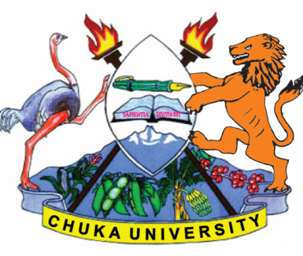 | UNIVERSITY
UNIVERSITY EXAMINATIONS
RESIT/SPECIAL EXAMINATION
EXAMINATION FOR THE AWARD OF DEGREE OF BACHELOR OF SCIENCE IN BIOCHEMEDICAL TECHNOLOGY
BMET 111: HUMAN PHYSIOLOGY
STREAMS: BSC BMET TIME: 2 HOURS
DAY/DATE: MONDAY 28/08/2023 2.30 P.M – 4.30 P.M.

INSTRUCTIONS:
- Answer question one and any other two questions.
QUESTION 1 (COMPULSORY) (30 MARKS)
- Name the six levels of organization of the human body. (6 marks)
- Explain why the smell of smoke when you are sitting ata campfire does not trigger alarm, but the smell of smoke inyour residence hall does. (5 marks)
- On his midsummer trek through the desert, Josh ran outof water. Explain why this particularly dangerous. (6 marks)
- Identify 3 most important plasma proteins and the role they play. (6 marks)
- Identify the four components of a negative feedbackloop and explain what would happen if secretion of a bodychemical controlled by a negative feedback system becametoo great. (7 Marks)
QUESTION 2 (20 MARKS)
- Explain five major functions played by human stomach in digestive process.(10 marks)
- Illustrate the mechanism of hormone response resulting from the binding of a hormone with an intracellular receptor. (10 Marks)
QUESTION 3 (20 MARKS)
- Compare and contrast endocrine and exocrine glands. (10 Marks)
- Compare and contrast ABO and Rh blood groups. (10 marks)

QUESTION 4 (20 MARKS)
- Explain the events during spermatogenesis that produce haploid sperm from diploid cells. (10 Marks)
- Describe the control of blood carbonic acid levelsthrough the respiratory system. (10 Marks)
---------------------------------------------------------------------------------------------------------------------

