CHUKA | 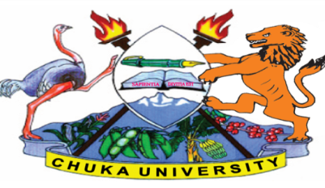 | UNIVERSITY
UNIVERSITY EXAMINATIONS
EXAMINATION FOR THE AWARD OF DIPLOMA IN AGRICULTURE AND RURAL DEVELOPMENT
BOTA 0131: GENERAL MICROBIOLOGY
STREAMS:DIP AGRI & RURAL DEVELP TIME: 2 HOURS
DAY/DATE: WEDNESDAY 12/04/2023 8.30 A.M – 10.30 A.M
INSTRUCTIONS:
Answer ALL questions
1. Draw a well labelled structure of deoxyribonucleic acid. [6 marks]
2. (a) State four differences between DNA and RNA. [4 marks]
(b) List two methods of obtaining a pure culture technique. [2 marks]
3. (a) Differentiate between enriched medium and differential medium. [2 marks]
(b) State two physical conditions used to discriminate the organism of interest. [2 marks]
(c) Define the following mode of nutrition.
(i) Chemoautotrophy [1 mark]
(ii) Chemoheterotrophy [1 mark]
4. Illustrate diauxic growth of an organism. [6 marks]
5. (a) List four types of microscopes. [4 marks]
(b) State two ways in which microbial culture can be maintained in long term storage. [2 marks]
SECTION B ( 40 MARKS): ANSWER ANY TWO QUESTIONS
6. Discuss the economic importance of fungi. [20 marks]
7. Describe the growth curve of microbes in batch culture. [20 marks]
8. Describe how purified DNA can be obtained from a cell culture. [20 marks]
---------------------------------------------------------------------------------------------------------------------

