CHUKA |  | UNIVERSITY
UNIVERSITY EXAMINATIONS
RESIT/SPECIAL EXAMINATION
EXAMINATION FOR THE AWARD OF DEGREE OF BACHELOR OF SCIENCE
CHEM 120: PHYSICAL CHEMISTRY 1
STREAMS: BSC TIME: 2 HOURS
DAY/DATE: WEDNESDAY 30/08/2023 8.30 A.M – 10.30 A.M.

INSTRUCTIONS:
- Answer all questions.
QUESTION ONE (30 MARKS)

Explain how the following factors influence the heat of reaction
- Physical state of reactants and products (2 marks)
- Allotropic forms of the element (2 marks)
- Enthalpies of solution (2 marks)
- Temperature: (2 marks)
- Reaction carried out at constant pressure or constant volume (4 marks)

- The standard heats of formation at 298 K for CCI₄ (g),H₂0(g),C0₂(g)andHC1(g) are -25.5, -57.8,-94.1 and-22.1 kcal mol^{-l} respectively. Calculate ${∆H}_{298}^{O}$for the reaction.(3 marks)

- When a student mixed 50 mL of lM HCI and 50 mL of l M NaOH in a coffee cup calorimeter. The temperature of the resultant solution increases from 21ºC to 27.5° C. Assuming that the calorimeter absorbs only a negligible quantity of heat that the total volume of solution is 100 mL, its density I g mL⁻¹ and that its specific heat is 4.18 J / g. Calculate:
- the heat change during mixing, (3 marks)
- the enthalpy change for the reaction, (2 marks)
- Outline four conclusions which can be experimentally verified based on Hess’s law and six applications of Hess’s law (7marks)
- write short notes on equilibrium expressions using appropriate reactions under the following cases : ∆n =0, ∆> 0, ∆n<0. (3marks)
QUESTION TWO (20 MARKS)
- Determine K c for the reaction
from the following data at 298 K;
The equilibrium constants for the following reactions,
(5 marks)
- Air entering the lungs ends up in tiny sacs called alveoli from which oxygen diffuses into the blood. The average radius of the alveoli is 0.0050 cm and the air inside contains 14 mole percent oxygen. Assuming that the pressure in the alveoli is 1.0 atm and the temperature is 37°C, calculate the number of oxygen molecules in one of the alveoli. (4marks)
- Some gases, such as NO₂ and NF₂, do not obey Boyle’s law at any pressure. Explain. (4marks)
- A 0.5122-g sample of naphthalene (C₁₀H₈) was burned in a constant-volume bomb calorimeter. Consequently, the temperature of the water in the inner jacket (see Figure 3.3) rose from 20.17°C to 24.08°C. If the effective heat capacity (CV) of the bomb calorimeter plus water is 5267.8 J K⁻¹, calculate ΔU and ΔH for the combustion of naphthalene in kJ mol⁻¹. Comment on the values of ΔU and ΔH obtained. (7marks)

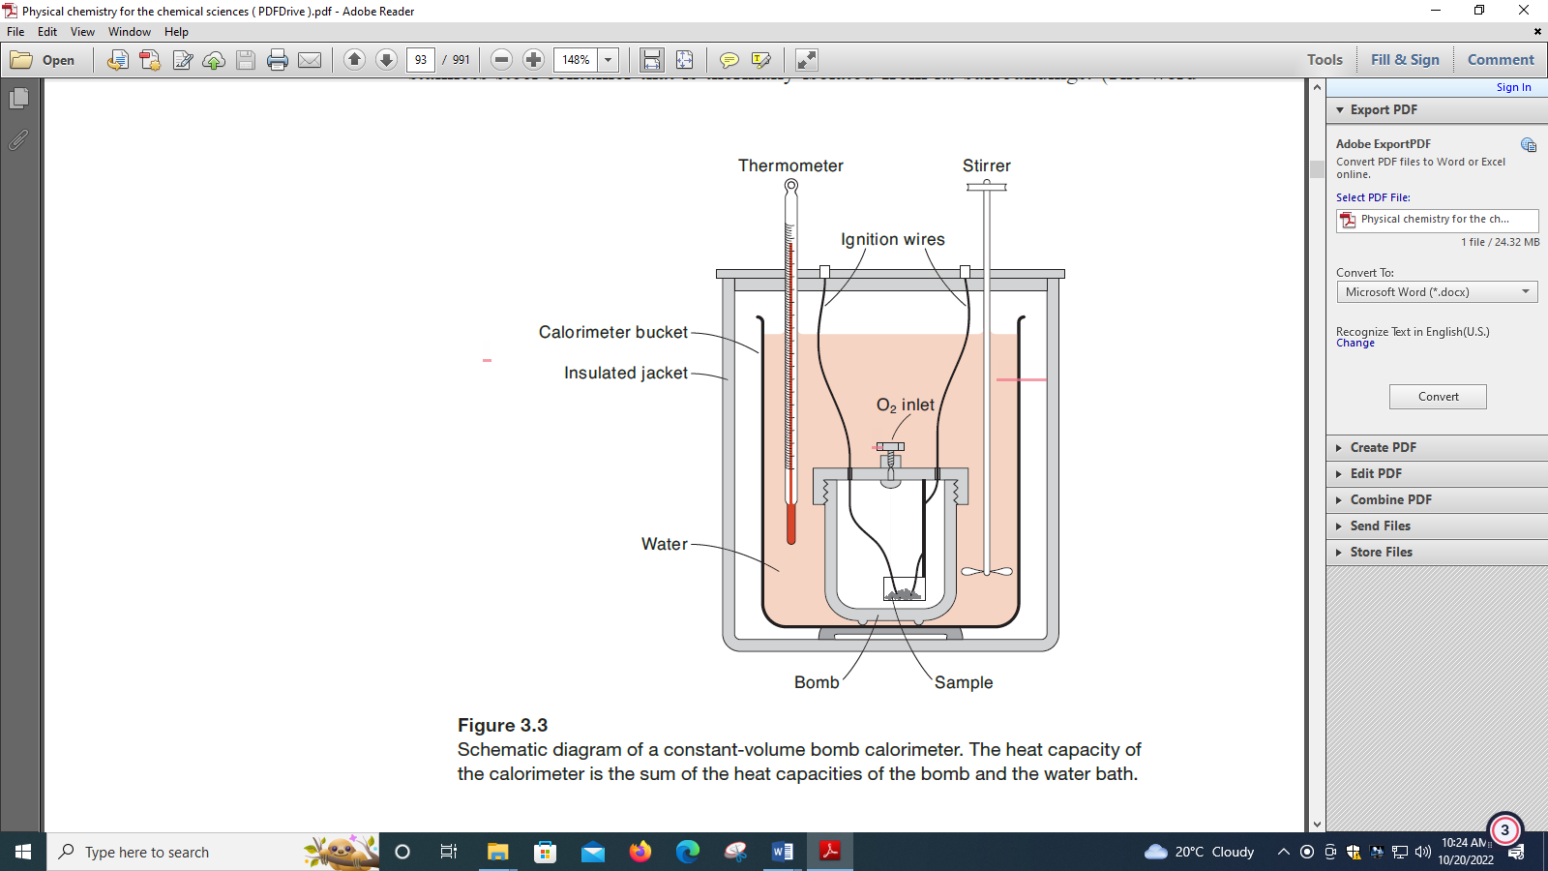
QUESTION THREE (20 MARKS)
a)The rate constants for the first-order decomposition of an organic compound in solution are measured at several temperatures:
Determine using regression equation the pre-exponential factor and the energy of activation for the reaction. (6 marks)
b)The following data were collected for the reaction between hydrogen and nitric oxide at
700°C:

- What is the rate law for the reaction? (3 marks)
ii)Calculate the rate constant for the reaction(3 marks)
c)In Arrhenius equation for a certain reaction, the value of A and E_{o} (activation energy) are
4 x 10¹³ sec ⁻¹] and98.6kJ mol^{-I} respectively. At what temperature, the reaction will have specific rate constant 1.1 x 10-3 sec ^{-I} ? (2 mark)
d)
From the following data for the reaction between A and B:
Calculate the following:
- The order of the reaction with respect to A and with
respect to B, (2 marks)

- The rate constant at 300K, (2 mark)
- The energy of activation ( 1 mark)
- The pre-exponential factor. ( 1 mark)

