CHUKA | 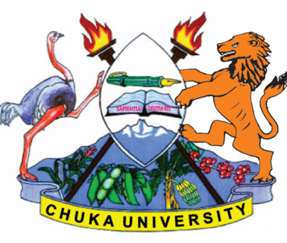 | UNIVERSITY
UNIVERSITY EXAMINATIONS
RESIT/SPECIAL EXAMINATION
EXAMINATION FOR THE AWARD OF DEGREE OF BACHELOR OF SCIENCE
BMET 233: MEDICAL HELMINTHOLOGY
STREAMS: BSC TIME: 2 HOURS
DAY/DATE: THURSDAY 31/08/2023 8.30 A.M – 10.30 A.M.
INSTRUCTIONS: Answer question one and any other two questions
Questions
Question 1 (Compulsory) (30 marks)
- Explain5general characteristics of cestodes. (5 Marks)
- Highlight 5pathways through which humans get exposed to helminthes. (5 Marks)
- Describe the life cycle of Strongyloidesstercoralis. (6 Marks)
- Describethe treatment and diagnosis of onchocerciasis. (6 Marks)
- Outline 3 differences between Hymenolepisdiminutaand Hymenolepis nana. (3 Marks)
- Describe briefly the laboratory diagnosis of Fasciola hepatica. (5 Marks)
Question 2 (20 marks)
- Describe the morphology and life cycle of Taeniasoliuminfection. (10 Marks)
- (i) Name etiologic agent fortrichinosis. (1 mark)
(ii) Discuss the pathogenicity and life cycle for the infection caused by the parasite named in (i) above. (9 marks)
Question 3 (20 marks)
- Describe, in detail, the life cycle and diagnosis of Taeniasignata. (10 Marks)
- State 5 medically important species schistosomes and indicate the diseases they cause in man. (10 marks)

Question 4 (20 marks)
- Describe clinical features, diagnosis and treatment of Ascaris lumbricoides. (10 marks)
- Discuss mode of transmission and pathogenesis of Wuchereriabancrofti. (10 marks)
------------------------------------------------------------------------------------------------------------

