CHUKA | 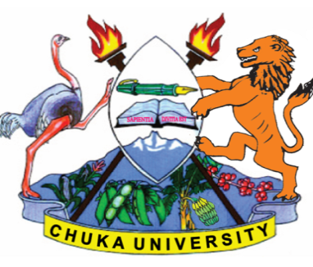 | UNIVERSITY
UNIVERSITY EXAMINATIONS
EXAMINATION FOR THE AWARD OF
DIPLOMA IN HUMAN RESOURCE MANAGEMENT

DIBM 0115: MANAGEMENT OF CHANGE

STREAMS: Y2 S2
TIME: 2 HOURS

DAY/DATE: TUESDAY 6 /07/ 2021 11.30 AM – 1.30 PM

INSTRUCTIONS:
- Answer question ONE (Compulsory) and any other TWO questions.
- Do not write on the question paper

QUESTION ONE:
(a) Distinguish between planned and unplanned change giving examples of each.
[8 Marks]
(b) Discuss any 5 conditions necessary to consider when introducing change. [10 Marks]
(c) Discuss six reasons why managers resist change. [12 Marks]

QUESTION TWO
(a) Explain the role of a leader in change management. [10 Marks]
(b) operating / industry environment impact on the success of an organization products. Discuss the forces that are found in this environment. [10 Marks]

QUESTION THREE
(a) You are currently appointed to spearhead change in your organization, briefly discuss change and innovation process that you would use to do so. [12 Marks]

(b) Organizations in nature tend to resist change discuss the sources of organizational resistance to change. [8 Marks]

QUESTION FOUR
(a) Discuss the advantages and disadvantages of using external consultants on managing change.
[8 Marks]
(b) Discuss organizational factors that would contribute to employee’s stress in a services
industry. [10 Marks]
……………………………………………………………………………………………………………………………………………………………….

