CHUKA | 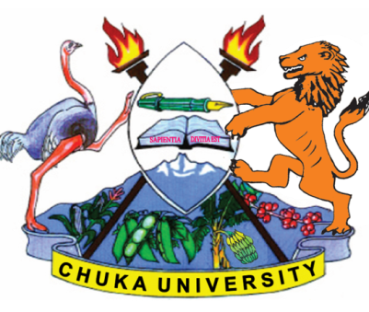 | UNIVERSITY
UNIVERSITY EXAMINATIONS

CHUKA AND EMBU CAMPUSES

EXAMINATION FOR THE AWARD OF CERTIFICATE IN COMMUNITY DEVELOPMENT

CDEV 00150: RESEARCH METHODS

STREAMS: CERT. CDEV TIME: 2 HOURS

DAY/DATE: MONDAY 05/07/2021 11.30 A.M. – 1.30 P.M.

INSTRUCTIONS:
- Answer question ONE and any other TWO questions

1. (a) Explain the following terms as used in research methods.
(i) Research (3 marks)
(ii) Simple random sampling (3 marks)
(iii) Research design (3 marks)
(iv) Sample (3 marks)

(b) Briefly explain the qualities of a good research. (6 marks)

(c) State and explain the significance of research. (12 marks)

2. (a) Explain the characteristics of scientific research. (8 marks)

(b) Discuss the various types of research. (12 marks)

3. (a) Discuss the different types of sampling techniques. (12 marks)

(b) State the characteristics of a good sample design. (8 marks)

4. Write short notes on the following research instruments.
(i) Interviews (10 marks)
(ii) Questionnaires (10 marks)

5. Discuss the process of developing a proposal. (20 marks)
--------------------------------------------------------------------------------------------------------------------

