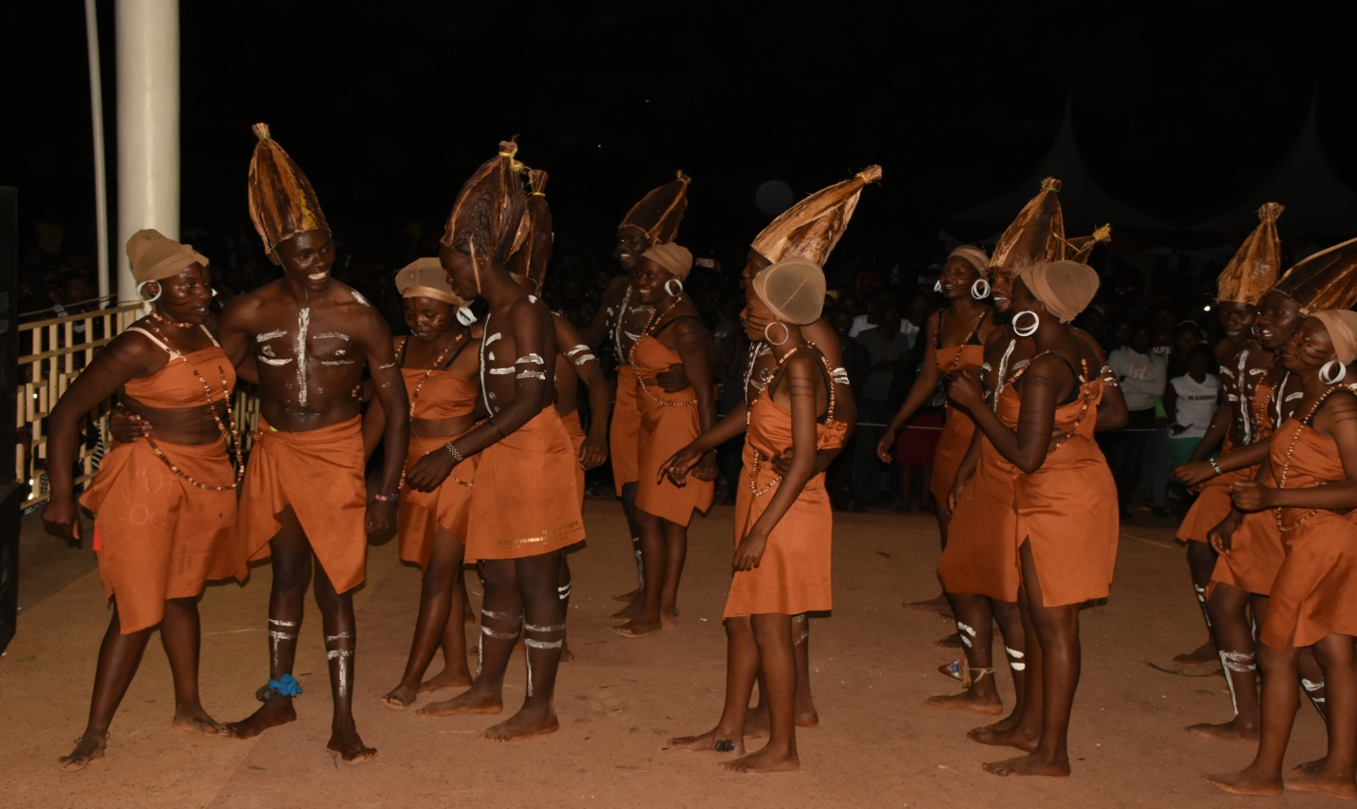Chuka University Students presenting a Kikuyu Folk Song during the September 30th - October 4th, 2019 Cultural Week.

