GPHY224


CHUKA UNIVERSITY

UNIVERSITY EXAMINATIONS
SECOND YEAR EXAMINATION FOR THE AWARD OF DEGREE
OF BACHELOR OF DEGREE IN PHYSICS

GPHY224: GEOPHYSICS PRACTICAL IV
STREAMS: GPHY224 TIME :2 HOURS
DAY/DATE: DAY DATE TIME
INSTRUCTIONS: Answer all questions
QUESTION ONE (20marks)
- Is glass a mineral? Frame your answer in terms of the criteria used to define a mineral.
[5marks]
- What ‘special’ physical properties are used to identify and classify a mineral?
[3marks]
- Why is colour a poor criteria for the recognition of most minerals [2marks]
- Do all minerals with metallic luster look like shiny metal? Comment in detail.
[2marks]
- What is streak? Would streak be a useful physical property in the identification of hard minerals such as diamond? Explain your answer in detail [2marks]
- What is specific gravity? Minerals with what type of luster will tend to have a higher specific gravity? [2marks]
- What Moh’s minerals are softer than a natural fingernail? [2marks]
- Quartz has a very simple chemical formula (SiO₂) and yet has about 120 known varieties. Why? [2marks]

QUESTION TWO (20marks)
- Describe the difference between cleavage and crystal form as a physical property that can be used identify a mineral. [2marks]
- Comment on the validity of the following statement “When breaking a crystal with a hammer the resulting fragments will have the same shape as the original crystal.” [2marks]
- The presence of cleavage in a mineral indicates what about the nature of chemical bonding at the atomic scale within a mineral? [2marks]
- Describe the difference in the physical appearance of a cleavage versus a fracture surface. [2marks]
- Identify the types of mineral cleavage fragments and give an example
[12marks]


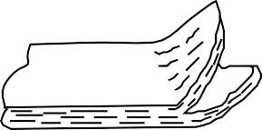

i) ii)

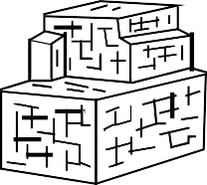
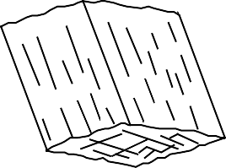
iii)
iv)

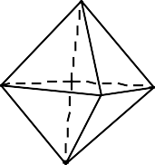
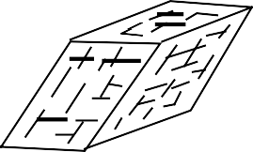

v) vi)

QUESTION THREE (20 marks)
- Name two analytical Equipment for Identifying Minerals. [2 marks]
- What are the basic components of a polarized light microscope (PLM)? [3marks]
- Name three types of evidence that could be examined with the PLM. [3marks]
- What types of evidence would not be examined with the PLM? Why? [2marks]
- Explain plane polarized light. [2marks]
- What is isotropic? Give examples [2marks]
- Giving relevant examples define anisotropic material. [2marks]
- What is birefringence? [1mark]
- What is pleochroism? [1mark]
- Name the mineral classes that the following belong [2marks]
- Calcite and fluorite
- Muscovite and biotite

