

library@chuka.ac.ke; www.chuka.ac.ke

ROLE OF ON-FARM RAINWATER HARVESTING IN AGRICULTURE AS A RESPONSE TO CLIMATE CHANGE IN KENYA

Kiguro, L.
World Vision Kenya, P. O. Box 50816-00200, Nairobi
E-mail: Lawrence_kiguro@wvi.org, lawrencekiguro@gmail.com, Tel.: 0723-723176

Citation:

Kiguro, L.(2014) Role of on-farm rainwater harvesting in agriculture as a response to climate change in Kenya In: Isutsa, D.K. and Githae, E.W. Proceedings of the Second Chuka University International Research Conference held in Chuka University, Chuka, Kenya from 28th to 30th October, 2015.215-221pp.

ABSTRACT
The objective of this paper is to show the role of on-farm rain water harvesting in Agriculture as a response to climate change in Kenya. It is based on the fact that water harvesting is a promising technique widely accepted throughout the world to cope with water scarcity problems in agriculture. Micro-and macro-water harvesting techniques are implemented in arid, semi-arid, and tropical regions, depending on the purpose and circumstances. Water harvesting has been shown to have a positive impact on agricultural production by providing irrigation water during critical growth stages of crops, hence increasing yields. Water harvesting reduces runoff velocity, soil erosion and recharges ground water. This paper is based on literature review and practical field experiences and concludes that a significant gain in crop production can be made in agriculture through small-scale harvesting of water in combination with suitable water conserving irrigation technologies.
Keywords: Global warming, Adaptation, Water resources, Food security

INTRODUCTION
Climate Change which refers to the change in the planet’s climate beyond its natural variability has lately become a major contributory factor both directly and indirectly to the increasingly deteriorating livelihoods for a majority of the communities in the developing world. The negative effects of climate change continue to be felt in all major sectors of the economy i.e. food security, health, energy, water resources and tourism.

The consequences of this change in climate are manifested in shrinking water resources following declining rainfall amounts and seasons; which in turn leads to a myriad of livelihood challenges like declining crop and livestock productivity, changing animal disease patterns, severe human disease endemics among others. These issues have collectively continued to erode the resilience of communities with children and women being the most affected due to their vulnerability.

Rain water harvesting (RWH) is a traditional water conservation technique, and there is a general consensus that conserving water will definitely promote agricultural production, especially in arid and semi-arid regions. The high competition for water and land has led to scarcity of water resources, which has in turn threatened the world's food security. Fortunately, recent technological developments have led to improvements in rainwater harvesting techniques, which will help guarantee the availability of food for the growing population. So this paper looks at the whole issue of On-Farm Rainwater Harvesting (RWH) in Agriculture as one of the adaptation measures to climate change in Kenya.

Why Rainwater Harvesting
The problem of water scarcity has been an issue of increasing concern to the communities, the national government and Research Institutions such as the Kenya Agricultural and Livestock Research Organization (KARLO) and even International Organizations such as the World Agroforestry Centre (ICRAF). This is because the East African Region and specifically Kenya has fallen into this unfortunate trap of water scarcity due to the increasing effects of climate change as rainfall failure is now being experienced at least once in every three years. Because of these changed rainfall patterns, hunger and poverty are becoming a major problem, especially in arid and semi-arid regions, because a large proportion of arable land in those areas frequently experience water scarcity and recurrent dry spells. Arid and semi-arid regions are also being referred to as “under-nutrition climatology areas” (Falkenmark, 2001). However, if proper attention is given to improving water productivity including rain water harvesting, then agriculture and hence the major livelihood of the people living in the dry arid and semi-arid areas can be salvaged and sustained (Oweis and Hachum 2006).

Beneﬁts of Rainwater Harvesting
Macro- and micro-catchment rainwater harvesting systems have positive impact on soil moisture regimes and crop yields (Walker et al., 2005; Wei et al., 2005; Mupangwa et al., 2006). Li and Gong (2002) and Tian et al. (2003) found that micro-water harvesting of ridges and furrows with plastic mulch increased the tuber yield of potatoes by 158–175% for two years (Wang et al., 2008), and the corn yield by 1.9 times (Li at al., 2000) because of the higher water use efﬁciency (Li et al, 2004a). Aftab et al. (2012) concluded that rainwater harvesting systems were shown to be a relatively low-cost option for temporal access to a water source. RWH minimizes some of the problems associated with irrigation, such as the competition for water between various end uses and users, low water use efficiency, and environmental degradation. RWH is a simple, cheap, and environmentally friendly technology that can easily be managed with limited technical skill (Ngigi, 2003). Supplemental irrigation during dry spells with micro-catchment rainwater harvesting could improve the soil water content of the rooting zone by up to 30% (Biazin et al., 2012). Harvested water from a small pond increased sorghum harvests by 41%, and when combined with added fertilization, by 180% (Fox and Rockström, 2000).

On-Farm Rainwater Harvesting Techniques
Rainwater harvesting basically entails concentrating, diverting, collecting, storing, utilizing, and managing runoff water for productive purposes (Ngigi, 2003). According to Wang and others, micro- harvesting of rainfall water is implemented in the dry semi-arid regions of northwest China in order to maximize the utilization of rainfall (Wang et al., 2008). Rainwater harvesting in India is also done via a traditional method for runoff catchment which is a method of aquifer recharge technique that increases the groundwater supply; it is also used to collect and store runoff during the heavy downpours of the Indian monsoon season (Glendenning and Vervoort, 2010).
The following are some of the methods/techniques of on-farm rainwater harvesting (RWH) based on field experiences in Kenya by the author: Use of Subsoilers; Zay-pits; Sunken beds; Bakaards/On-farm Water-pods (Silangas)

The Use of Sub-Soiler Technology
Continuous use of the Oxen Plough has created a hardpan which impedes water infiltration into the soil. The Sub-Soiler helps to break the hardpan and hence improve water infiltration into the soil for use by crops.

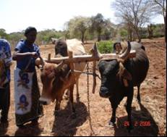
Captions 1 and 2: The Subsoiler tool and strong bulls to engage

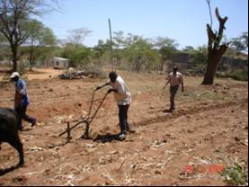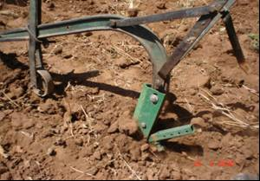
Captions 3 and 4: The Subsoiler tool at work!

Zay-pits
These are pits that are well fertilized with deeply loosened soil, which enables intensive growing of crops that gives high yields from a small unit area of land.

Procedure of making Zay-pits
- Dig a hole of 2ftx2ftx2ft, and maintain a 2ft distance between the holes;
- Make sure during the digging, that the topsoil (usually first one foot) is put separate from the sub soil;
- The alignment of the pits should be alternating as in a chess board;
- Once done put a layer of vegetation material at the bottom half foot of the hole;
- Mix a debe of manure (boma or compost) with topsoil (earlier set aside) and put into the hole at a ratio of 1:1, which is now 1/4 full with vegetation materials;
- Leave a top space of about 2-3 inches for water collection into the hole;
- Plant 5 seed during the short rains and 9 seeds during the long rains;
- When the crop is at knee high, one can apply liquid manure at the rate of 5litres per hole and completely cover the hole with the subsoil.
- The pit can be used for two and a half years or 4 crop seasons but crop rotation should be maintained.

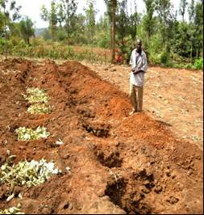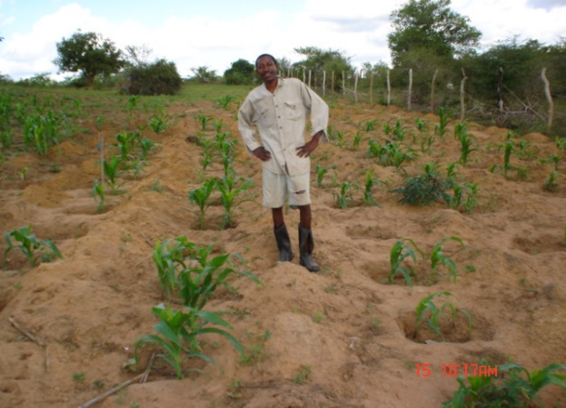
Captions 1 and 2: Making Zaypits supported by Food for Work (FFW) in Makuyu and a young crop of maize growing in Zaypits in Kilifi (Kenya)

Sunken beds
These are well fertilized beds with deeply loosened soil, suitable for vegetable growing. The width should be a maximum of 1M wide to avoid people from trampling inside the bed while working but the length can vary depending on the need. These type of beds are suitable and mainly used for kitchen gardening.

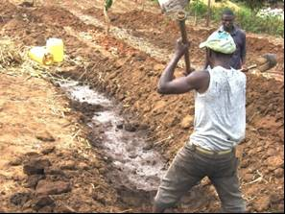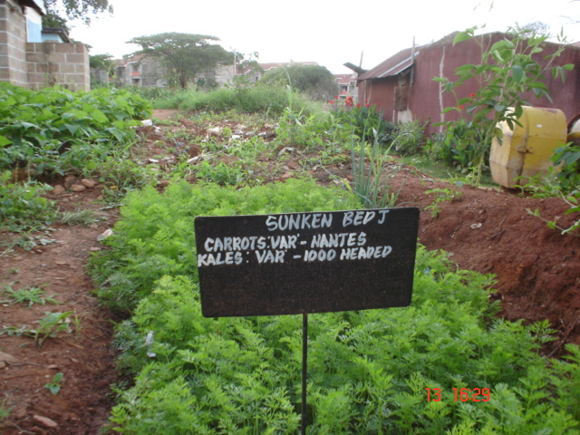
Captions 1 and 2: Making a sunken bed in Makuyu and carrots growing in a sunken bed in Makueni (Kenya)

Bakaards/On-farm Water-pods (Silangas)
In the drylands, road runoff water should not be left to go in to waste as it ends up causing damage to crops in the farm and soil erosion amongst other havoc. Instead, this water should be tapped and put into good use through on-farm reservoirs. The water can then be used for small scale irrigation using a Pendle pump to get out the water into the farm.
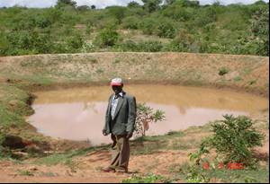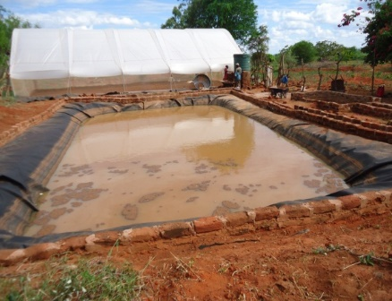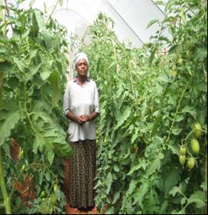
Captions 1 and 2: An on-farm water reservoir in Makueni and a bakaard for rainwater harvesting and use in the greenhouse in Mtito Andei (Kenya)

Basic method for selecting a proper water harvesting system (Hatibu and Mahoo, 1999)

Challenges of Rainwater Harvesting
The following are some of the chalpenges facing rain water harvesting in Kenya: On-farm rainwater harvesting is tedious, costly and quite demanding in terms of time and effort and so this tends to discourage people from engaging on the same; Lack of national level coordination; and Inadequate water related legislations.

CONCLUSION
Water harvesting is a promising technique that is widely accepted throughout the world and is used to cope with water scarcity problems in agricultural production. Micro- and macro- water harvesting techniques are implemented in arid, semi-arid, and tropical regions depending on the purpose and the circumstances. The implementation of a water harvesting system has been shown to have a positive impact on agricultural production by providing irrigation water during critical growing stage of crops, hence increasing the yields. A water harvesting system also helps to reduce runoff velocity and soil erosion, and thus, contributes to groundwater recharge. However, poor design, poor management, and poor communication between designers, the government, and farmers can lead to the failure of a water harvesting system.

RECOMMENDATION
Irrigation plays a very important role in supplying food, but the potential for increasing water withdrawals for irrigation is considered limited (Falkenmark, 2001). Therefore, a significant gain in crop production in rainfed agriculture must come from small- scale harvesting of water in combination with protective irrigation. However, the potential of a rainwater harvesting system to sustain agricultural production should be supported by other technologies, speciﬁcally Information Technology (IT); Soil and nutrient management, as well as a consideration of the farmers' social and economic condition during implementation in order to ascertain the success of the water harvesting system in improving local agricultural production.

REFERENCES
Aftab, T.B., Hasnain, S.A. and Iqbal, S.R. 2012. Save Water and Safe water: Evaluation of design and storage period on water quality of rainwater harvesting system. Journal of Environment and Earth Science, 2: 106-111.
Barron, J. and Okwach, G. 2005. Run-off water harvesting for dry spell mitigation in maize (Zea mays L.): Results from on-farm research in semi-arid Kenya. Agricultural Water Management, 74: 1-21.
Biazin, B., Sterk, G., Temesgen, M., Abdulkedir, A. and Stroosnijder, L. 2012. Rainwater harvesting and management in rainfed agricultural systems in sub-Saharan Africa -A review. Physics and Chemistry of the Earth, 47:139-151.
Falkenmark, F.M., Persson, P., Rockström, G. and Johan. 2001. Water harvesting for upgrading of rainfed agriculture: Problem analysis and research needs. Stockholm International Water Institute and MISTRA.
Fox, P. and Rockström, J. 2000. Water-harvesting for supplementary irrigation of cereal crops to overcome intra-seasonal dry-spells in the Sahel. Phys. Chem. Earth (B), 25: 289-296.
Glendenning, C.J. and Vervoort, R.W. 2011. Hydrological impacts of rainwater harvesting (RWH) in a case study catchment: The Arvari River, Rajasthan, India. Part 2: Catchment-scale impacts. Agricultural Water Management, 98: 715-730.
Glendenning, C.J., Van Ogtrop, F.F., Mishra, A.K. and Vervoort, R.W. 2012. Balancing watershed and local scale impacts of rain water harvesting in India-A review. Agricultural Water Management, 107:1-13.
Hatibu, N. and Mahoo, H. 1999. Rainwater harvesting technologies for agricultural production: A case for Dodoma, Tanzania in Kaumbutho PG, Simalenga TE (eds) Conservation tillage with animal traction: A resource book of the animal traction network for Eastern and Southern Africa (ATNESA). Harare. Zimbabwe: 173 pp.
Hatibu, N., Mutabazi, K., Senkondob, E.M. and Msangi, A.S.K. 2006. Economics of rainwater harvesting for crop enterprises in semi-arid areas of East Africa. Agricultural Water Management, 80: 74-86.
Kahinda, J.M.M., Rockström, J.,Taigbenu, A.E. and Dimes, J. 2007. Rainwater harvesting to enhance water productivity of rainfed agriculture in semi-arid Zimbabwe. Physics and Chemistry of the Earth, 32: 1068-1073.
Li, X., Su, D. and Yuan, Q. 2007. Ridge-furrow planting of alfalfa (Medicago sativa L.) for improved rainwater harvest in rainfed semiarid areas in Northwest China, Soil and Tillage Research, 93:117-125.
Li, X.Y. and Gong, J.D. 2002. Compacted micro catchments with local earth materials for rainwater harvesting in the semiarid region of China. Journal of Hydrology, 257: 134-144.
Li, X.Y. and Gong, J.D. 2004a. Effects of different ridge: Furrow ratios and supplemental irrigation on crop production in ridge and furrow rainfall harvesting system with mulches. Agricultural Water Management, 54: 243-254.
Li, X.Y., Liu, L.Y., Gao, S.Y., Shi, P.J., Zou, X.Y. and Zhang, C.L. 2005. M i c r o c a t c h m e n t water h a r v e s t i n g f o r g r o w i n g Ta m a r i x ramosissima in the semiarid loess region of China. Forest Ecology and Management, 214: 111-117.
Li, X.Y., Zhao, W.W., Song, Y.X., Wang, W. and Zhang, X.Y. 2008. Rainfall harvesting on slopes using contour furrows with plastic- covered transverse ridges for growing Caragana korshinskii in the semiarid region of China. Agricultural Water Management, 95: 539-544.
Mupangwa, W., Love, D. and Twomlow, S. 2006 . Soil-w a t e r conservation and rainwater harvesting strategiesin the semi-arid Mzingwane Catchment, Limpopo Basin, Zimbabwe. Physics and Chemistry of the Earth, 31: 893-900.
Ngigi, S.N. 2003. What is the limit of up-scaling rainwater harvesting in a river basin? Physics and Chemistry of the Earth, 28: 943-956. O'Hogain S, McCarton L, McIntyre N, Pender J and Reid J (2011) Physicochemical and microbiological quality of harvested rainwater from an agricultural installation in Ireland. Water and Environment Journal, 26:1-6.
Oweis, T.Y. and Taimeh, A.Y. 1996. Evaluation of a small basin water-harvesting system in the arid region of Jordan. Water Resources Management, 10: 21-34.
Oweis, T., Hachum, A. and Kijne, J. 1999. Water harvesting and supplemental irrigation for improved water use efficiency in dry areas. System Wide Initiative on Water Management (SWIM) paper;
Suleman, S., Wood, M.K., Shaht, B.H. and Murray, L. 1995. Development of a rainwater harvesting system for increasing soil moisture in arid rangelands of Pakistan. Journal of Arid Environments, 31: 471-481.
Tian, Y., Su, D., Li, F. and Li, X. 2003. Effect of rainwater harvesting with ridge and furrow on yield of potato in semiarid areas. Field Crops Research, 84: 385-391.
Walker, S., Tsubo, M. and Hensley, M. 2005. Quantifying risk for water harvesting under semi-arid conditions. Part II. Crop yield simulation - Agricultural Water Management, 76: 94-107.
Wang, Q., Zhang, E., Li, F. and Li, F. 2008. Runoff efficiency and the technique of micro-water harvesting with ridges and furrows, for potato production in semi-arid areas. Water Resource Management, 22: 1431-1443.
Wang ,Y., Xie, Z., Malhi, S.S., Vera, C.L., Zhang, Y. and Guo, Z. 2011. Effects of gravel-sand mulch, plastic mulch and ridge and furrow rainfall harvesting system combinations on water use efficiency, soil temperature and watermelon yield in a semi- arid Loess Plateau of northwestern China. Agricultural Water Management, 101: 88-92.
Wei, H., Li, J.L. and Liang, T.G. 2005. Study on the estimation of precipitation resources for rainwater harvesting agriculture in semi- arid land of China. Agricultural Water Management, 71: 33-45.
******

LOCAL COMMUNITY PERCEPTION OF THE BENEFITS AND COSTS OF CONSERVA

