CHUKA |  | UNIVERSITY
UNIVERSITY EXAMINATIONS

EXAMINATION FOR THE AWARD OF DEGREE OF BACHELOR OF SCIENCE IN PUBLIC HEALTH

PUHE 131: TECHNICAL DESIGNS AND DRAWING

STREAMS: BSC PUHE TIME: 2 HOURS

DAY/DATE: FRIDAY 12/4/2024 8.30 A.M. – 10.30 A.M.
INSTRUCTIONS: This paper consists of four questions
Question one is compulsory
Attempt Question one and any other two

QUESTION ONE (30 marks) (COMPULSORY)

Q1 (a) Divide a 153mm line into ratio 2:3:4 (5 marks)

(b) Construct a hyperbola of e = 3/2 if the distance of the focus from the directrix = 50 mm (10 marks)

(c) Draw a FV sectional orthographic projection of the object in Fig.Q1(c) (10 marks)
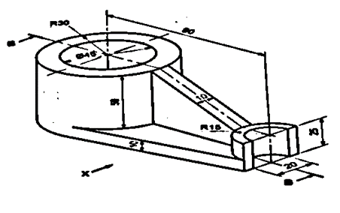 Fig.Q1(c)
(d) Draw the isometric projection of a regular hexagon of base side 25mm in H.P, keeping two of its bases
perpendicular to V.P (5 marks)

QUESTION TWO (20 marks)

Fig.Q2 shows the Isometric view of an engineering component. Draw the components Top View and Front View
and Side View (20 marks)
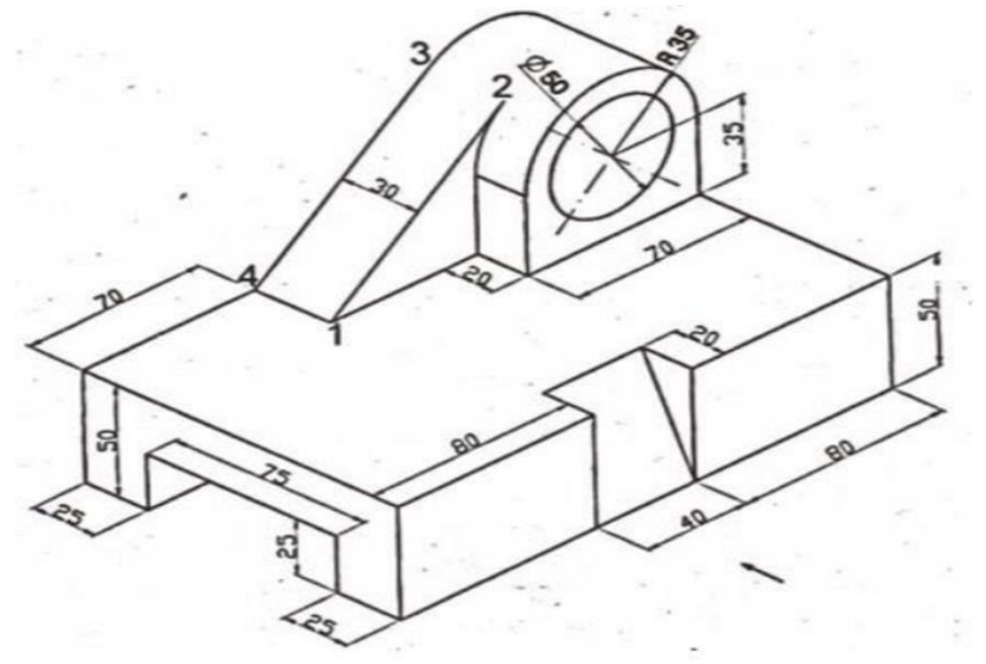Fig.Q2

QUESTION THREE (20 marks)

(a) Draw an ellipse if the distance of focus from the directrix is 70 mm and the eccentricity is ¾ (10 marks)

(b) Draw the orthographic projection of the object in Fig.Q3(b) (10 marks)

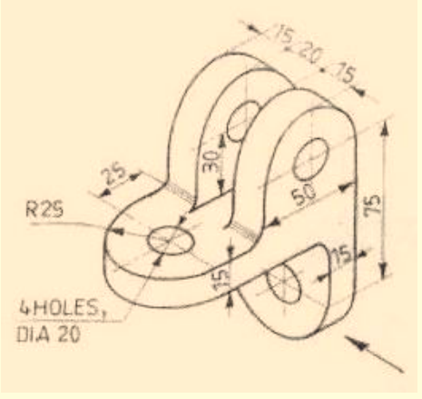 Fig,Q3(b)

QUESTION FOUR (20 marks)

(a) Draw an involute of a circle of 50mm diameter (10 marks)

(b) Fig.Q4(b) shows an engineering component. Draw the component’s Isometric
Projection (10 marks)
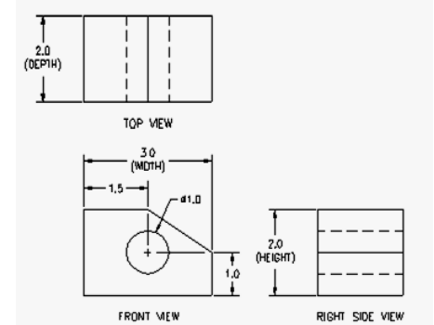 Fig.Q4(b)

………………………………………………………………………………………………………………………………………………………

