CHUKA | 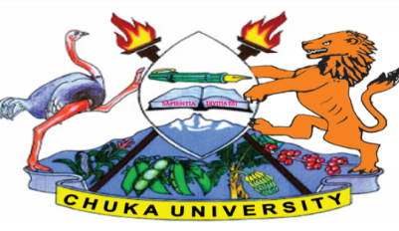 | UNIVERSITY
UNIVERSITY EXAMINATIONS
EXAMINATION FOR THE AWARD OF DEGREE OF BACHELOR OF SCIENCE IN BIOCHEMISTRY
BIOC 425: METABOLISM REGULATIONS AND INTEGRATION
STREAMS: BSC BIOC TIME: 2 HOURS
DAY/DATE: WEDNESDAY 19/04/2023 11.30 A.M – 1.30 P.M
INSTRUCTIONS:
Answer question one and any other two questions
Do not write on the question paper
QUESTION ONE (30 MARKS)
- Describe the role of the following enzymes in metabolic regulation and integration.
- Pyruvate dehydrogenase complex [2 marks]
- Acetyl CoA Carboxylase [2 marks]
- Describe regulation of pyrimidine nucleotide biosynthesis in the liver. [6 marks]
- Outline biochemical basis of diabetes ketoacidosis (DKA) [5 marks]
- Explain the role of fructose -2, 6 biophosphate in regulation of glycolytic and gluconeogenesis pathways. [7 marks]
- Explain why AMP activated protein kinase (AMPK) is usually referred to as master metabolic regulator. [8 marks]
QUESTION TWO (20 MARKS)
- Using illustrative diagrams, discuss tryptophan (trp) operon regulation in Esherichia coli. [10 marks]
- Using clear illustration, describe factors that control the rate of reaction sequence in the citric acid cycle. [10 marks]
QUESTION THREE (20 MARKS)
- The body maintains a relatively large free amino acid pool in the blood, even during fasting.
- Give reasons for this observation. [6 marks]
- Describe the mechanism which maintains free amino acid pool in the blood. [7 marks]
- Discuss the Janus kinase – signal transducers and activators of transcription mechanism of leptin signal transduction in the hypothalamus. [7 marks]
QUESTION FOUR (20 MARKS)
- Why are metabolic processes highly regulated and integrated in the cell? [8 marks]
- Describe metabolic changes in the adipose tissue during fasting (starvation). [12 marks]
---------------------------------------------------------------------------------------------------------------------

