See discussions, stats, and author profiles for this publication at: https://www.researchgate.net/publication/305500380

Current status of fodder production, conservation and marketing in the arid and semi-arid lands of Tharaka Nithi County, Kenya
Article in African Journal of Agricultural Research · June 2016
DOI: 10.5897/AJAR2016.11162

CITATIONS
7
READS
15,970

1 author:


Onesmus Nderi
CHUKA UNIVERSITY, KENYA
7 PUBLICATIONS 51 CITATIONS
SEE PROFILE

All content following this page was uploaded by Onesmus Nderi on 22 July 2016.

The user has requested enhancement of the downloaded file.



Vol. 11(26), pp. 2337-2347, 30 June, 2016 DOI: 10.5897/AJAR2016.11162  Article Number: AA8B2C359262 ISSN 1991-637X  Copyright ©2016  Author(s) retain the copyright of this article  http://www.academicjournals.org/AJAR | African Journal of Agricultural  Research

Full Length Research Paper
Current status of fodder production, conservation and marketing in the arid and semi-arid lands of Tharaka Nithi County, Kenya
Levi Mugalavai Musalia¹*, Gilbert Abura Odilla², Onesmus Munene Nderi¹ and Viona Muleke³
mnderi@chuka.ac.ke
¹Department of Animal Science, Chuka University, P. O. Box 109-60400, Chuka, Kenya.
²Department of Education, Chuka University, P. O. Box 109-60400, Chuka, Kenya.
³School for Human Resource Development, Jomo Kenyatta University of Agriculture and Technology, P. O. Box, 62000- 00200, Nairobi, Kenya.
Received 29 April, 2016; Accepted 2 June, 2016

The purpose of the survey was to document the current status of fodder production, conservation and marketing in the arid and semi-arid land (ASAL) Divisions of Tharaka Nithi County, Kenya. The survey covered specifically Nkondi, Igambang’ombe and Tharaka Central divisions. A sample of 74 livestock farmers selected through stratified random sampling was engaged in the study. The study adopted a descriptive research design and data was collected using a structured questionnaire to obtain farm level information from livestock farmers. The data was analyzed using descriptive statistics and inferential statistics. Chi-square statistics was used to test the relative significance between land owned and fodder production. The majority of the respondents (68%) owned between 1 and 6 acres. The results indicated that most farmers did not grow fodder crops. The main type of fodder produced by farmers in the study area was Napier grass (cultivated by 10% of the respondents). Although a number of livestock farmers grew napier grass, it was not adequate for marketing and conservation. The results further indicated that only 1% of the respondents grew fodder on a piece of land between 1 and 3 acres thus implying that the amount of fodder grown was too little and could not cater for the livestock feeds required. There was a significant association between land sizes and fodder production (p < 0.05). Thus preference was given to crop cultivation due to limited land and approximately 80% of the respondents conserved maize stalks and other crop residues for their livestock. Fodder production, conservation and marketing were very low despite the high potential for its production and the possibility of becoming an income generating enterprise. The study therefore recommended for outreach programmes to train farmers on fodder production, conservation and marketing through Chuka University in collaboration with the area extension agents.

Key words: Arid and semi-arid lands (ASAL), fodder production, fodder conservation, marketing.

INTRODUCTION

In Kenya, about, 56% of the rural dwellers live below the poverty line while 48% are food insecure (Government of
Kenya, 2004). They derive their livelihood largely from agriculture which contributes 25% of the gross domestic

product (GDP) and provides livelihood to over 80% of the population (Alila and Atieno, 2006). Livestock, on the other hand, contributes approximately 30 and 10% of the agricultural and overall GDP’s, respectively. Thus, livestock production plays an important role in the national economy, especially in the subsistence and semi-commercial smallholder farming systems, dominated by resource poor farm households to improve their households' food security and livelihoods (Lanyasunya et al., 2005).
Livestock is raised in the mixed livestock-crop system and the arid and semi-arid lands (ASAL) where pastures, fodder crops, crop residues and agro-industrial by- products represent the bulk of animal feed resources in the country. The areas have biannual rainfall pattern with long rains between March and May and short rains from October to December. The rains are unreliable and characterized with periodic droughts. Seasonal variation in the nutrient content and nutritive value of feeds has been reported in most parts which lead to inadequate dry matter (DM) intake and limited organic matter digestibility (McDowell, 1987). High population growth rate, together with the traditional land inheritance norms and the Government’s policy of resettlement, have culminated in subdivision of land which exert high pressure on animal feed resources (Zemmelink et al., 1999). Apart from pastures and fodder crops many tropical regions are endowed with leguminous fodder trees and shrubs that are deep rooted for survival during the dry season while providing livestock feed resource base (Abdulrazak et al., 2001). Although, they require little or no cash investment or land taken away from producing food or other crops, the adoption of this technology in feeding systems for ruminants is low mainly due to limited knowledge (Franzel and Wambugu, 2007). Consequently, the scarcity and low quality feed and fodder resources, in addition to the shortage of water, contribute significantly to low production of milk and meat in these regions (Chinogaramombe et al., 2008; Mapiye et al., 2006). On the contrary, many farmers do not know how to produce, conserve and manage fodder, despite the high demand of feeds. However, fodder production and conservation is an appropriate intervention in cushioning pastoralists and agro-pastoralist against the impact of droughts by providing more food and income to improve their livelihoods (African Development Solutions, 2012).
Tharaka Nithi county has a large population of livestock
but the productivity of milk and other livestock product per animal is very low compared to other many counties in the country. This is attributed to severe shortage of feeds which affects, the future growth of livestock that can be sustainable primarily through enhanced animal productivity and not on increased number of animals
(Tharaka Nithi County, 2013). According to Ministry of Agriculture, Livestock and Fisheries (2013) pasture and browse situation is fair to poor in ASAL divisions and fair in rain fed and mixed farming zones. In view of this shortage, livestock owners in the lower parts of the county access pasture in Meru National Park during the dry spell where they are charged Kenya shillings (KES) 100 (1.1 US$) for cattle and KES. 40 (0.44 US$) for small stock every month. Scarcity of animal feeds has been associated with massive losses of livestock and livelihood assets, despondency and rising poverty (Tharaka Nithi County, 2013). Considering this scarcity of feed / fodder resources, it is important to emphasise on fodder development programmes for augmenting fodder/feed supply, when formulating livestock development strategies. The study aimed at gathering information on the current status of fodder production and marketing within three targeted ASAL divisions in Tharaka Nithi County.

MATERIALS AND METHODS

Description of the study area

Tharaka Nithi County borders the Counties of Embu to the South and South West, Meru to the North and North East, Kirinyiga and Nyeri to the West and Kitui to the East and South East (Figure 1). The County lies between latitude 000 07’ and 000 26’ South and
between longitudes 370 19’ and 370 46’ East. The total area of the County is 2,662.1 km², including Mt Kenya forest which is estimated at 360 km². The County is divided into four administrative Sub Counties namely Tharaka North, Tharaka South, Meru South and Maara. The lower altitude is classified as semi-arid. The study mainly focused on 3 areas in the lower altitude region namely Marimanti (Tharaka Central Division), Nkondi (Tharaka Central Division) and Igambang’ombe (Meru South). The region has a bimodal rainfall distribution pattern with the long rains falling between March and May and the short rains between October and December. The average rainfall ranges between 200 and 800 mm per year. The ambient temperatures range between 22 and 27°C, with the lowest temperatures being in July and the highest in January. Temperatures of up to 40°C are experienced at certain periods (Ministry of Agriculture, Livestock and Fisheries, 2013).

Data collection

The study adopted a descriptive research design as it was aimed at describing the status of fodder production and conservation in the County. According to Polit and Hungler (2004) descriptive design describes data and characteristics about the population or phenomenon being studied. A stratified random sampling was used to select 74 livestock farmers in target area. Data was collected using a structured questionnaire to obtain farm level information from livestock farmers on the production, conservation and marketing of forages.

*Corresponding author. E-mail: mugalavai@mail.com. Tel: +254722273792.

Author(s) agree that this article remain permanently open access under the terms of the Creative Commons Attribution License 4.0 International License

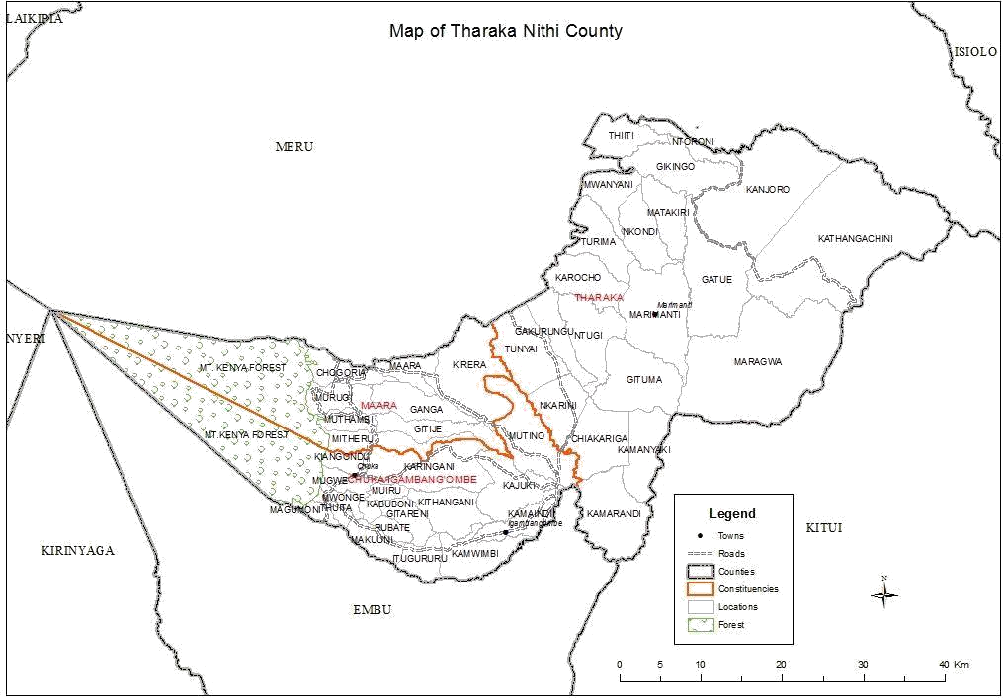
Figure 1. Map of Tharaka Nithi County.

Data analysis

The data were analyzed using descriptive statistics and inferential statistics. Cross tabulation and chi-square statistics was used to test for significance of relationship between land owned and fodder production.

RESULTS AND DISCUSSION
Respondents’ characteristics

The respondent characteristics assessed by the study were gender, farm size, land under pasture and under fodder. The results indicate that majority of the respondents (51%) were female while 49% were male. The respondents were from three ASAL divisions where 22% were from Nkondi, 57% were from Igambang’ombe and 21% were from Marimanti.

Farm utilization

Land utilization by farmers is summarized in Table 1. The majority of farmers did not disclose information about their land size and usage and were classified as non responsive. The land sizes ranged from 0.5 to 24 acres. However, the majority of the respondents (68%) owned between 1 and 6 acres. These farm sizes are characteristic of smallholder farms in Kenya (Musalia et al., 2007), whereas there were no farmers who did not spare land for crop production, about 19% did not have land under pasture. The land spared for pasture ranged between 0.25 and 13 acres with the majority of farmers (31%) sparing between ≤1 and 3 acres. Most farmers (34%) allocated between 1 to 3 acres for crops. About 5% of the farmers did not plant any fodder crops as compared to 23% and 1% who planted fodder on ≤1 acre and between 1 to 3 acres, respectively. This implies that

Table 1. Land use in the arid and semi-arid areas of Tharaka Nithi.

Land sizes (acres) | Land under pasture |  | Land under fodder |  | Land under crops
Land sizes (acres) | Frequency | Percent | Frequency | Percent | Frequency | Percent
< 1 | 10 | 13.4 | 17 | 23 | 1 | 1.4
1 to 3 | 13 | 17.6 | 1 | 1.3 | 25 | 33.7
4 to 6 | 2 | 2.7 | 0 | 0 | 5 | 6.8
7 to 9 | 1 | 1.4 | 0 | 0 | 0 | 0
10 | 2 | 2.7 | 0 | 0 | 0 | 0
Non response | 46 | 62.2 | 56 | 75.7 | 43 | 58.1
Total | 74 | 100.0 | 74 | 100.0 | 74 | 100.0

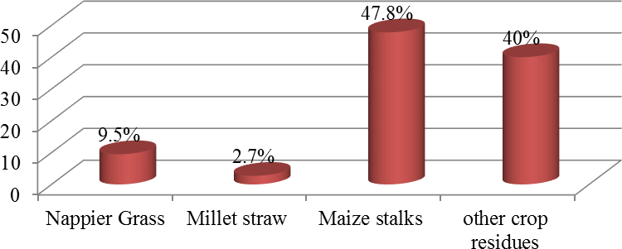

Figure 2. Type of forage fed to animals in arid and semi arid areas of Tharaka Nithi.

the land spared for pasture and amount of fodder grown was too little compared to the acreage spared for crops. Thus, farmers tended to utilize most of the land for crops compared to forage production. This is a typical crop- livestock production system where all farmers in this study planted crops and spared very little land for pastures and fodder production.

Fodder production

The main type of fodder produced by farmers in the study area was Napier grass (Pennisetum purpureum), which was cultivated by 10% of the respondents. Napier grass is the major fodder used by smallholder farmers in Kenya (Orodho, 1990). It is estimated to form about 40% of the total dry matter intake in the diet of dairy cattle. However, the cultivation of small amounts of Napier grass in the study area can be attributed to low rainfall and small pieces of land (Glover and Birch, 1962). Apparently, the bulk of feeds for the animals came from the crop residues (Figure 2). About 3% of the respondents used millet straw to feed livestock, 48% used maize stalk and 40% used other crop residues such as beans, pigeon peas (Cajanus cajan) and sorghum residues etc. This
observation is typical in the crop-livestock farming system where crop residues form a significant portion of the ration due to lack of land that can be spared for pasture and fodder crops (McDowell, 1987). The findings agree with the study of Orodho (1990) who also observed that the smaller the farms the more the contribution of crop residues to the diet of animals. On average crop residues are estimated to provide from 35 to 45% of the total livestock feeds in addition to grazing on the fallow land (Orodho, 1990), which, can go up to 80% in very critical times (Sandford, 1989). These findings are in agreement with Shah et al. (2011) who reported that feed and fodder production and its utilization depend on the cropping pattern, climate, socio-economic condition and livestock type. Apart from the limited land for planting fodder, the study further revealed that one required KES 3000 (32.6 US$) to get cuttings (Napier grass) for planting in 1 acre piece of land. This amount was considered high by most farmers and most probably explains why the production of fodder is too low in the region. Further, the results indicate that 98% confirmed that their animals got enough feeds during the wet season as illustrated in Figure 3. This implies that availability of more feeds during the rainy season can be conserved for use during the dry period. Inadequate supply of feeds during the dry season

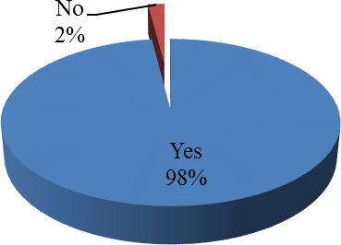
Figure 3. Adequacy of feed during the wet season in arid and semi arid areas of Tharaka Nithi.

Table 2. Chi square test results.

Test | Value | Df | Asymp. Sig. (2-sided)
Pearson Chi-Square | 59.699ª | 40 | 0.023
Likelihood Ratio | 41.291 | 40 | 0.414
Linear-by-linear association | .110 | 1 | 0.740
No. of Valid Cases | 22

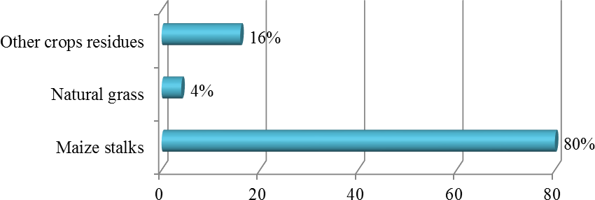

Figure 4. Type of fodder conserved in arid and semi arid areas of Tharaka Nithi.

was expressed by 93%. A chi square test was run to established whether the size of the land influenced the cultivation of fodder. As shown in Table 2, the test yielded a chi square value; χ =59.699 with a high association between land sizes and fodder production (p < 0.05). Similar to these findings, Musalia et al. (2007) also observed that farmers with large farms spared more proportion of land for pasture and fodder production. In Contrast, Franzel and Wambugu (2007) found that fodder trees require little or no cash investment or land taken away from producing food or other crops but still most farmers did not grow them. It is estimated that a 250 metre hedgerow of fodder trees like Calliandra calothyrsus, can supplement one dairy cow in a lactation period (Paterson et al., 1998).

Fodder conservation

The study further investigated the kind of fodder that was being conserved, methods used and technologies that were applied in the conservation. Regarding the kind of fodder that was being conserved, 80% of the respondents indicated that they were conserving maize stalks, 16% were conserving other crop residues such as sorghum straw, beans residue and millet straws, while 4% were conserving natural grasses (Figure 4). These findings revealed that maize stalk was the major livestock feed that was conserved by the local community, though other crop residues, and natural grasses were conserved. The higher percentage of maize stalk conservation was due to the fact that the communities practiced mixed

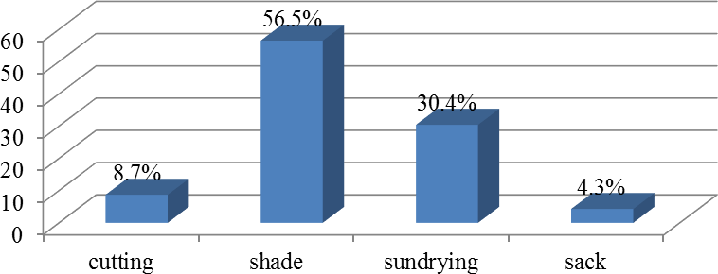
Figure 5. Method used in conservation of fodder in arid and semi arid areas of Tharaka Nithi.

farming whereby maize was considered to be a major staple diet and the residues were used as livestock feeds. These results accord with the work done by Nderi et al. (2014), that mixed farming was common in Igambang’ombe division. Conservation of conventional fodder such as Napier grass was poor probably due to low scale of production which was fed while green thus leaving none for conservation.
Figure 5 also revealed that 57% of the respondents conserved fodder under a shade particularly on tree branches (Figure 6) and makeshift sheds (Figure 7), 30% of them dried fodder under direct sunlight before storing in sacks (4.3%), and only 8.7% of them chopped fodder into small pieces before storage. From these findings, it is clear that the majority of farmers employed traditional methods to conserve fodder. This can be attributed to little knowledge on modern farming methods among the residents which could be due to limited agricultural extension services. This situation, therefore, calls for farmers training on the modern conservation technologies.

Fodder marketing

An assessment of fodder marketing revealed that only 1% of the respondents had produced fodder for sale. This is a clear demonstration that the farmers were not producing adequate fodder despite the potential. Other farmers indicated that they were not producing enough to cater for their livestock needs and sale. Although selling fodder may not be a primary objective of livestock farmers in the County, Ekodere et al. (2014) observed that sustainable fodder production has a significant impact not only on income but also on livestock asset and food security. Furthermore, during periods of drought, lack of fodder is often a major cause of livestock mortality in the ASAL regions such as parts of the study area. As shown in Table 3, 1% of the respondents generated an income KES 500 (5.4 US$), while 1 % generated KES 10,000 (108.7 US$) in one season. However, the majority
of the respondents (97%) did not sell any amount of fodder.

Factors influencing price formation and variability

When asked to indicate the factors that influenced price fluctuation and determination, 12% felt that the price changed with seasons while 12% stated that the changes were as a result of demand and supply (Table 4). The outcomes showed that the prices were highly volatile, probably because of the forces of demand and supply. The findings were in accordance with that observed by the Economic Research Service (1999) where the degree of variability in commodity prices is traditionally believed to depend heavily on stock levels and on the nature and frequency of unexpected shifts in demand and supply. Contrary to these findings, Wright (2010) found that fodder prices were also determined by certain quality aspects like good lustre, taste, cleanliness, softness, and moisture contents of fodder other than the market forces. The results also indicate that majority of the respondents (76%) did not know the factors that affected the fodder prices because they had not been involved in the sale of fodder.

Types of livestock kept

An evaluation of the types of cattle kept in the ASAL areas of Tharaka Nithi was also undertaken as presented in Table 5. Results indicate that dairy cattle were mostly kept in Igambang’ombe (54.8%) but they were not popular in Marimanti (0%). There was a similar trend for the local cattle whereby 88% were found in Igambang’ombe and only 1.4% was kept in Marimanti. Generally, it emerged that majority of the farmers reared local breeds as it is practiced by most smallholder farmers (Musalia et al., 2007). However, dairy cattle farming are practiced in the transition agro-ecological zones of the upper parts of Igambang’ombe and Nkondi

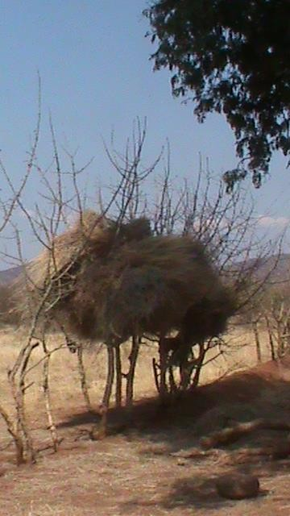
Figure 6. Storing hay on a tree in the arid and semi arid areas of Tharaka Nithi.

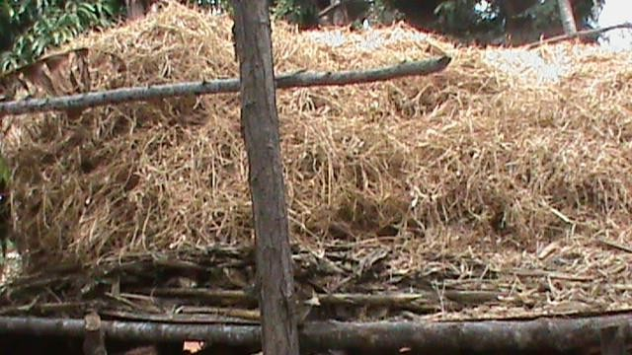
Figure 7. Storing crop residues in a constructed structure in the arid and semi arid areas of Tharaka Nithi.

Table 3. Income from sales of fodder (Kenya shillings) in Tharaka Nithi County.

Income | Frequency | Percent
500.00 | 1 | 1.4
10000.00 | 1 | 1.4
Never sold | 72 | 97.3
Total | 74 | 100.0

Table 4. Factors influencing price formation and variability of fodder.

Factor | Frequency | Percent
Seasonal | 9 | 12.2
Demand and supply | 9 | 12.2
Total | 18 | 24.3
Don’t Know | 56 | 75.7
Total | 74 | 100.0

where climate is more favorable but at a relatively lower scale. The introduction of modern farming technologies like irrigated fodder crops can spur livestock production in ASAL where land is plenty, thus enhancing feed security and improving rural livelihood.
Nkondi division reported the highest milk yield of 2.9 L per cow per day (Table 6). This production could be due
to the favorable agro-ecological location of Nkondi division and influenced by the lucrative dairy farming enterprises in Meru central region which is an immediate neighbour. The level of milk production in the area is low and animals do not require high inputs in terms of feeds which can be supplied by fodder trees planted as hedgerows (Paterson et al., 1998).

Table 5. Types of cattle kept in the arid and semi-arid lands of Tharaka Nithi county.

Division |  | Female dairy cattle | Male dairy cattle | Total dairy cattle | Female local cattle | Male local cattle | Total local cattle
Nkondi | Frequency | 10.00 | 4.00 | 14.00 | 9.00 | 13.00 | 22.00
Nkondi | % | 50.0 | 36.4 | 45.2 | 7.0 | 18.3 | 10.5
Igambang'ombe | Frequency | 10.00 | 7.00 | 17.00 | 119.00 | 55.00 | 184.00
Igambang'ombe | % | 50.0 | 63.6 | 54.8 | 93.0 | 77.5 | 88.0
Marimanti | Frequency | 0 | 0 | 0 | 0.00 | 3.00 | 3.00
Marimanti | % | 0 | 0 | 0 | 0.0 | 4.2 | 1.4
Overall | Frequency | 20.00 | 11.00 | 31.00 | 128.00 | 71.00 | 209.00
Overall | % | 100.0 | 100.0 | 100.0 | 100.0 | 100.0 | 100.0
N= 74.

Table 6. Milk yield per cow in the arid and semi arid areas of Tharaka Nithi (litres/day).

Division | Average milk yield
Nkondi | 2.8571
Igambang'ombe | 2.6207
Total | 2.6667

Table 7. Goat production in the arid and semi-arid lands of Tharaka Nithi County

Division |  | Females | Males | Total
Nkondi | Frequency | 28 | 8 | 36
Nkondi | % | 7.3 | 7.1 | 6.3
Igambang'ombe | Frequency | 344 | 103 | 522
Igambang'ombe | % | 90.3 | 92.0 | 91.9
Marimanti | Frequency | 9 | 1 | 10
Marimanti | % | 2.4 | 0.9 | 1.8
Overall | Frequency | 381 | 112 | 568
Overall | % | 100.0 | 100.0 | 100.0

The results on goat rearing in the Arid and Semi-Arid Lands of Tharaka Nithi County are presented in Table 7. Among the divisions, Igambang’ombe had the highest population of goats (91.9%) with Nkondi and Marimanti having very low goat populations. The high number of goats in Igambang’ombe can be attributed to availability of the browse forage compared to Marimanti where some parts are bare, thus having low ability to support livestock growth.
The results further indicate that Igambang’ombe Division was leading in sheep production (96.6%), followed by Nkondi (3.4%) which showed a noteworthy difference (Table 8). This trend is similar to what was
observed in goat rearing which implies that Igambang’ombe division is favorable for small stock production probably due to availability of feeds and the possibility of farmers relying on animals as an income earner. Sheep were absent in Marimanti, which is drier compared to the other two divisions.

Conclusion

Very few farmers grew pasture and fodder for livestock feeding. The cost of planting materials was high and together with the small pieces of land may have resulted

Table 8. Sheep rearing in the arid and semi-arid lands of Tharaka Nithi.

Division |  | Females | Males | Total
Nkondi | Frequency | 5 | 0 | 5
 | % | 4.8 | 0 | 3.4
Igambang'ombe | Frequency | 99 | 44 | 144
 | % | 95.2 | 100.0 | 96.6
Total | Frequency | 104 | 44 | 149
 | % | 100.0 | 100.0 | 100.0

in low production of fodder in the region. The main type of feed for animals was crop residues from the crop- livestock production system that favoured crop cultivation to fodder production. The area produced enough feeds for animals during the wet season with scarcity in the dry season. Farmers did not have the technology for conserving excess forage in the wet season. Fodder production, marketing and conservation were very low despite the high potential for its production and demand. In order to improve the productivity of livestock in the ASAL part of the County there is need to improve linkages between fodder suppliers and farmers to stimulate the production and marketing of fodder. Farmers should also adopt modern fodder conservation technologies to reap the benefits of seasonal price fluctuations and maximize the scarcity during drought.

Conflict of Interests

The authors have not declared any conflict of interests.

ACKNOWLEDGEMENTS

This research was supported, in part, by ST&I Grant Fund of the National Council for Science and Technology, Ministry of Higher Education Science and Technology, Kenya. Special thanks are due to staff members of the Ministry of Livestock and Fisheries Development (MoLFD) and administrative staff in Tharaka Nithi County for their support in administering the survey questionnaire especially in mobilizing the farmers. The authors also wish to thank all the farmers for their cooperation and provision of valuable information in this study.

REFERENCES

Abdulrazak SA, Nyangaga J, Fujihara T (2001). Relative Palatability to sheep of some browse species, their in saccodegradability and in vitro gas production characteristics. Asian-Aust. J. Anim. Sci. 14(11):1580-1584.
African Development Solutions (2012). LISHE-Supporting
Livelihoods through Fodder Production Garissa, Kenya. Available at: http://www.adesoafrica.org Retrieved April 26, 2016.
Alila PO, Atieno R (2006). Agricultural Policy in Kenya: Issues and Processes. A paper presented in, Future Agricultures Consortium workshop, Institute of Development Studies, 20-22 March 2006 at the Institute for Development Studies, University of Nairobi, Nairobi, Kenya, P 3. Available at: http://www.fao.org/fileadmin/user_upload/fsn/docs/Ag_policy_Ke nya.pdf Retrieved on March 2, 2016.
Chinogaramombe G, Muchenje V, Mapiye C, Ndlovu T, Chimonyo M, Musemwa L (2008). Challenges for improving smallholder dairy production in the semiarid areas of Zimbabwe. Crops 7:0-3. Economic Research Service (1999). Assessing Agricultural Commodity Price Variability. Agricultural Outlook/October, USDA.
pp. 16-19.
Ekodere P, Koen J, Miano G (2014).Best Practice Brief – Fodder production in Baringo County. International Livestock Research Institute, pp. 2-4. Available at: https://asals- markets.wikispaces.com/file/view/Best+practice+brief+-
+Mayiani+fodder+group+%282%29.pdf Retrieved.on April 26, 2016.
Franzel S, Wambugu C (2007). The uptake of fodder shrubs among smallholders in East Africa: key elements that facilitate widespread adoption. In: Hare MD, Wongpichet K (Eds.). Forages: a pathway to prosperity for smallholder farmers. Proceedings of an international symposium. Ubon Ratchathani University, Thailand: Faculty of Agriculture, pp. 203-222.
Glover JA, Birch WRB (1962). The effect of rainfall and age on the yield of some unfertilized fodder crops in Kenya. J. Agric. Sci. 58(1):53-57.
Government of Kenya (2004). Ministry of Agriculture, Ministry of Livestock and Fisheries Development, Strategy for Revitalizing Agriculture (SRA) 2004-2014, March 2004. pp. 37-39.
Lanyasunya TP, Musa HH, Yang ZP, Mekki DM, Mukisira EA (2005). Effects of poor nutrition on reproduction of dairy stock on smallholder farms in the tropics. Pak. J. Nutr. 4:117-122.
Mapiye C, Foti R, Chikumba N, Poshiwa X, Mwale M, Chivuraise C, Mupangwa J (2006). Constraints to adoption of forage and browse legumes by smallholder dairy farmers in Zimbabwe. Livest. Res. Rural Dev. (12). Available at: http://www.lrrd.org/lrrd18/12/mapi18175.htm Retrieved on April 26, 2016.
McDowell RE (1987). Importance of crop residues for feeding livestock in smallholder farming systems. In: Reed JD, Capper BS, Neate PJH (Eds.). 1988. Plant breeding and the nutritive value of crop residues. Proceedings of a workshop held at ILCA, Addis Ababa, Ethiopia,7-10 December 1987. ILCA, Addis Ababa. Available at:
http://www.fao.org/wairdocs/ilri/x5495e/x5495e02.htm Retrieved on April 26, 2016.
Ministry of Agriculture, Livestock & Fisheries (2013). Regional Pastoral Livelihoods Resilience Project project Report on

Environmental and Social Management Framework pp. 23-26.
Musalia LM, Wangia SMM, Shivairo RS, Okutu P, Vugutsa V (2007). Dairy production practices among smallholder dairy farmers in Butere/Mumias and Kakamega districts in Western Kenya. Trop. Anim. Health. Prod. 39:199-205.
Nderi MO, Musalia LM, Ombaka O (2014). Livestock farmers perceptions on the relevance of natural licks in Igambang’ombe Division, Tharaka-Nithi County, Kenya. Int. J. Agric. Sci. Vet. Med. 7:52-59.
Orodho AB (1990). Intensive forage production for smallholder dairying in East Africa. Available at: from http://www.fao.org/ag/agp/agpc/doc/newpub/napier/eastafrica_or odho.htm Retrieved.on April 26, 2016.
Paterson RT, Karanja GM, Nyaata OZ, Kariuki IW, Roothaert RL (1998). A review of tree fodder production and utilization within smallholder agroforestry systems in Kenya. Agroforest. Syst. 41(2):181-199.
Polit DF, Hungler BP (2004) Nursing research: Principles and methods. Philadelphia. Lippincott, pp. 61-62.
Sandford S (1989). Crop residues/livestock relationships. In: Renard C, Vandenbeldt RC, Parr JF (Eds.). Soil, Crop and Water Management Systems for Rainfed Agriculture in the Sudano- Sahelian Zone. Proceedings of an International Workshop, 11-16 January 1987, ICRISAT Sahelian Centre, Niamey, Niger. International Crops Research Institute for the Semi-Arid Tropics, Patancheru, India. pp. 169-182.
Shah VD, Makwana M, Sharma S (2011). Economics of Production, Processing and Marketing of Fodder Crops in Gujarat. Agro- Economic Research Centre, Sardar Patel University Vallabh Vidyanagar, Gujarat.
Tharaka Nithi County (2013). Long Rains Food Security Assessment Report. pp. 1-12.
Wright A (2010). Improvement of Fodder Markets and Identification of Crop Varieties with Improved Fodder Characteristics in Selected Disadvantaged Areas of India. New Delhi 110012, India. International Livestock Research Institute pp. 5-6.
Zemmelink G, Premaratne S, Ibrahim MNM, Leegwater PH (1999). Feeding of dairy cattle in the Forest-Garden farms of Kandy, Sri Lanka, Trop. Anim. Health Prod. 31(5):307-319.

View publication stats

