CHUKA |  | UNIVERSITY
UNIVERSITY EXAMINATIONS

EXAMINATION FOR THE AWARD OF DEGREE OF BACHELOR OF SCIENCE IN HUMAN NUTRITION AND DIETETICS AND BACHELOR OF PUBLIC HEALTH

HNDS 213/PUHU 244: BIOSTATISTICS/MEDICAL STATISTICS

STREAMS: BSc. (HNDS & NURU) TIME: 2 HOURS

DAY/DATE: TUESDAY 09/04/2024 2.30 P.M. – 4.30 P.M.
INSTRUCTIONS:
- Answer ALL questions
- Do not write anything on the question paper
- No use of mobile phones or any other unauthorized materials
- You are required to show all your workings
- Write your answers legibly and use your time wisely

SECTION A: MULTIPLE CHOICE QUESTIONS [ONE MARK EACH] [30 MARKS]
- Analysis of variance is a statistical method of comparing-of several populations.
- Means
- Variances
- Standard Deviations
- None Of The Above
- _______is a statistical test for detecting differences in group means when there is one
parametric dependent variable & one or more independent variables.
- T-test
- ANOVA
- Paired t-test
- None of the above
- Which is a raw score that has been transformed into standard deviation units?
- z score
- SDU score
- t score
- e score

- How many dependent variables are used in multiple regression?
- One
- One or more
- Two or more
- Two
- The ______ sum of squares measures the variability of the observed values around their respective treatment means.
- Treatment
- Error
- Interaction
- Total
- To use a t-test, the dependent variable must have
- Nominal or interval data
- Ordinal or ratio data
- Interval or ratio data
- Ordinal or interval data
- Which of the following is the correct way to calculate the MS(between)?
- SS(between) / DF(between)
- SS(between) * DF(between)
- SS(between) / SS(total)
- SS(between) * DF(total)
- Which of the following measures is the most resistant to outliers?
- Median
- Mean
- Mode
- Range
- Using a goodness-of-fit test, we can assess whether a set of obtained frequencies differs from a set of _______ frequencies
- Mean
- Actual
- Predicted
- Expected
- The number of degrees of freedom (df) is the:
- Number of factors in the experiment.
- Number of participants who had contributed non-outlier data when computing a statistic.
- Number of values that are free to vary when computing a statistic.
- Number of data points that were free from systematic error when computing a statistic.
- If a distribution is skewed to the left, then it is __________.
- Negatively skewed
- Positively skewed
- Symmetrically skewed
- Symmetrical
- A graph that uses vertical bars to represent data is called a ____.
- Line graph
- Bar graph
- Scatterplot
- Vertical graph

- Approximately what percentage of scores fall within two standard deviations of the mean in a normal distribution?
- 34%
- 95%
- 99%
- 68%
- Which of the following graphs would be helpful in illustrating the correlation between two variables?
- Bar cart
- Histogram
- Scatter plot
- Pie chart
- Which of the following statements about continuous variables is accurate?
- The pie charts are drawn only for continuous variables
- The bar diagrams are drawn only for continuous variables
- The histograms are drawn only for continuous variables
- The frequency curves are drawn only for continuous variables
- It is possible to __________ the magnitude of sampling error if we take a ______ sample.
- Increase, smaller
- Decrease, larger
- Decrease, smaller
- None of the above
- The coefficient of variation is a percentage expression for __________.
- Standard deviation
- Quartile deviation
- Mean deviation
- None of the above
- How much variance has been explained by a correlation of .9?
- 18%
- 9%
- 81%
- None of these
- Chi-square is used to analyse:
- Scores
- Ranks
- Frequencies
- All of the above
- The Z value selected for constructing a given confidence interval is also called what?
- The Z value is also called the critical value.
- The Z value is also called the student value
- The Z value is also called the confidence value.
- The Z value is often called the error value

For questions 21-30 indicate if the statement provided is True or False
- If the Pearson Product Moment Correlation Coefficient shows zero value, this definitely means that there is no relationship between the two variables
- True
- False
- The smaller the variance the less spread of the data around the mean
- True
- False
- Alpha is the level of Type II error that we can expect.
- True
- False
- Probability is usually measured on a scale of between zero and 1
- True
- False
- Frequency distributions are a subset of inferential statistics
- True
- False
- A product-moment correlation of -1.00 means that there is no linear relationship between the variables.
- True
- False
- Contingency tables and degrees of freedom are key elements of the chi-square test
- True
- False
- Skewed distributions usually show the familiar bell shape.
- True
- False
- The area of a normal curve between any two designated z scores expresses the proportion or percentage of cases falling between the two points.
- True
- False
- About 10% of scores fall 3 standard deviations above the mean.
- True
- False

SECTION B: [20 MARKS]
- Define the following terms as used in biostatistics.
  - Confidence interval [2 marks]
  - Statistical inference [2 marks]

- At a nursing home with 290 elderly residents, the average weight (x ̅ ) was 68 kg with a standard deviation of 8.6 kg.
- What is the Z- score for a resident whose weight is 58 kg [2 marks]
- How many of the residents had a weight between 56 and 82 kg? [4 marks]

- The ages of patients who were admitted to a hospital were given as follows 12,21,21,23,27,28,30,34,37,39,39,39,40,49,54. Calculate the
- Geometric mean [2 marks]
- Coefficient of variation [5 marks]

- Vivian collected data on uric acid values from 36 adult males. The mean uric acid level was 4.8 mg/100ml with a standard deviation of 1.46 mg/100ml. A 99% confidence interval was calculated. Attach a 99% level of confidence to the mean. [3 marks]

SECTION C:[20 MARKS]

- The following table shows the age (years) and corresponding blood sugar ( mg/dL) levels of 7 participants in a research survey. [14 marks]
Repondent | A | B | C | E | F | G | H
Age | 46 | 22 | 26 | 44 | 58 | 36 | 60
Glucose | 98 | 60 | 76 | 72 | 88 | 61 | 82
Use the data to;
- Calculate the product-moment correlation coefficient for these data
- Interpret the correlation coefficient
- Find the equation of the regression line of blood on age

- Compare and contrast between parametric and non-parametric statistics [6 marks]

……………………………………………………………………………………………………

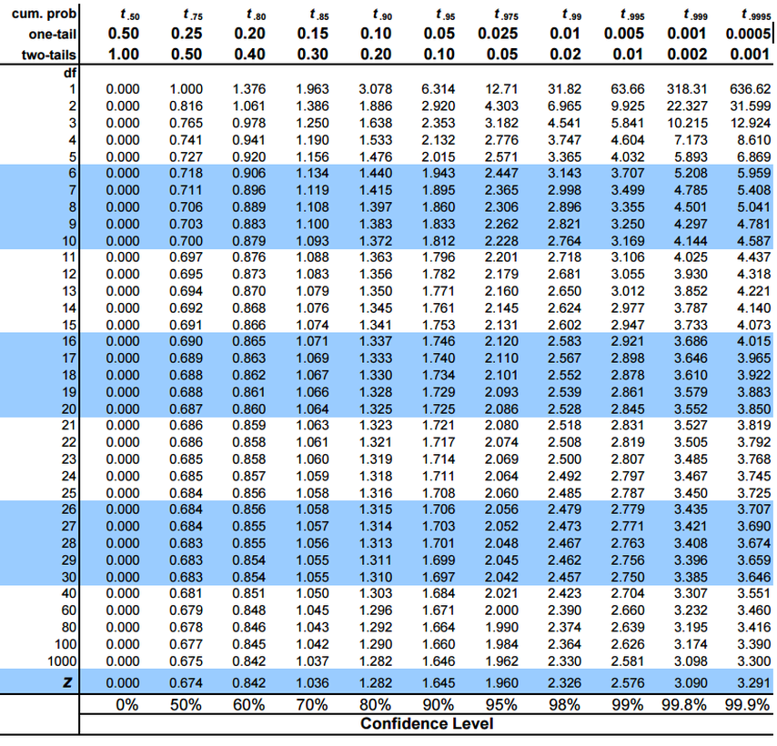
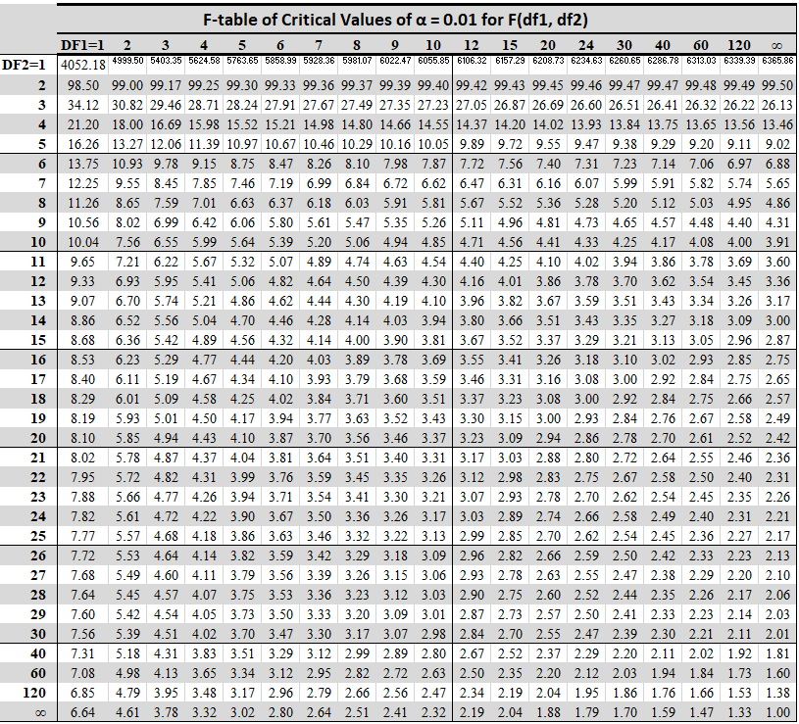

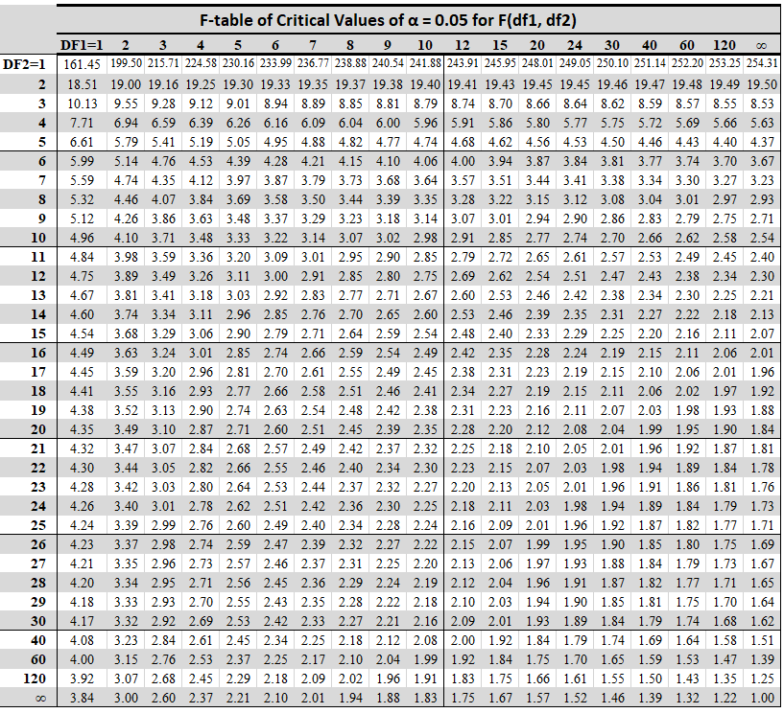

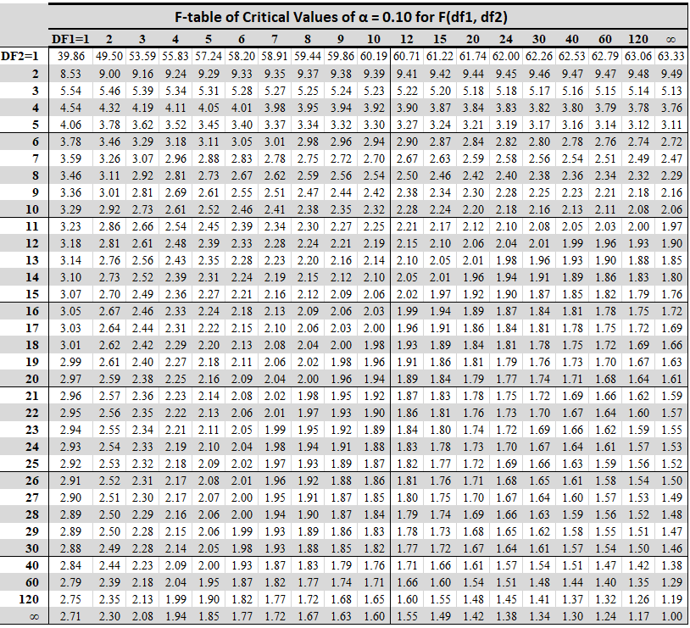

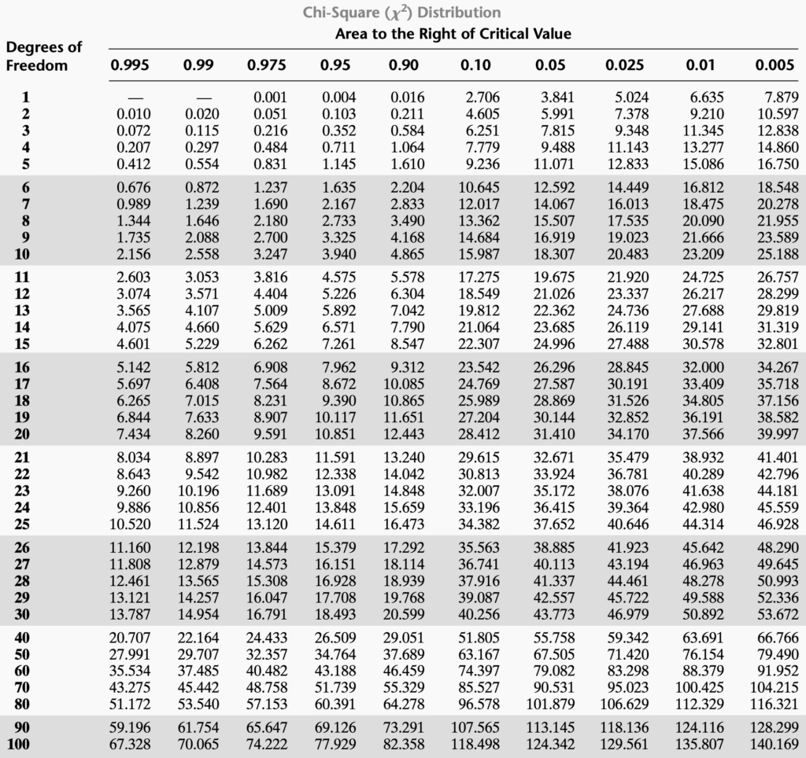

Critical Values of Expanded Dixon Outlier Test (Q -Test)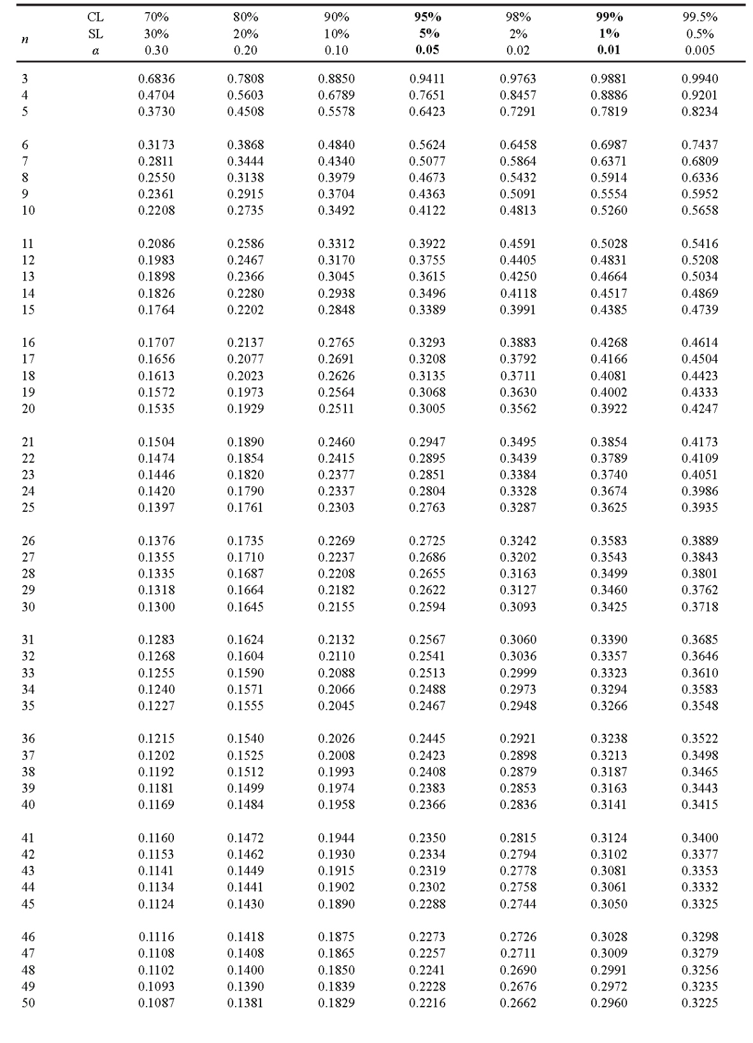

Standard Normal Distribution Tables

z | 0.00 | 0.01 | 0.02 | 0.03 | 0.04 | 0.05 | 0.06 | 0.07 | 0.08 | 0.09
0.0 | 0.0000 | 0.0040 | 0.0080 | 0.0120 | 0.0160 | 0.0199 | 0.0239 | 0.0279 | 0.0319 | 0.0359
0.1 | 0.0398 | 0.0438 | 0.0478 | 0.0517 | 0.0557 | 0.0596 | 0.0636 | 0.0675 | 0.0714 | 0.0753
0.2 | 0.0793 | 0.0832 | 0.0871 | 0.0910 | 0.0948 | 0.0987 | 0.1026 | 0.1064 | 0.1103 | 0.1141
0.3 | 0.1179 | 0.1217 | 0.1255 | 0.1293 | 0.1331 | 0.1368 | 0.1406 | 0.1443 | 0.1480 | 0.1517
0.4 | 0.1554 | 0.1591 | 0.1628 | 0.1664 | 0.1700 | 0.1736 | 0.1772 | 0.1808 | 0.1844 | 0.1879
0.5 | 0.1915 | 0.1950 | 0.1985 | 0.2019 | 0.2054 | 0.2088 | 0.2123 | 0.2157 | 0.2190 | 0.2224
0.6 | 0.2257 | 0.2291 | 0.2324 | 0.2357 | 0.2389 | 0.2422 | 0.2454 | 0.2486 | 0.2517 | 0.2549
0.7 | 0.2580 | 0.2611 | 0.2642 | 0.2673 | 0.2704 | 0.2734 | 0.2764 | 0.2794 | 0.2823 | 0.2852
0.8 | 0.2881 | 0.2910 | 0.2939 | 0.2967 | 0.2995 | 0.3023 | 0.3051 | 0.3078 | 0.3106 | 0.3133
0.9 | 0.3159 | 0.3186 | 0.3212 | 0.3238 | 0.3264 | 0.3289 | 0.3315 | 0.3340 | 0.3365 | 0.3389
1.0 | 0.3413 | 0.3438 | 0.3461 | 0.3485 | 0.3508 | 0.3531 | 0.3554 | 0.3577 | 0.3599 | 0.3621
1.1 | 0.3643 | 0.3665 | 0.3686 | 0.3708 | 0.3729 | 0.3749 | 0.3770 | 0.3790 | 0.3810 | 0.3830
1.2 | 0.3849 | 0.3869 | 0.3888 | 0.3907 | 0.3925 | 0.3944 | 0.3962 | 0.3980 | 0.3997 | 0.4015
1.3 | 0.4032 | 0.4049 | 0.4066 | 0.4082 | 0.4099 | 0.4115 | 0.4131 | 0.4147 | 0.4162 | 0.4177
1.4 | 0.4192 | 0.4207 | 0.4222 | 0.4236 | 0.4251 | 0.4265 | 0.4279 | 0.4292 | 0.4306 | 0.4319
1.5 | 0.4332 | 0.4345 | 0.4357 | 0.4370 | 0.4382 | 0.4394 | 0.4406 | 0.4418 | 0.4429 | 0.4441
1.6 | 0.4452 | 0.4463 | 0.4474 | 0.4484 | 0.4495 | 0.4505 | 0.4515 | 0.4525 | 0.4535 | 0.4545
1.7 | 0.4554 | 0.4564 | 0.4573 | 0.4582 | 0.4591 | 0.4599 | 0.4608 | 0.4616 | 0.4625 | 0.4633
1.8 | 0.4641 | 0.4649 | 0.4656 | 0.4664 | 0.4671 | 0.4678 | 0.4686 | 0.4693 | 0.4699 | 0.4706
1.9 | 0.4713 | 0.4719 | 0.4726 | 0.4732 | 0.4738 | 0.4744 | 0.4750 | 0.4756 | 0.4761 | 0.4767
2.0 | 0.4772 | 0.4778 | 0.4783 | 0.4788 | 0.4793 | 0.4798 | 0.4803 | 0.4808 | 0.4812 | 0.4817
2.1 | 0.4821 | 0.4826 | 0.4830 | 0.4834 | 0.4838 | 0.4842 | 0.4846 | 0.4850 | 0.4854 | 0.4857
2.2 | 0.4861 | 0.4864 | 0.4868 | 0.4871 | 0.4875 | 0.4878 | 0.4881 | 0.4884 | 0.4887 | 0.4890
2.3 | 0.4893 | 0.4896 | 0.4898 | 0.4901 | 0.4904 | 0.4906 | 0.4909 | 0.4911 | 0.4913 | 0.4916
2.4 | 0.4918 | 0.4920 | 0.4922 | 0.4925 | 0.4927 | 0.4929 | 0.4931 | 0.4932 | 0.4934 | 0.4936
2.5 | 0.4938 | 0.4940 | 0.4941 | 0.4943 | 0.4945 | 0.4946 | 0.4948 | 0.4949 | 0.4951 | 0.4952
2.6 | 0.4953 | 0.4955 | 0.4956 | 0.4957 | 0.4959 | 0.4960 | 0.4961 | 0.4962 | 0.4963 | 0.4964
2.7 | 0.4965 | 0.4966 | 0.4967 | 0.4968 | 0.4969 | 0.4970 | 0.4971 | 0.4972 | 0.4973 | 0.4974
2.8 | 0.4974 | 0.4975 | 0.4976 | 0.4977 | 0.4977 | 0.4978 | 0.4979 | 0.4979 | 0.4980 | 0.4981
2.9 | 0.4981 | 0.4982 | 0.4982 | 0.4983 | 0.4984 | 0.4984 | 0.4985 | 0.4985 | 0.4986 | 0.4986
3.0 | 0.4987 | 0.4987 | 0.4987 | 0.4988 | 0.4988 | 0.4989 | 0.4989 | 0.4989 | 0.4990 | 0.4990
3.1 | 0.4990 | 0.4991 | 0.4991 | 0.4991 | 0.4992 | 0.4992 | 0.4992 | 0.4992 | 0.4993 | 0.4993
3.2 | 0.4993 | 0.4993 | 0.4994 | 0.4994 | 0.4994 | 0.4994 | 0.4994 | 0.4995 | 0.4995 | 0.4995
3.3 | 0.4995 | 0.4995 | 0.4995 | 0.4996 | 0.4996 | 0.4996 | 0.4996 | 0.4996 | 0.4996 | 0.4997
3.4 | 0.4997 | 0.4997 | 0.4997 | 0.4997 | 0.4997 | 0.4997 | 0.4997 | 0.4997 | 0.4997 | 0.4998
3.5 | 0.4998 | 0.4998 | 0.4998 | 0.4998 | 0.4998 | 0.4998 | 0.4998 | 0.4998 | 0.4998 | 0.4998
3.6 | 0.4998 | 0.4998 | 0.4999 | 0.4999 | 0.4999 | 0.4999 | 0.4999 | 0.4999 | 0.4999 | 0.4999
3.7 | 0.4999 | 0.4999 | 0.4999 | 0.4999 | 0.4999 | 0.4999 | 0.4999 | 0.4999 | 0.4999 | 0.4999
3.8 | 0.4999 | 0.4999 | 0.4999 | 0.4999 | 0.4999 | 0.4999 | 0.4999 | 0.4999 | 0.4999 | 0.4999
