CHUKA | 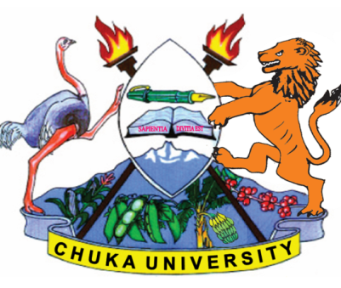 | UNIVERSITY
UNIVERSITY EXAMINATIONS

CHUKA, EMBU AND CHOGORIA CAMPUSES

EXAMINATION FOR THE AWARD OF DIPLOMA IN BUSINESS MANAGEMENT

DIBM 0112: PRINCIPLES OF MANAGEMENT

STREAMS: DIBM TIME: 2 HOURS

DAY/DATE: MONDAY 22/03/2021 8.30 A.M. – 10.30 A.M.

INSTRUCTIONS:
- Question ONE is compulsory.
- Answer any other TWO questions.

QUESTION ONE

(a) Management is defined as “getting things done through people.” To what extent is management a profession? (5 marks)

(b) Discuss the essentials of a good control system. (7 marks)

(c) Discuss some of the skills a manager should have so as to manage effectively and efficiently. (8 marks)

(d) Discuss the arguments for and against corporate social responsibility. (10 marks)

QUESTION TWO

(a) Identify any 5 external environment forces and explain how they influence managerial decisions of a company. (10 marks)

(b) Describe any three leadership styles that managers can embrace while managing resources. (10 marks)

QUESTION THREE

(a) Fredrick Taylor is referred to as the father of “Scientific Management Theory”.
Critically analyze the contributions and shortcomings of the theory in management thought. (12 marks)

(b) Identify and explain the factors that affect the span of control in an organization.
(8 marks)

QUESTION FOUR

(a) Define planning and its importance as a function of management. (10 marks)

(b) Identify and explain the steps to undertake during organizing function. (10 marks)
---------------------------------------------------------------------------------------------------------------------

