CHUKA | 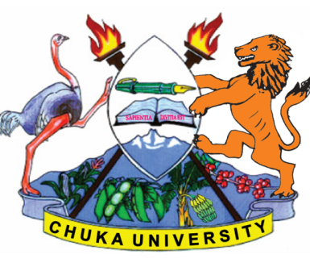 | UNIVERSITY
UNIVERSITY EXAMINATIONS

EXAMINATION FOR THE AWARD OF DEGREE OF BACHELOR OF ARTS

HIST 437: IMPERIAL AND COMMONWEALTH HISTORY II

STREAMS: B.A TIME: 2 HOURS
DAY/DATE: MONDAY 08/04/2024 8.30 A.M – 10.30 A.M.

INSTRUCTIONS:
- Answer question ONE and any other TWO.

1. (a) Define Commonwealth and give reasons why African sovereign states joined the commonwealth. (15 marks)

(b) Discuss the terms and implications of Durham Report of 1839. (15 marks)

2. Examine the terms of Versailles treaty of 1919 in light of the causes of World War I.
(20 marks)
3. (a) What were the causes of World War II. (12 marks)

(b) Assess the effects of world War II on Britain? (8 marks)

4. Analyze the role of commonwealth to the member states. (20 marks)

5. Examine the terms and implications of the following;

(a) The statute of Westminster, 1931 (10 marks)

(b) Balfour Report, 1926 (10 marks)
---------------------------------------------------------------------------------------------------------------------

