CHUKA UNIVERSITY


Knowledge is Wealth (Sapientiadivitiaest)
Telephones: 020 2310512/18 P. O. Box 109-60400, Chuka
Email: info@chuka.ac.ke Website: www.chuka.ac.ke
DEPARTMENT OF PHYSICAL SCIENCES
EXAMINATION FOR THE AWARD OF BACHELOR OF SCIENCE IN ELECTRICAL AND ELECTRONIC ENGINEERING
EENG 292: PHYSICAL ELECTRONICS II

INSTRUCTIONS:
Answer question one and any other two
Do not write on the question paper
Take:
1 eV= 1.602176634×10⁻¹⁹ J
h=6.62607004 × 10⁻³⁴ m² kg / s
c= 3x10⁸ m/s
QUESTION ONE
- Differentiate between a photodiode and a solar cell (2 Mks).
- Define the following terms as used in semiconductor devices (4Mks)
- A Gunn diode
- Quantum efficiency
- Photo detectors
- Multi-junction (MJ) solar cell
- Find number of images formed according to the given case (4 Mks)
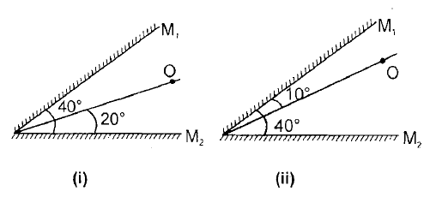
- Systems using high-concentration photovoltaics (HCPV) have the potential to become competitive in the near future. Explain. (2 Mks)
- Explain the operation of a MESFET both in Enhancement mode and Depletion mode (6 Mks)
- The Schottky photodiode is unique as a photodetector as it is able to operate in two photo-detection modes. Discuss. (4 Mks)
- Consider a LED which is made up of GaAsP semiconductor whose forbidden energy gap is 1.875 eV.
- Determine the wavelength of light emitted from LED (2 Mks)
- Mention the colour of the light emitted (1 Mk)
- With the help of a well labelled diagram explain the principle of photoelectric emission in semi-conductors (5 Mks)
QUESTION TWO
- The relay shown in Figure 2.1 (a) is to be controlled by a photoconductive cell and other Figure 2.1 (b) is of photocell illumination characteristics
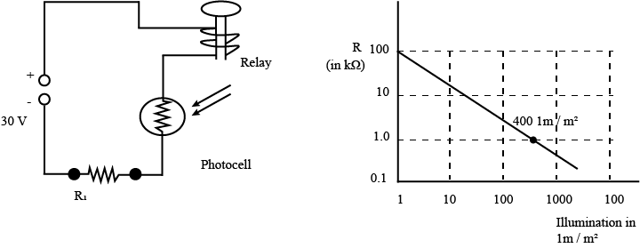
Figure 2.1 (a) Figure 2.1 (b)

The circuit delivers 10 mA at a 30 V setting when the cell is illuminated with about 400 lm/m². The circuit becomes de-energized when the cell is dark. Determine,
- The required series resistance R₁ (in kΩ) (3 Mks)
- The dark current (in mA) respectively (3 Mks)
- Calculate the change in barrier potential of a P-N junction at 300ºK if doping on the N-side is increased 1000 times while keeping doping on P-side unchanged (4 Mks)
- Three photo diodes D₁​,D_{2​} and D₃​ are made of semiconductor having band gaps 2.5eV,2eV and 3eV , respectively . Which ones of the 3 photo diodes will be able to detect light of wavelength 6000 $Å$ (4 Mks)?
- List and explain Performance parameters of a photodiode (6 mks)
QUESTION THREE
- A 36-cell PV module has a parallel resistance per cell of 6.6 Ω and a series resistance of 0.005 Ω. Under full sun, and under some load, the current I = 2.14 A while the output voltage V = 19.41 V. If one cell is fully shaded and this current somehow stays the same, then calculate
- the new module output voltage and power (2 Mks)
- the voltage drop across the shaded cell (2 Mks)
- the power that would be dissipated in the shaded cell (2 Mks)
- The metal-semiconductor (MS) contact is an important component in the performance of most semiconductor devices in the solid state.
- Show the equilibrium energy band diagram for a metal to an p-type semiconductor where (4 Mks)
(a) Φ_{M}<Φ_{S} and
(b) Φ_{M}<Φ_{S}
- Find the expression of the barrier height Φ_{B} of the rectifying p-type contact (3 Mks)
- When a MS contact is formed for Φ_{M}=χ, under what conditions will the contact behaves as the Ohmic contact, and under what conditions will the contact behaves as the rectifying? (1 Mks)
- Discuss the principle of operation and design of a QDIP with the aid of a well labelled diagram (6 Mks)
QUESTION FOUR

A PV module is made up of 36 identical cells, all wired in series. With 1-sun insolation (1 kW/m²), each cell has short-circuit current I_{SC} = 3.4 A and at 25◦ C its reverse saturation current is I_{o} = 6 × 10 ⁻¹⁰ A. Parallel resistance R_{P} = 6.6 Ω and series resistance R_{S} = 0.005 Ω. Find the voltage, current, and power delivered when the junction voltage of each cell is V_{d} = 0.50 V (6 Mks).

An earth satellite has on board 12-V battery which supplies a continuous current of 0.5 A. Solar cells are used to keep the battery charged. The solar cells are illuminated by the sun for 12 hours in every 24 hours. If during exposure, each cell gives 0.5 V at 50 mA, determine the number of cells required (4 Mks)
- Calculate forward current in Ge diode at 20ºC when forward voltage is 0.3 V. Compare this value with that after a temperature rise of 50ºC. Assume that reverse saturation current doubles for every 10ºC rise in temperature (4 Mks)
- Imagine a normal incidence light is passing into a diamond crystal having an index of refraction n=2.41. Find the percentage of light that is reflected. (3 Mks)
- Explain the reason why photo diodes are required to be operated in reverse bias (3 Mks)?

