
CHUKA UNIVERSITY

Knowledge is Wealth (Sapientia divitia est) Akili ni Mali

GPHYS 261 GEO-HYDROLOGY Y2:S2

SEPTEMBER- DECEMBER SEMESTER

INSTRUCTIONS
You should have the following for this examination:
- Answer booklet
- Scientific calculator
This paper contains FIVE questions
Attempt question ONE and any other TWO questions.
Question ONE carries 30 marks, all other questions carry 20marks

QUESTION ONE (30 MARKS)
- Define the following terms geo-hydrology and an aquifer (4 marks)

- A well is located in an aquifer with a conductivity of 25 meters per day and a storativity of 0.008. The aquifer is 20 meters thick and is pumped at a rate of 3500 cubic meters per day. What is the drawdown at a distance of 10 meters from the well after one day of pumping?
(5 marks)

- Describe the different classification of aquifers. (6 marks)

- Describe ground water pollution (4 marks)

- List five aims of groundwater pollution investigation and describe four remedial measures which can be used to prevent or reduce aquifer contamination. (9 marks)

- Explain why there is need of the hydrologic studies (2 marks)

QUESTION TWO (20 MARKS)
- List four of areas in which groundwater studies are carried out. (4 marks)

- Describe the different types of ground water (4 marks)

- Differentiate between primary and secondary porosity (4 marks)

- Describe four different types of geologic formations that serve as aquifers (4 marks).

- Explain the following hydraulic parameters (4 marks)

QUESTION THREE (20 MARKS)
- List five objectives of groundwater investigations (6marks)

- A confined aquifer has the following characteristics:Thickness = 7m, Material = Coarse sand with some gravel, Q = 788 m³ /day, 20<K<100 m/day. Therefore 140<t<700 m² /day. Below are the four piezo-meters located in the aquifer, with their characteristics. Determine T. (5 marks)

- Explan why there is need of the hydrologic studies (4 marks)

- A well in a confined aquifer was pumped at arate of 240 gallons per minute in 10 hours. The aquifer is 20 feet thick. Time draw down data for the observation well 824 feet away are given below. Find T, K and S. (5 marks)

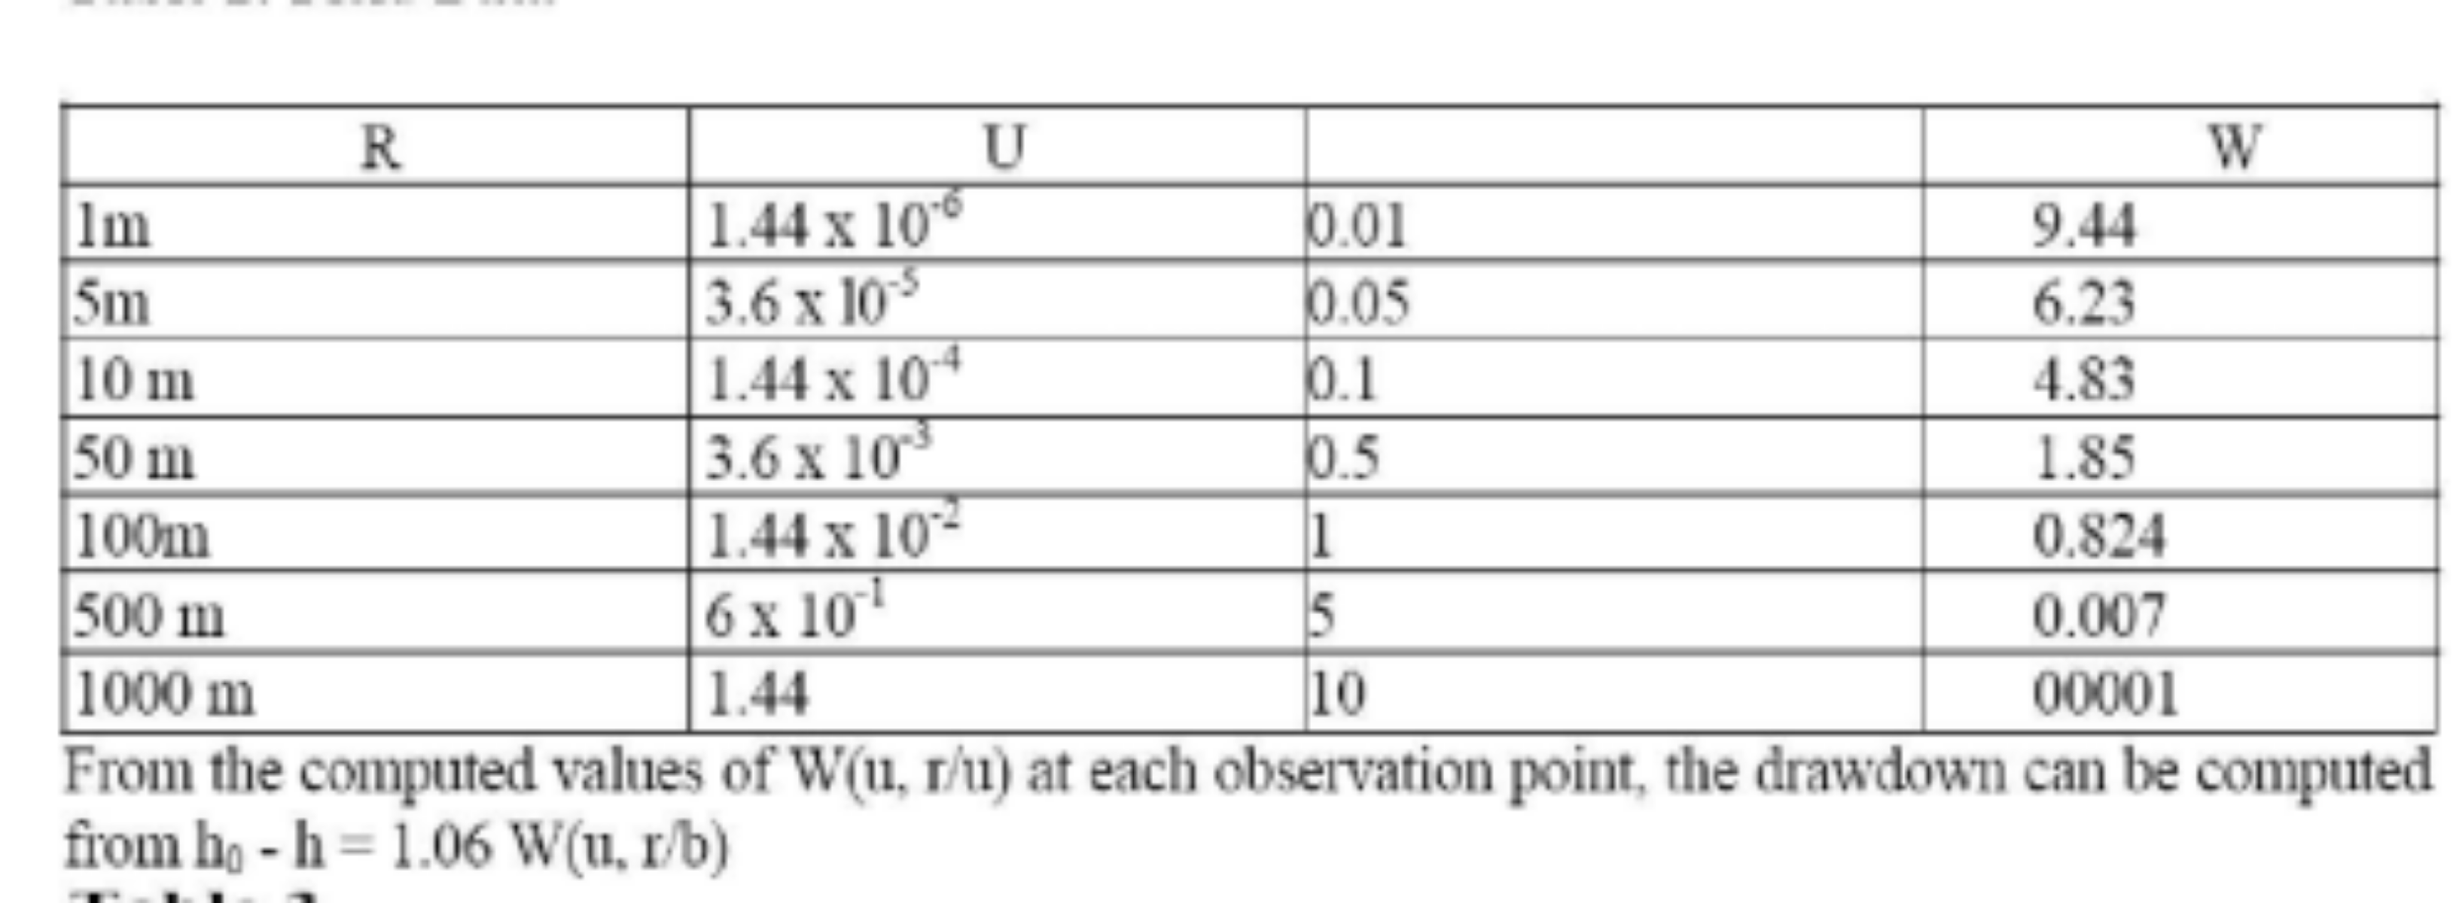

QUESTION FOUR (20 MARKS)
- Describe four major doctrines under which groundwater law falls (8 marks)

- List six factors that influence the choice of water well and method of design (3 marks)

- Explain three basic categories of the interactions between surface water and groundwater using Losing, gaining and perched streams. (9 marks)

QUESTION FIVE (20 MARKS)
- Explain what it entails groundwater characterisation : (7 marks)

- Describe the hydraulic processes involved in surface water groundwater interaction. (4 marks)

- Describe the range of human activities that affect the interaction between surface water and groundwater. (6 marks)
- What are the main jobs of a hydrologist (3 marks)

