CHUKA | 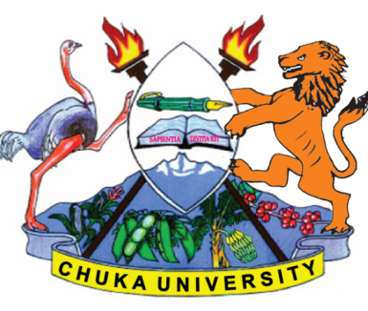 | UNIVERSITY
UNIVERSITY EXAMINATIONS
RESIT/SPECIAL EXAMINATION
EXAMINATION FOR THE AWARD OF DEGREE OF BACHELOR OF SCIENCE
BMET 230: MEDICAL AND VETERINARY ENTOMOLOGY
STREAMS: BSC TIME: 2 HOURS
DAY/DATE: FRIDAY 01/09/2023 2.30 P.M – 4.30 P.M.

INSTRUCTIONS: Answer question one and any other two questions
Questions
Question 1 (Compulsory) (30 marks)
- Briefly discuss the existing public health problems associated with arthropods in tropical countries. (4 Marks)
- Highlight 7 common characteristics shared among all arthropods. (7 Marks)
- Explain 5 basic components of the mouth parts of insects. (5 Marks)
- Briefly describe the 4 phases in insect entogeny. (8 Marks)
- Explain 3 hormone types that areintegral to the growth and reproductive functions of insects. (6 Marks)
Question 2 (20 marks)
- Describe 5 medically important classes of the phylum Arthropoda. (10 Marks)
- Discuss about different insect collecting techniques. (10 marks)
Question 3 (20 marks)
- Discuss 5 general methods of control of arthropods. (10 Marks)
- Explain with examples the distinguishing characteristics and importance to humans of the insects in the order Diptera. (10 marks)

Question 4 (20 marks)
- Discuss 8 major types of insect legs. (8 marks)
- Describe 6 types of reproduction in arthropods. (12 Marks)

--------------------------------------------------------------------------------------------------------------------

