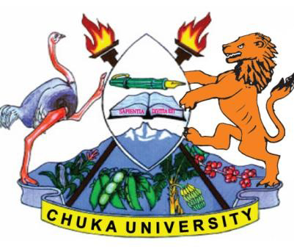
CHUKA UNIVERSITY

UNIVERSITY EXAMINATIONS
EXAMINATION FOR THE AWARD OF DEGREE OF BACHELOR OF LAWS
BLAW 328: BANKRUPTCY LAW
STREAMS: BLAW TIME:2HRS
DAY/DATE: ________________
_________________________________________________________________
INSTRUCTIONS:
- ANSWER THREE QUESTIONS
- QUESTION 1 IS MANDATORY

QUESTION ONE
Ruku, a high-flying business man in Meru town, has been engaged in the miraa business for two decades. In the course of his business, he made good money in the selling Miraa to Nairobi and other towns with in Kenya. In the last five years he opened a new trade route to the neighboring country of Somalia. His business thrived three folds when he started the sale of Miraa to Somalia, from which he was paid in dollars as opposed to the Kenya shillings.
Recently Somalia experienced internal turmoil that necessitated the Kenyan government to intervene militarily. This move never went down well with the local Somalia leadership, which in turn sanctioned all exports from Kenya to the country. This move has made Ruku a worried man. He had taken huge loans from a local bank that he was paying from the proceeds of the miraa business.
The banks without hesitation have moved to auction the properties, which he had acquired from the proceeds of his miraa trade.
You are a high-flying advocate with recent wins in impeachment cases for the county governor. Mr. Ruku has sought your professional advice on the way forward for him.
- Advise him on the remedies available for him in the circumstance. (15 marks)
- Draft for him a legal opinion. (15 marks)

QUESTION TWO
With the enactment of the Insolvency Act, Cap 53, new features were added to law governing
Bankruptcy in Kenya. With the Aid of relevant provisions, discuss the three Alternatives to
Bankruptcy. (20 Marks)

QUESTION THREE
Discuss with the help of authorities the implications of charges as security under the law of bankruptcy in general. (20 marks)
QUESTION FOUR
There are various offences under the Insolvency Act, Cap 53. Critically analyze the offences and their net outlook for the bankrupt individual. (20 marks)
QUESTION FIVE
a) With the help of authorities, analyze the roles and powers of a bankruptcy trustee. (10 marks)
b) Discuss the roles and powers of the Receiver Manager. (10 marks)

