CHUKA |  | UNIVERSITY

UNIVERSITY EXAMINATIONS

FIRST YEAR EXAMINATION FOR THE AWARD OF CERTIFICATE IN
COMPUTER SCIENCE

COSC 00107: APPLICATION PROGRAMMING

STREAMS: CERT COMP SCI Y1S2 TIME: 2 HOURS
DAY/DATE:…………………… ……………………….
INSTRUCTIONS:
- Answer question ONE and TWO other questions
- Do not write anything on the question paper
- This is a closed book exam, No reference materials are allowed in the examination room
- There will be NO use of mobile phones or any other unauthorized materials
- Write your answers legibly and use your time wisely.
- Marks are awarded for clear and concise answers.

SECTION A (Answer ALL questions in this section)
QUESTION ONE (30 Marks)
- Define the following terms as used in visual basic programming
  - Compiling (2marks)
  - Debugging (2marks)
  - Execution (2marks)
  - Graphical user interface (2marks)
  - Application (2marks)
- Under what circumstances would each of the following errors occur in Visual Basic programming? (4marks)
- Syntax error
- Logic error
- State any 3 advantages of using GUI over a CLI (3 marks)
- Describe the functions of the following windows found in VB.NET
    - Properties Window (2 marks)
    - Toolbox (2 marks)
- Name any three events in VB.NET (3 marks)
- Explain any two characteristics of a good user interface (2 marks)
- Distinguish between local variable and global variable as used in visual basic program
(4marks)
SECTION B (Answer any TWO questions)

QUESTION TWO (20 Marks)
- Write a Visual Basic Code that displays the words "This is COSC 00107 Class on Visual Basic Programming" on a form. (4 marks)
- Define the following terms as used in Desktop Application Development
- Identifier (2 marks)
- Keyword (2 marks)
- Source files (2 marks)
- Explain the function of the following windows that are found in VB.NET (6 marks)
- Solution Explorer.
- Properties window
- Form Designer window
- State the standard prefix for the following data types: (4marks)
i. Boolean
ii. Currency
iii. Byte
iv. Double
QUESTION THREE (20 Marks)

- Explain the function of each of the following visual basic programming tools
i. Menu bar (2 marks)
ii. Context menu (2 marks)
- List and explain any 5 types of user interfaces (10marks)
- explain the basic elements found in any graphical user interface (4 marks)
- Illustrate the syntax of If…Then…ElseIf statement (4 marks)

QUESTION FOUR (20 Marks)
  - Identify the following parts of a Visual Basic Program. (9marks)
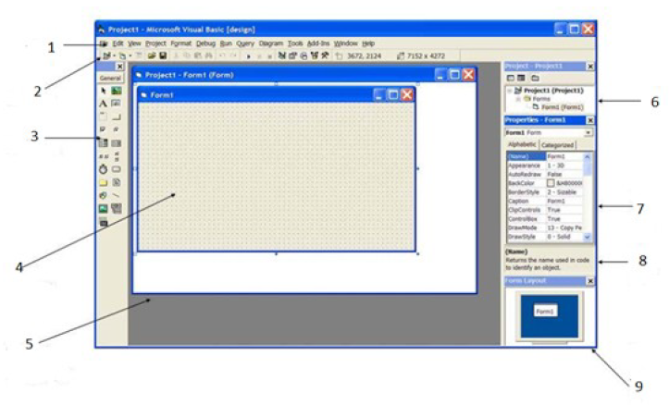

  - Explain the difference between each of the following widgets: (6marks)
    - List box
    - Check box
    - Combo box
  - Write Visual basic code that displays the text “Hello World” on a form (5 marks)

QUESTION FIVE (20 Marks)

        - Distinguish between run-time error and logic error as used in visual basic programming. (4marks)
        - State two differences between sub procedures and event procedures as used in Visual programming
(4marks )
        - State and explain any THREE events associated with a textbox control in visual basic (6marks)

        - Using the form below, write a program that would enable a teacher to input the marks and get the grade as “PASS” if the marks are 50 and above otherwise “FAIL” (6marks).

