CHUKA | 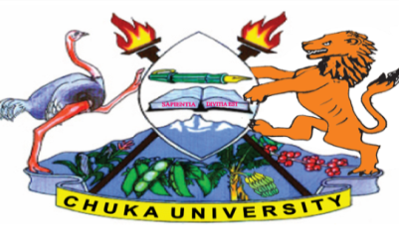 | UNIVERSITY
UNIVERSITY EXAMINATIONS
EXAMINATION FOR THE AWARD OF DEGREE OF BACHELOR OF SCIENCE IN BIOMEDICAL SCEINCES AND TECHNOLOGY
BMET 111: HUMAN PHYSIOLOGY
STREAMS: TIME:2 HOURS
DAY/DATE: WEDNESDAY 19/04/2023 11.30 A.M. –1.30 P.M.
INSTRUCTIONS
Answer question one and any other two questions

Question 1 (Compulsory) (30 marks)
- Explain the of biosynthesis and effects of testosterone in male reproductive system.
(5 marks)
- Describe the mechanism of blood pH regulation by the respiratory system. (5 marks)
- Compare and contrast the short-term and long- term stress response. (5 marks)
- Highlight five major functions played by human stomach in digestive process. (5 marks)
- Describe the feedback mechanism involved in regulation of human body temperature
(5 marks)
- Explain the mechanism of ADH water-regulation on renal collecting tubules. (5 marks)
Question 2 (20 marks)
- Explain the various components of heart conduction system. (10 marks)
- Explain the steps in oogenesis. (10 marks)
Question 3 (20 marks)
- Discuss the processes and control of ingestion, propulsion, mechanical digestion, chemical digestion, absorption, and defecation. (10 marks)
- Explain the process of intrinsic, extrinsic and common pathway in blood coagulation cascade. (10 marks)
Question 4 (20 marks)
- Compare and contrast the signaling events involving the second messengers CAMP and IP3.
(10 marks)
- Discuss the various fluid compartments and composition in the human body (10 marks)

---------------------------------------------------------------------------------------------------------------------

