CHUKA |  | UNIVERSITY
UNIVERSITY EXAMINATIONS
RESIT/SPECIAL EXAMINATION
EXAMINATION FOR THE AWARD OF DEGREE OF BACHELOR OF SCIENCE
EENG 586: NAVIGATION AND SURVEILANCE SYSTEM
STREAMS: BSC TIME: 2 HOURS
DAY/DATE: THURSDAY 31/08/2023 8.30 A.M – 10.30 A.M.

INSTRUCTIONS: This paper consists of fourquestions
Question one is compulsory
Attempt Question one and any other two

QUESTION ONE (30MARKS)

(a)(i) State any Two applications of navigation and surveillancetechnology (2 marks)
(ii) Explain any Two applications of a radar system (4 marks)

(b) (i) A radar has the following parameters:
-peak power transmitted by theradar = 450kW
–gain of transmitting antenna = 6,000
–effective aperture of the receiving antenna = 4m²
–radar cross section of the target = 50m²
–power of minimum detectable signal = 10⁻¹² W.
Calculate the maximum range of the radar (3 marks)
(ii) State any THREE factors that affect the radar performance (3 marks)

(c) (i) Explain the difference between receiver noise and signal to noise ratio
and state how they affect radar performance (6 marks)
(ii) A radar amplifier has a gain of 6dB calculate the output of the amplifier
if the input signal is:
(I)-3dB (2 mark)
(II) 0.5mW (2 marks)

(d) (i)The intensity of a transmitted electromagnetic wave at a range of 500mfrom the
radar is 0.04W/m². Calculate its intensity at 2km. (2 marks)
(ii)A radar has a pulse repetition interval of 0.5milliseconds calculate the maximum
unambiguous Doppler shift that it can measure (2 marks)

(e) Determine the range resolution of a pulse radar system with the characteristics shown in
table Q.1(e) (4 marks)
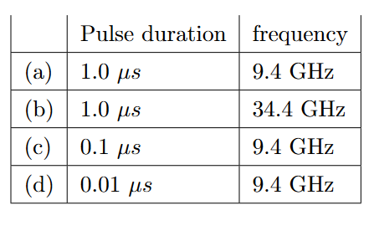Q.1 (e)

QUESTION TWO (20MARKS)

(a) (i) Derive the simplest form of Radar equation and show that the range is given by
R =$\sqrt[4]{\frac{P_{t GδAe}}{{(4π)}^{3 }P_{r}}}$(6mks)
(ii) With reference to Radar system explain the functions of:
(I) Pulse modulator (2 marks)
(II) IF amplifier (2 marks)

(b)(i) Explain the most common used radar frequency band (4 marks)
(ii) Distinguish between Monostatic and Bistatic types of radar systems and give an example
of each (4 marks)
(iii) Prove using pulse train that the unambiguous range of a Radar is given by Ru = $\frac{c}{{2f}_{p}}$
(2 marks)

QUESTION THREE (20MARKS)

(a) (i) With the aid of a block diagram explain the basic radar system (6 marks)
(ii) Derive the simplest form of a radar equation from the basic principles
(4mks)
(b) (i) A radar system has the following specifications:
-Operating frequency = 10GHz
–Peak power transmitted by the radar = 400kW
–Effective aperture of the receiving antenna = 5m²
–Radar cross section of target = 30m²
–Power of minimum detectable signal = 10⁻¹⁰ W.
Calculate the maximum range of the radar (4 marks)
(ii) Fig Q3(b) shows a block diagram of a Moving Target Indicator withpower amplifier
transmitter explain the functions of each block (6 marks)
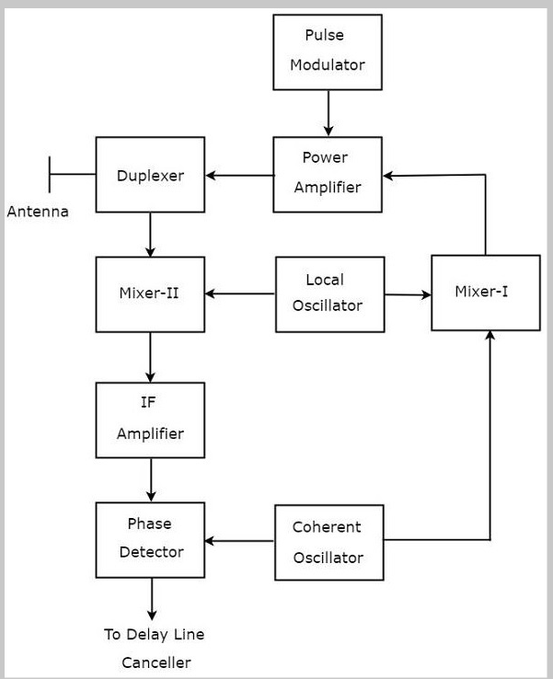
Fig Q3(b)

QUESTION FOUR (20MARKS)

(a) (i) Distinguish the following methods of tracking with radar:
(I) Monopulse tracking ( 2 marks)
(II) Conical scan (2 marks)
(ii) A Moving Target Indicator Radar operates at a frequency of 6GHz with a pulse
repetition frequency of 1kHz. Find the first, second- and third-blindspeeds of the radar
(6 marks)
(b) (i) With the aid of a block diagram describe functions of a single Delay linecanceller and
draw its frequency response curves (6 marks)
(ii) Explain the effect of the following parameters on radar wave propagationprocess:
(I) Diffraction (2 marks)
(II) Scattering (2 marks)

--------------------------------------------------------------------------------------------------------------------------

