CHEM 405: ANALYTICAL CHEMISTRY II
INSTRUCTIONS
Answer question one and any other two.
Useful data are provided.
QUESTION ONE (30 MARKS)
a)(i)Discuss fundamental vibrational modes with help of suitable illustrations.
(4 marks)

b) Define the following terms and explain:
- singlet state (1 mark)
- triplet state (1.5 marks)
- vibrational relaxation (1.5 marks)
- internal conversion (1 mark)
c)(i)
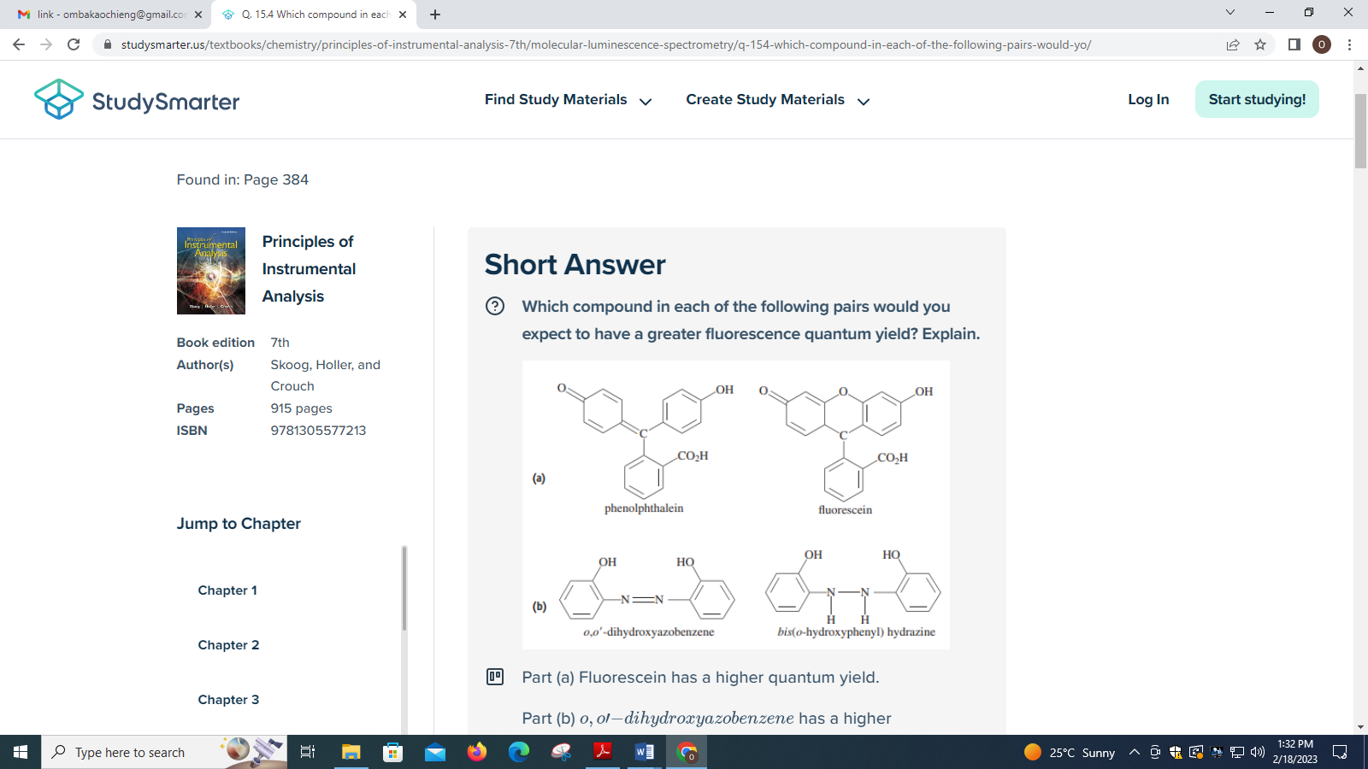
(2 marks)
(ii) Quinine is one of the best-known fluorescent molecules, and the sensitivities of fluorometers are often specified in terms of the detection limit for this molecule. The structure of quinine is given next. Predict the part of the molecule that is most likely to behave as the chromophore and fluorescent center.
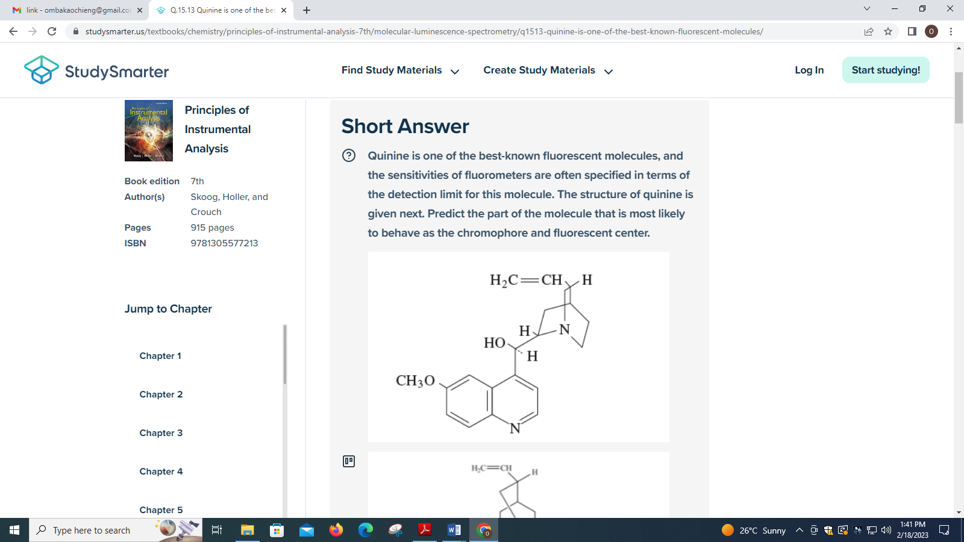
(3 marks)
(iii) Cyclohexanone exhibits its strongest IR absorption band at 5.86 μm, and at this wavelength there is a linear relationship between absorbance and concentration.
I.Identify the part of the molecule responsible for the absorbance at this wavelength.
(1 mark)
II.Suggest a solvent that would be suitable for a quantitative analysis of cyclohexanone at this wavelength. (1 mark)
III. A solution of cyclohexanone (4.0 mg/mL) in the solvent selected in part (II) exhibits a blank-corrected absorbance of 0.800 in a cell with a path length of 0.025 mm. What is the detection limit for this compound under these conditions if the noise associated with the spectrum of the solvent is 0.001 absorbance units? (2 marks)
d) (i) Why does the ratio of anti-Stokes to Stokes intensities increase with sample temperature?
(3 marks)
(ii)

a)3 marks, b)2 marks

(iii) Define

(a) Magnetic anisotropy (1 mark)

(b) The chemical-shift parameter (1 mark)

(c) Larmor frequency (1 mark)

(d) Coupling constants (1 mark)

QUESTION TWO (20 MARKS)

a)(i)

(2 marks)

ii) Identify the ions responsible for the peaks in the mass spectrum shown in Figure 20-22b

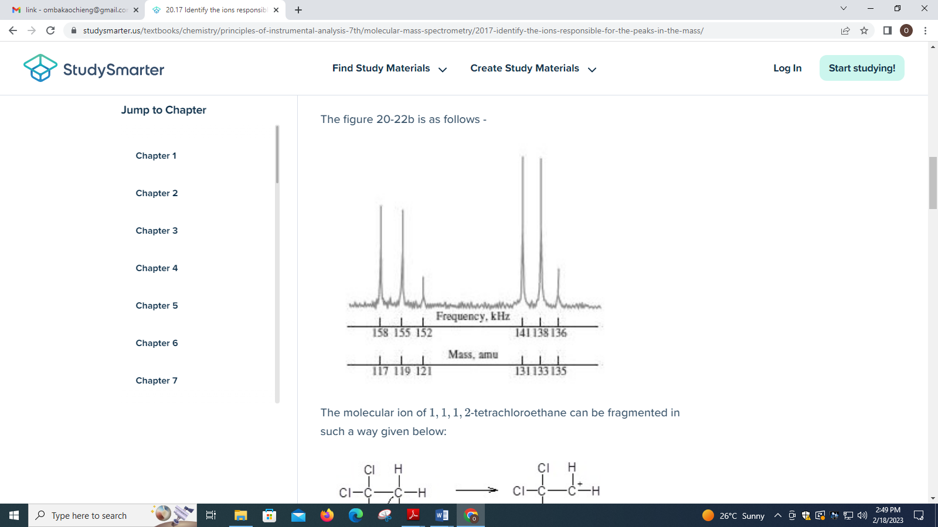

(3 marks)

iii) Identify the ions responsible for the four peaks having greater mass-to-charge ratios than the M⁺peak in Figure 20-4a.

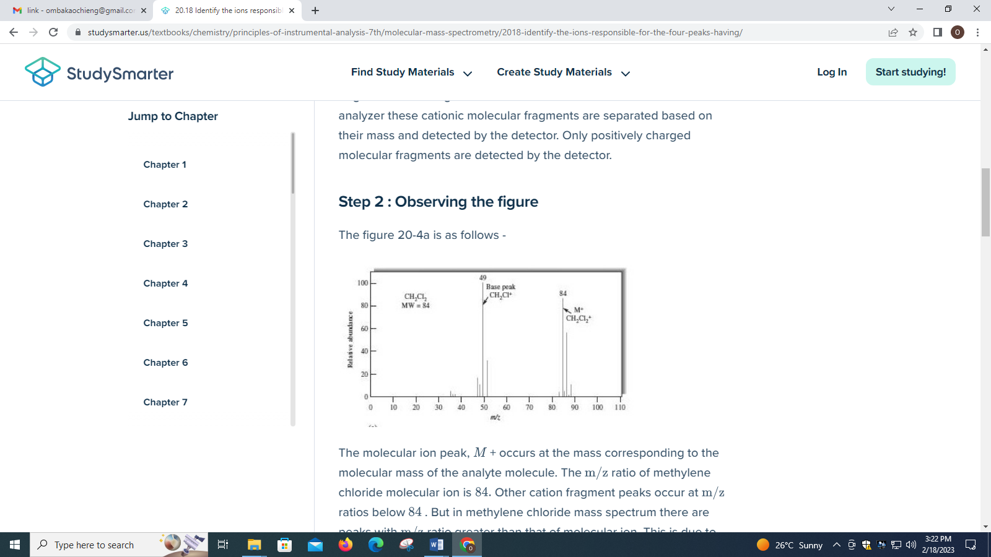

(3 marks)

b) The reduced form of nicotinamide adenine dinucleotide (NADH) is an important and highly fluorescent coenzyme. It has an absorption maximum of 340 nm and an emission maximum at 465 nm. Standard solutions of NADH gave the following fluorescence intensities:

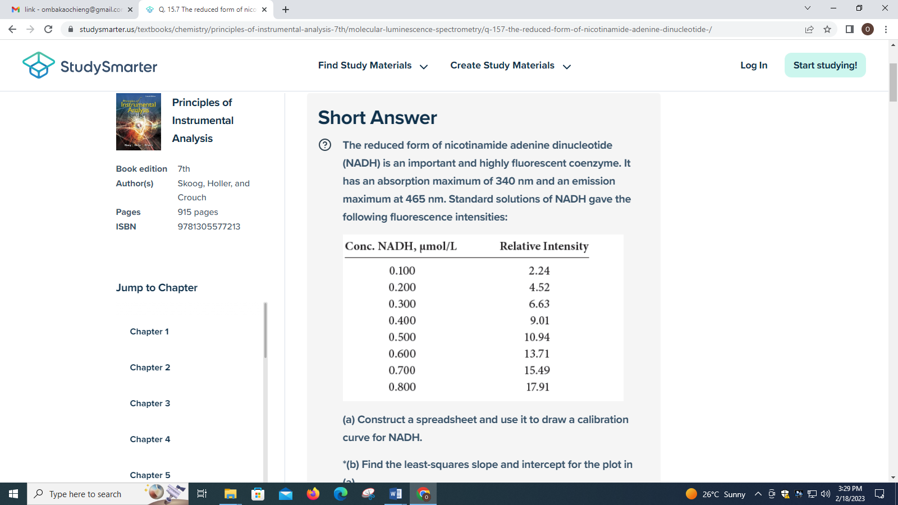

(i) Determine the regression equation using the above data for NADH. (3.5 marks)

(ii) Calculate the standard deviation of the slope and the standard deviation about regression for the curve. (2 marks)

(iii) An unknown exhibits a relative fluorescence intensity of 12.16. Calculate the concentration of NADH. (1 mark)

(iv) Calculate the relative standard deviation for the result in part (iii). (2 marks)

(v) Calculate the relative standard deviation for the result in part (iii) if a result of 7.95 was the mean of three measurements. (2 marks)
c) Aluminum is to be used as windows for a cell for X-ray absorption measurements with the Ag Kα line. The mass absorption coefficient for aluminum at this wavelength is 2.74; its density is 2.70 g/cm³. What maximum thickness of aluminum foil could be used to fabricate the windows if no more than 2.8% of the radiation is to be absorbed by them? (1.5 marks)

QUESTION THREE (20 MARKS)
a)(i) The proton NMR spectra shown in Figure 19-25 are for colorless, isomeric liquids containing only carbon and hydrogen. Identify the two compounds. (3 marks)

(ii) Calculate the approximate wavenumber and wavelength of the fundamental absorption due to the stretching vibration of a carbonyl group
(2 marks)

b) The following questions deal with laser sources in Raman spectroscopy.

(i) Under what circumstances would a helium-neon laser be preferable to an argon-ion laser?

(2 marks)

(ii) Under what circumstances would a diode laser be preferable to an argon-ion or helium-neon laser? (3 marks)

c) (i)

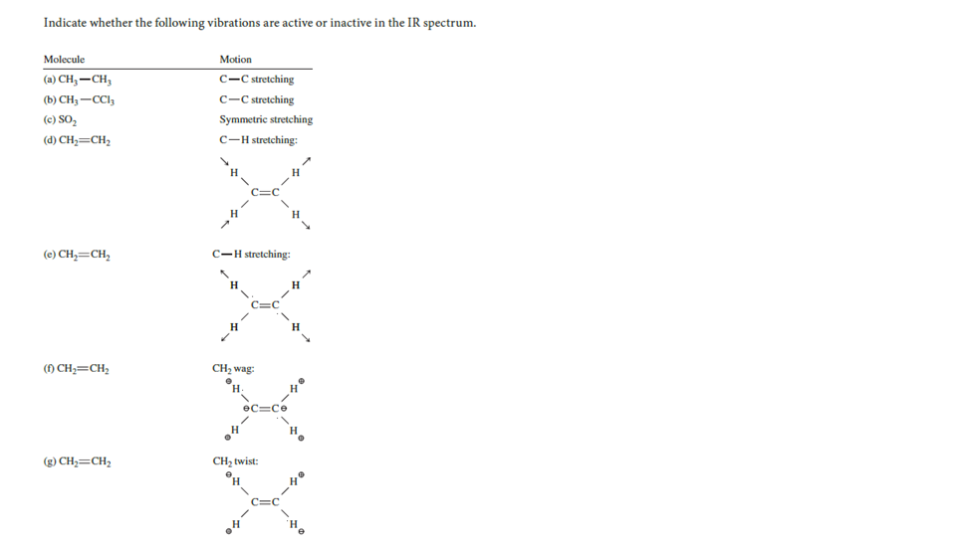

(3.5 marks)

(ii)Outline the advantages of an FTIR spectrometer with a dispersive instrument. (2.5 marks)

d) Gaseous HCl exhibits an IR absorption at 2890cm⁻¹ due to the hydrogen-chloride stretching vibration.

(i)Calculate the force constant for the bond. (2 marks)

(ii)Calculate the wavenumber of the absorption band for HCl assuming the force constant is the same as that calculated in part (i). (2 marks)

QUESTION FOUR (20 MARKS)
- (i)

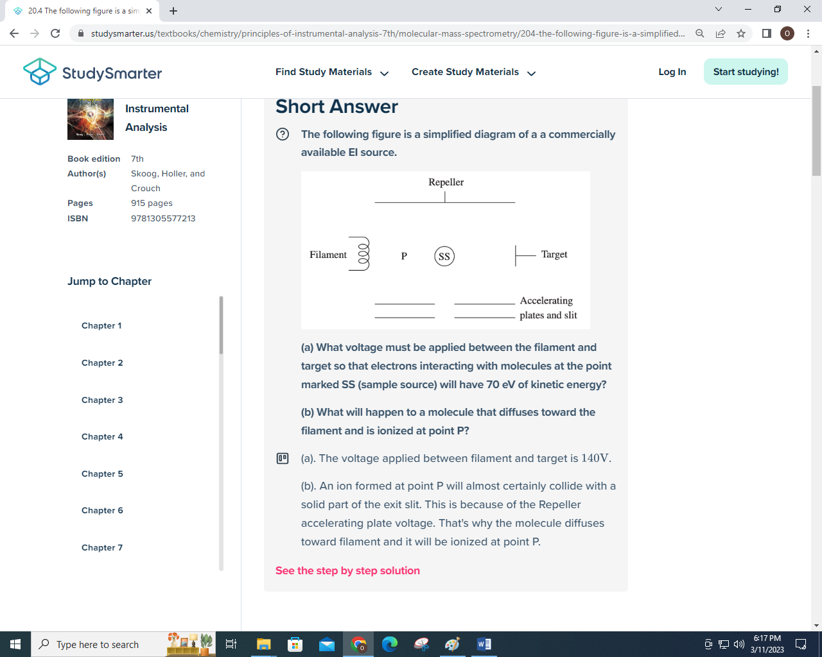

a) 2 marks b) 1 mark

(ii)

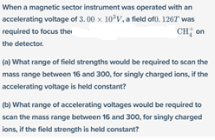
- 2 marks b) 1.5 marks

b)

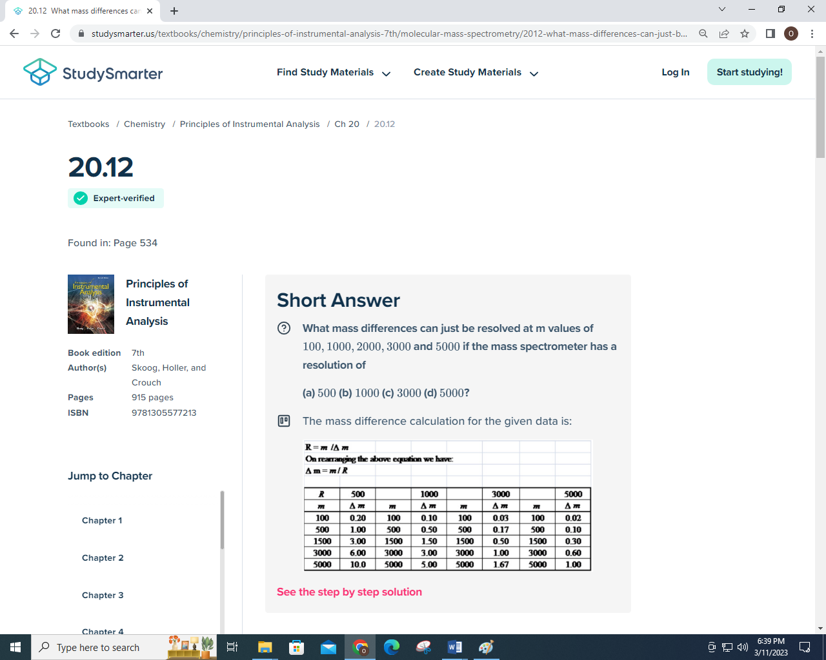

(5.5 marks)

c) (i) Which one of the vibrations shown in Figure 1.11 is ‘infrared-inactive’? (2 marks)

(ii)

(2 marks)

(iii)

(2 marks)
d)` What is the flight time associated with a 435.67 m/z ion accelerated into a 1.850m

flight tube by an acceleration voltage of 15.0 kV? (2 marks)

