CHUKA |  | UNIVERSITY
UNIVERSITY EXAMINATIONS
EXAMINATION FOR THE AWARD OF DEGREE OF BACHELOR OF SCIENCE IN ELECTRICAL AND ELECTRONIC ENGINEERING
EENG 251: CIRCUIT AND NETWORK ANALYSIS I
STREAMS: TIME:2 HOURS
DAY/DATE: THURSDAY 13/04/2023 2.30 P.M. –4.30 P.M.
INSTRUCTIONS
Answer question ONE and any other TWO questions
Do not write on the question paper
k = 1.38066×10⁻²³J/K, e = 1.60219×10⁻¹⁹ C, h = 6.626176 x 10⁻³⁴ J s,
ϵ₀ = 8.85✕ 10⁻¹² F/m, μ₀ = 4𝝅×10⁻⁷ H/m, c= 3x10⁸ m/s
QUESTION ONE
- State the law of conservation of energy (1 mark)
- Define the following terms as used in electrical and electronic engineering (2 Marks)
- Electrostatics
- Electric flux density
- Explain the reason why hard steel is unsuitable in the manufacture of a.c excited devices
(2 Marks)
- The movement of energy from one location to another is known as energy transfer. Discuss four ways through which energy can be transferred (8 Marks)
- Two coils connected in series have a resistance of 18 Ω and when connected in parallel have a resistance of 4 Ω. Find the value of resistances (4 Marks)
- The field winding of a 4-pole d.c. generator consists of 4 coils connected in series, each coil being wound with 1200 turns. When the field is excited, there is a magnetic flux of 0·04 Wb/pole. If the field switch is opened at such a speed that the flux falls to the residual value of 0·004 Wb/pole in 0·1 second, calculate the average value of e.m.f. induced across the field winding terminals (4 Marks)
- Find the current in and voltage across 2 Ω resistor in Figure.1.1 (5 Marks)
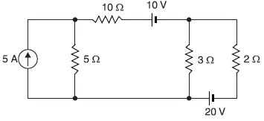
Figure 1.1
- Determine the m.m.f. required to generate a total flux of 100μWb in an air gap 0.2 cm long. The cross-sectional area of the air gap is 25 cm² (4 Marks)
QUESTION TWO
- A 16 μF capacitor is charged to 100 V. After being disconnected, it is immediately connected in parallel with an uncharged capacitor of capacitance 4μF. Determine
- the p.d. across the combination (2 Marks)
- the electrostatic energies before and after the capacitors are connected in parallel and
(2 Marks)
- loss of energy (2 Marks)

  - Find the value of resistance R to have maximum power transfer in the circuit shown in Figure 2.1 (3 Mks).
  - Also obtain the amount of maximum power (3 Mks).
All resistances are in ohms (

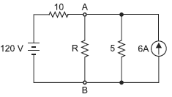
Figure 2.1
- A circuit consists of four 100 W lamps connected in parallel across a 230 V supply. Inadvertently, a voltmeter has been connected in series with the lamps. The resistance of the voltmeter is 1500 Ω and that of the lamps under the conditions stated is six times their value then burning normally. What will be the reading of the voltmeter (3 Marks)?
- Using diagrams where necessary for illustration, discuss the Generation of 3 Phase E.M.Fs in a 3 Phase Circuits (5 Marks)
QUESTION THREE
- A p.d. of 10 kV is applied to the terminals of a capacitor consisting of two parallel plates, each having an area of 0·01 m2 separated by a dielectric 1 mm thick. The resulting capacitance of the arrangement is 300 pF. Calculate
- total electric flux (2 Marks)
- electric flux density (2 Marks)
- potential gradient and (2 Marks)
- relative permittivity of the dielectric (2 Marks)
- Use superposition theorem to find current I in the circuit shown in Figure 3.1. All resistances are in ohms. (4 Marks)
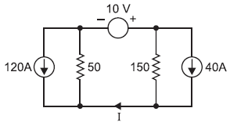
Figure 3.1

- Using Norton’s theorem, calculate the current in the 5 Ω resistor in the circuit shown in Figure 3.2 (5 Marks).
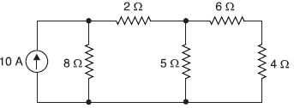
Figure 3.2
- Explain three properties of magnetic lines of force (3 Marks)

QUESTION FOUR
- Using Thevenin’s theorem, find p.d. across terminals AB in Figure 4.1 (6 Marks).

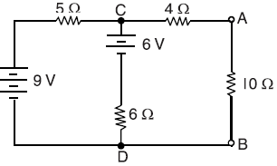
Figure 4.1

- Calculate the dielectric flux between two parallel flat metal plates each 35 cm square with an air gap of 1·5 mm between; the potential difference being 3000 V. A sheet of insulating material 1·5 mm thick is inserted between the plates and the potential difference raised to 7400V. What is the relative permittivity of this material if the charge is now 32 μC
(4 Marks)
- A generator of e.m.f. E volts and internal resistance r ohms supplies current to a water heater. Calculate the resistance R of the heater so that three-quarter of the total energy developed by the generator is absorbed by the water (4 Marks)
- A circuit has 1000 turns enclosing a magnetic circuit 20 cm² in section. With 4A, the flux density is 1 Wb/m² and with 9A, it is 1.4 Wb/m². Find the mean value of the inductance between these current limits and the induced e.m.f. if the current falls from 9A to 4A in 0·05 seconds (4 Marks)
- Explain two advantages of Parallel Circuits (2 Marks)
---------------------------------------------------------------------------------------------------------------------

