CHIN 428: INDUSTRIAL ELECTROCHEMISTRY AND CORROSION
INSTRUCTIONS
Answer question one and any other two.
Useful data are provided.
QUESTION ONE (30 MARKS)
a) Briefly describe the following types of corrosion
(I)Crevice corrosion (3 marks)
(II) Pitting corrosion (3 marks)
b) (i)Outline the advantages and limitations of E-pH diagram. (3 marks)
(ii) Predict whether or not Sn will dissolve spontaneously in hydrochloric acid.
(2 marks)
(iii) Calculate the tendency for corrosion to occur in the following metal electrolyte systems:
(a) Silver in cupric acid and (1 mark)
(b) Nickel in silver nitrate. (1 mark)
(iv) Tin is immersed in a solution of CuCl₂ with activity of Cu²⁺=0.2. Determine the concentration of Sn²⁺ at which the corrosion will stop. (2 marks)

c) (i) What is the selectivity coefficient? Discuss its significance and how you would determine its
value. (2 marks)
(ii) Describe the different types of ion-selective electrodes. Include in your discussion the construction of the electrodes, differences in membranes, and their usefulness. (3 marks)
(iii) A potassium ion-selective electrode is used to measure the concentration of potassium ion in a solution that contains 6.0 × 10⁻³M cesium (activity). From Table 13.3, the electrode responds equally to either ion (K_{KCs} = 1). If the potential versus a reference electrode is −18.3mV for a 5.0 × 10−3 M KCl solution and +20.9 mV in the sample solution, what is the activity of K⁺ in
the sample? Assume Nernstian response. (2 marks)
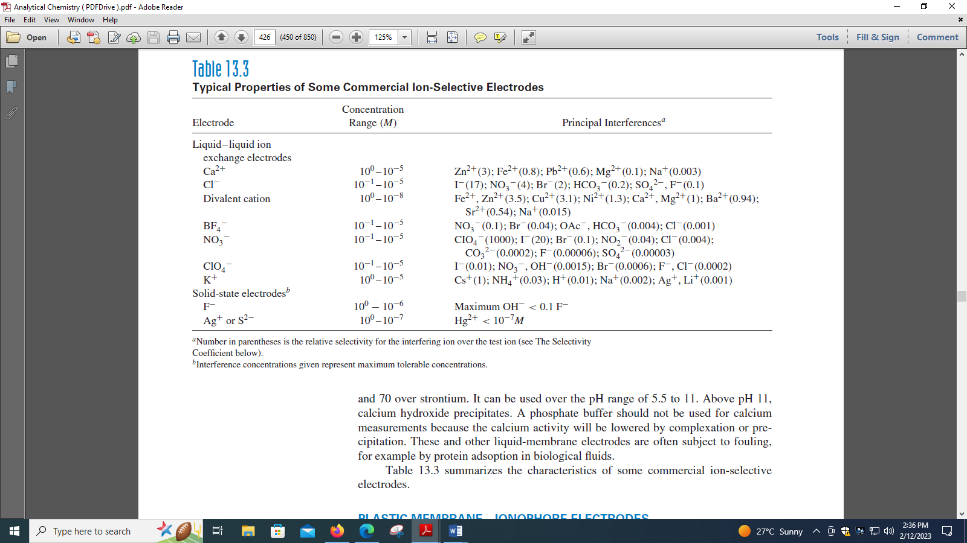

d) (i) The sulfide content in a pulp plant effluent is determined with a sulfide ion-selective electrode using the method of standard additions for calibration. A 10.0-mL sample is diluted to 25.0 mL with water and gives a potential reading of −216.4 mV. A similar 10.0-mL sample plus 1.00 mL of 0.030 M sulfide standard diluted to 25.0 mL gives a reading of −224.0 mV. Calculate the concentration of sulfide in the sample. (3 marks)

(ii) The limiting current of lead in an unknown solution is 5.60 μA. One milliliter of a 1.00 × 10⁻³ M lead solution is added to 10.0 mL of the unknown solution and the limiting current of the lead is increased to 12.2 μA. What is the concentration of lead in the unknown solution? (2 marks)

e) Distinguish between
(i) Faradaic impedance and double-layer capacitance, (1 mark)
(ii) A limiting current and a diffusion current, (1 mark)
(iii) Laminar flow and turbulent flow (1 mark)

QUESTION TWO (20 MARKS)
a)(i)

(3 marks)
(ii)Explain how galvanic corrosion can be minimized. (3 marks)
b)(i)Discuss amperometric sensors with reference to oxygen sensor. (3 marks)
(ii)Outline the advantages and limitations of electrochemical sensors. (4 marks)
(iii) . Iron(III) is polarographically reduced to iron(II) at potentials more negative than about +0.4 V versus SCE and is further reduced to iron(0) at −1.5 V versus SCE. Iron(II) is also reduced to the metal at −1.5 V. A polarogram is run (using a DME) on a solution containing Fe³⁺ and/or Fe²⁺ .A current is recorded at zero applied volts, and its magnitude is 12.5 μA. A wave is also recorded with E_{1/2} equal to −1.5 V versus SCE, and its height is 30.0 μA. Identify the iron species in solution (3+ and/or 2+) and calculate the relative concentration of each. (2 marks)
c) A solution containing Cd²⁺ was analyzed voltammetrically using the standard addition method. Twenty-five milliliters of the deaerated solution, which was 1M in HN0₃, produced a net limiting current of 1.78 µA at a rotating mercury film working electrode at a potential of
-0.85 V (versus SCE). Following addition of 5.00 mL of a 2.25 x 10-3 M standard Cd²⁺ solution, the resulting solution produced a current of 4.48 µA. Calculate the concentration of Cd²⁺ in the sample. (2 marks)
d) (i) What arc the advantages of performing voltammetry with microelectrodes? (1.5 marks)
(ii) Is it possible for an electrode to be too small'? Explain your answer. (1.5 marks)

QUESTION THREE (20 MARKS)
- Describe and explain the shape of the voltammogram given below
(i)
3 marks)
(ii)
(2 marks)
- The working curve for the determination of dopamine at a nanoneedle electrode 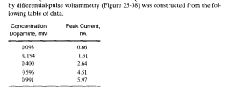

(i)Use the least-squares analysis of the data to determine the slope, intercept, and regression statistics, including the standard deviation about regression. (3 marks)
(ii) Use your results to find the concentration of dopamine in a sample solution that produced a peak current of 3.62 nA. This value is the average of duplicate experiments. (1 mark)
(iii) Calculate the standard deviation of the unknown concentration and its 95% confidence interval assuming that each of the data in the table was obtained in a single experiment. (2 marks)

c) Account for the following features of cyclic voltammograms:
(i) Why is it expected that peak current is proportional to the square root of scan
rate? (2 marks)
(ii) Why is the peak current less in the limit of slow electrode kinetics? (2 marks)
(iii) Why does altering the diffusion coefficient of the product (D_{B}) for a given
diffusion coefficient of the reactant (D_{A}) affect the forward peak potential but
not the forward peak current? (2 marks)
(iv) Why, in practice, does a plot of I_{pf} vs. c∗ often not go through the origin?
(3 marks)

QUESTION FOUR (20 MARKS)
a) (i)Briefly discuss electrochemical impedance spectroscopy. (5 marks)
(ii)

a)6 marks ,b) 1 mark ,c) 1 mark d) 1 mark e) 1 mark, f) 1 mark

- Suggest how Equation 25-13 could be used to detcrmine the number of electrons n involved in a reversible reaction at an electrode. (1 mark)

c)State and explain the advantages of microelectrodes. (3 marks)

