CHUKA | 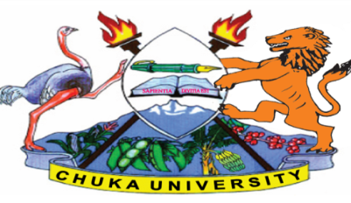 | UNIVERSITY

SUPPLEMENTARY / SPECIAL EXAMINATIONS

EXAMINATION FOR THE AWARD OF DIPLOMA

DIBM 0112: PRINCIPLES OF MANAGEMENT

STREAMS: DIBM/DPLM/DIAC
TIME: 2 HOURS

DAY/DATE: MONDAY 16/11/2020 11.30 A.M - 1.30 P.M.

INSTRUCTIONS:
- Answer question ONE and any other TWO questions

Q1. (a) Define the term management and discuss the various characteristics of
management. [7 Marks]

(b) Discuss the various roles of management and the skills a manager should possess
in order to function effectively. [10 Marks]

(c) Define the term power and discuss the various sources of power. [6 Marks]

(d) Discuss the principles of management as pro founded by Henri Fayol. [7 Marks]

Q2. (a) Planning is one of the functions of every manger in an organization. Discuss the
advantages and disadvantages of planning. [10 Marks]

(b) Explain the merits and demerits of functional organizational structure. [10 Marks]

3. (a) Briefly discuss the control process in management. [8 Marks]

(b) Discuss any four sources of power to a leader in an organization [8 Marks]

(c) Employees are very important as far as the success of ay organizations is
concerned. Discuss various ways through which the management expresses social
responsibility of its employees. [4 Marks]

Q4. (a) Discuss the activities carried out by managers when executing the staffing
function. [7 Marks]

(b) Explain the benefits of management by objectives to an organization. [6 Marks]

(c) Highlight types of barriers faced by managers when delegating. [7 Marks]

---------------------------------------------------------------------------------------------------------------------

