CHUKA | 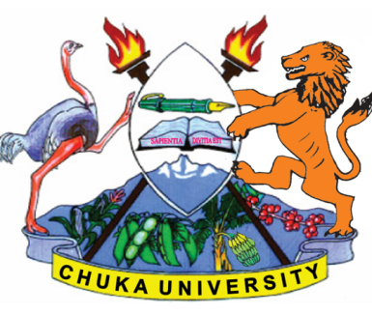 | UNIVERSITY
UNIVERSITY EXAMINATIONS
RESIT/SPECIAL EXAMINATION
EXAMINATION FOR THE AWARD OF DEGREE OF BACHELOR OF HOTEL MANAGEMENT
BCHM 403: TECHNIQUES OF SUPERVISION
STREAMS: BCHM Y4S2 TIME: 2 HOURS
DAY/DATE: TUESDAY 02/11/2021 8.30 A.M – 10.30 A.M.
INSTRUCTIONS:
- Answer ALL questions in SECTION A and any Two in SECTION B.
- Do not write anything on the question paper.
SECTION A (30 MARKS)
- Differentiate between empowerment and delegation as used in supervision. [6 Marks]
- Briefly explain the main sources of power for leaders in a workplace environment. [6 Marks]
- Briefly explain the essential skills of a supervisor. [6 Marks]
- Highlight on-job training methods you would adopt as a supervisor. [3 Marks]
- Briefly explain the most suitable conflict resolution style for a functional conflict in business organization. [4 Marks]
- Briefly explain the concept of organization culture. [5 Marks]
SECTION B (40 MARKS)
- (a) As a supervisor you are faced with a dysfunctional work team. Discuss how you would diagnose the likely problems and how handle to ensure team effectiveness. [10 marks]
(b) Discuss ethical issues for supervisors to consider in ensuring good employee relations. [10 marks]
- (a) Assuming you have been appointed to facilitator a seminar on effective delegation. Explore the main issues in your training manual. [10 marks]
(b) Discuss ways by which supervisors can enhance employee motivation and morale. Support your answer with a relevant theory. [10 marks]
- (a) As a supervisor you are appointed to head a cross-functional team tasked to enhance communication in the organization. Discuss the main challenges you expect to explore in seeking for solutions. [10 marks]
(b) As a supervisor, discuss how you can ensure effective leadership so as to cultivate influence over your subordinates. [10 marks]
---------------------------------------------------------------------------------------------------------------------

