CHUKA |  | UNIVERSITY
UNIVERSITY EXAMINATIONS

RESITS/SPECIAL EXAMINATIONS

EXAMINATION FOR THE AWARD OF DIPLOMA IN COMPUTER SCIENCE

PHYS 0111: PRINCIPLES OF PHYSICS
STREAMS: DIP (COMP SCI) TIME: 2 HOURS
DAY/DATE: MONDAY 28/8/2023 8.30 A.M. – 10.30 A.M.
INSTRUCTIONS:
- Answer Question One in Section A and any other Two Questions in Section B
- Do not write anything on the question paper
- This is a closed book exam, No reference materials are allowed in the examination room
- There will be No use of mobile phones or any other unauthorized materials
- Write your answers legibly and use your time wisely
- You may use the data below
g=10m/s²
c=3.0×10⁸m/s

QUESTION ONE (30MARKS)
- Differentiate between derived and fundamental quantities giving an example for each. (4 marks)
- The velocity of a body increases from 72 km/h to 144 km/h in 10 seconds. Calculate its acceleration. (3marks)
- A person weighing 500 N takes 4 seconds to climb upstairs to a height of 3.0 m. What is the average power in climbing up the height? (3marks)
- State ohms law giving its mathematical equation (2marks)
- Define efficiency of a machine giving its mathematical expression (3marks)
- Given that the resistivity of nichrome is 1.1× 10⁻⁶Ωm, what length of nichrome wire of diameter 0.42 mm is needed to make a resistance of 20 Ω? (4marks)
- State coulomb’s law and hence give its mathematical expression (2marks)
- State and explain three methods used to make magnets (6marks)
- State the laws of refraction of light (2marks)
- What is dispersion of light? (1mark)
QUESTION TWO (20 MARKS)
- State the Kirchhoff’s rules. (2marks)
- With the help of well labeled circuit diagram, explain the working of the following rectifiers.
- Bridge rectifier. (6marks)
- Centre tap full wave rectifier. (6marks)
- Calculate each of the unknown currents I_{1,}I₂and I₃ for the circuit in Figure below
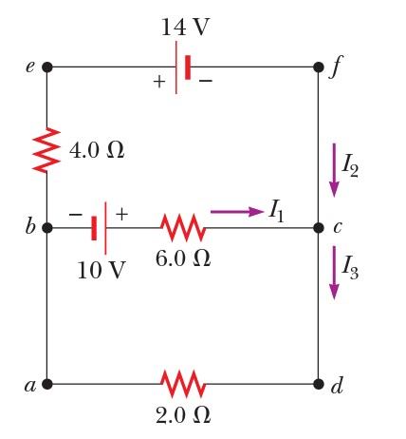 (6marks)
QUESTION THREE (20MARKS)
- Calculate angle ϴ below ,given that refractive indices of glass and water are 3/2 and 4/3 respectively (4marks)
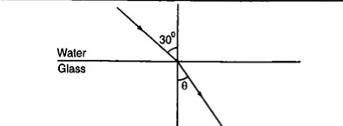
- Given that the refractive index of diamond is 2.42 and the velocity of light in air is 3.0 ×10⁸m/s, calculate the velocity of light in diamond. (3marks)
- Define the term critical angle and hence state the conditions for total internal reflection to take place. (3marks)
- Draw the sketch of a fiber optic cable and label the main parts. Hence list two of its applications. (4marks)
- Determine the position, size and nature of the image of an object 4cm tall placed on the principal axis of a concave mirror of focal length 15cm at a distance 30cm from the mirror (3marks)
- List three applications of spherical mirrors and curved reflecting surfaces(3marks)
QUESTION FOUR (20 MARKS)
- List and explain the basic components of a computer power supply.(8marks)
- For the figure shown below(The capacitance for the capacitors are in µF) , Calculate:
    - The equivalent capacitance between a and b. (4marks)
    - The charge on the 4µF capacitor and the voltage drop across it given that a 12V battery is connected between points a and b
(5marks)

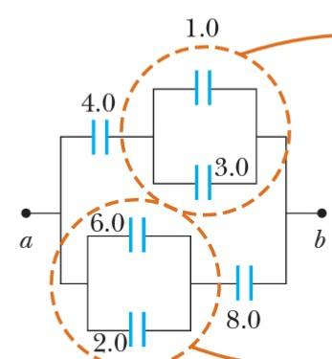

- A charge of 4.5 × 10⁻⁹ C is located 3.2 m from a charge of −2.8 × 10⁻⁹ C. Find the electrostatic force exerted by one charge on another. (3marks)
QUESTION FIVE (20MARKS)
- A body moves 30 m due east in 4 seconds, then 40 m due north in 8 seconds. Determine:
    - The total distance moved by the body. (2marks)
    - The displacement of the body. (3marks)
    - The average speed of the body. (3marks)
    - The average velocity of the body. (3marks)
- Determine the work done when a force of 50 N pushes an object 1.5 km in the same direction as the force. (4marks)
- State the law of conservation of energy. Hence list four forms of energy (5marks)

