
CHUKA UNIVERSITY

Knowledge is Wealth (Sapientia divitia est)
Telephones: 020 2310512/18 P. O. Box 109-60400, Chuka
Email: info@chuka.ac.ke Website: www.chuka.ac.ke
DEPARTMENT OF PHYSICAL SCIENCES
EXAMINATION FOR THE AWARD OF BACHELOR OF SCIENCE IN ELECTRICAL AND ELECTRONIC ENGINEERING
EENG 354: DIGITAL LOGIC DESIGN
INSTRUCTIONS:
Answer question ONE and any other TWO questions
Do not write on the question paper

QUESTION ONE
- Show the logic arrangements for implementing a NOT circuit using a two-input EX-NOR gate (2 Mks)
- Define the following terms as used in digital design (4 Mks)
- Frequency division.
- A Synchronous Counter
- A Finite State Machine (FSM)
- A state
- In a 7-segment display, each of the seven segments is activated for various digits. For example, segment a is activated for the digits 0, 2, 3, 5, 6, 7, 8, and 9, as illustrated in Figure 1.1 Since each digit can be represented by a BCD code, derive an SOP expression for segment a using the variables ABCD and then minimize the expression using a Karnaugh map (4 Mks).
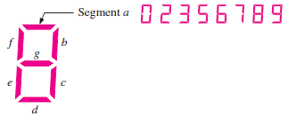
Figure 1.1

- Apply DeMorgan’s theorems to the following expression: (3 Mks)
- A portion of a periodic digital waveform is shown in Figure 1.2. The measurements are in milliseconds. Determine the following:
- period (1 Mk)
- frequency (1 Mk)
- duty cycle (1 Mk)
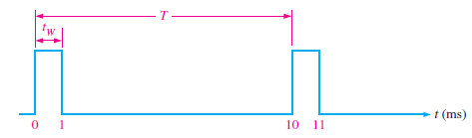
Figure 1.2
- Simplify the following expression using k-map (4 Mks)
F(A, B, C, D) = $π$M (0, 1, 3, 6, 7, 8, 9, 11, 13, 14, 15)
- Prove the following Boolean identity : (A + B) (A + $\overline{B}$ ) ( $\overline{A}$ + C) = AC (3 Mks)
- A grocery retail outlet entrance door needs a counter that will count the number of customers who come shopping each day. A photodetector and a light source combination is used to generate a single pulse, each time a person enters the door. The counter must be able to count as many as 1000 persons. How many flip-flops are required to construct the counter (3 Mks)?
- From the relevant Boolean expressions for half-adder and half-subtractor circuits, design a halfadder–subtractor circuit that can be used to perform either addition or subtraction on two one-bit numbers. The desired arithmetic operation should be selectable from a control input (4 Mks).

QUESTION TWO
- In a certain chemical-processing plant, a liquid chemical is used in a manufacturing process. The chemical is stored in three different tanks. A level sensor in each tank produces a HIGH voltage when the level of chemical in the tank drops below a specified point.
- Design a circuit that monitors the chemical level in each tank and indicates when the level in any two of the tanks drops below the specified point (5 Mks).
- If the sensors in the chemical tanks are being replaced by a new model that produces a LOW voltage instead of a HIGH voltage when the level of the chemical in the tank drops below a critical point, modify the circuit to operate with the different input levels and still produce a HIGH output to activate the indicator when the level in any two of the tanks drops below the critical point. Show the logic diagram (5 Mks).
- Determine the output waveforms in relation to the clock for Q_{A}, Q_{B}, and Q_{C} in the circuit of Figure 2.1 and show the binary sequence represented by these waveforms (5 Mks).
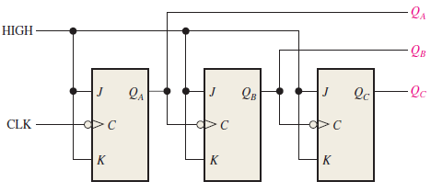
Figure 2.1

- Design a circuit from the following Boolean expressions using a PROM (5 Mks).
f₁ (x₂, x₁, x₀) = $\sum{m (0, 1, 2, 5, 7)}$
f₂ (x₂, x₁, x₀) = $\sum{m (1, 2, 4, 6)}$

QUESTION THREE
- Design a logic circuit with four input variables that will only produce a 1 output when exactly three input variables are 1s (5 Mks).
- Design a counter with the irregular binary count sequence shown in the state diagram of Figure 3.1. Use D flip-flops (10 Mks).
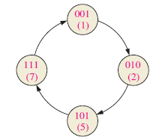
Figure 3.1
QUESTION FOUR
- As part of an aircraft’s functional monitoring system, a circuit is required to indicate the status of the landing gears prior to landing. A green LED display turns on if all three gears are properly extended when the “gear down” switch has been activated in preparation for landing. A red LED display turns on if any of the gears fail to extend properly prior to landing. When a landing gear is extended, its sensor produces a LOW voltage. When a landing gear is retracted, its sensor produces a HIGH voltage. Design a circuit to meet this requirement (5 Mks).
- Design a synchronous 3-bit up/down counter with a Gray code sequence using J-K flip-flops. The counter should count up when an UP/$\overline{DOWN}$ control input is 1 and count down when the control input is 0 (12 Mks).
- Discuss three applications of FPGA (3 Mks)

