FOURTH YEAR, FIRST SEMESTER EXAMINATION FOR THE DEGREE OF BACHELOR OF SCIENCE IN ELECTRICAL AND ELECTRONICS ENGINEERING
EENG 482: SIGNAL AND SYSTEMS

TIME: 2 HOURS
INSTRUCTIONS: Answer question one and any other two.
QUESTION ONE (30 MARKS)
a). For the Fourier transform of a signal g(t) to exist, it is sufficient but not necessary , that g(t) satisfies three conditions. Discuss these conditions. (6 marks)

b). Explain the following concepts as applied to systems theory; (6 marks)
- Homogeneity
- Superposition
- Time invariance
c). Discuss three properties of convolution integral (6 marks)
Find the Laplace transform of the following functions and establish the ROC for each case.
(6 marks)
- $e^{-5t}u\left(t\right)$
- 𝛅(t)

e). State and derive the following properties of DTFT (6 marks)
- Linearity
- Time Scaling
- Time Shifting and Frequency Shifting

QUESTION TWO (20 MARKS)
a). State and express the impulse response of a system (2 marks)

b). For each of the following signals, determine whether it is periodic or aperiodic and if periodic, determine the period. (6 marks)
(i) x(t) = 2 cos(4πt) + 3 sin(3πt)
(ii) x(t) = 2 cos(4πt) + 3 sin(10t)
c). Obtain by graphical method the convolution of the two signals in Fig. Q2 (c). (12 marks)
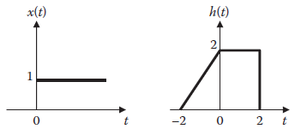
Fig. Q2 (c)
QUESTION THREE (20 MARKS)
a). state and express the two types of Laplace transforms (4 marks)

b). Obtain the Laplace transform of:
(4 marks)
c). The output of a linear system is $Y\left(t\right)= e^{-t}cos4t u\left(t\right)$when the input is $X\left(t\right)= {10e}^{-t}u(t)$. Find the transfer function of the system. (4 marks)

d). using the Residue method, Determine x(t) given that; (8 marks)
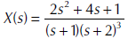

QUESTION FOUR (20 MARKS)
a). Highlight two applications of the discrete Fourier transforms (4 marks)
b). Find the Fourier transform of the following functions:
- δ(t),
- $sinω_{0}t$ (6 marks)

c). Find the z-transform of the following composite signal and determine its region of convergence.
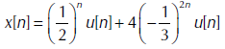 (5 marks)
d). Use long division expansion to find x[n] given that: (5 marks)
