CHIN 433: INDUSTRIAL PHYSICAL METHODS FOR ANALYSIS
INSTRUCTIONS
Answer question one and any other to questions
Useful data are provided.
QUESTION ONE (30 MARKS)
a i) A terpolymer is prepared from vinyl monomers A, B, and C; the molecular weights of the repeat units are 104, 184, and 128, respectively. A particular polymerization procedure yields a product with the empirical formula A355 32.20C1.00- The authors of this research state that the terpolymer has “an average unit weight of 134” and “the average molecular weight per angstrom of 53.5.” Verify these values. Evaluate also the overall degree of polymerization of this terpolymer, if the molecular weight were 43000 (3 marks)
ii) It has been hypothesized that cross—linked polymers would have better mechanical properties if interchain bridges were located at the ends rather than the center of chains. To test this, low molecular weight polyesters were synthesized from a diol and two different diacids: one saturated and the other unsaturated. The synthetic procedure was such that the unsaturated acid units were located at either the center (“centrene”) or the ends (“endene”) of the chains. Some pertinent aspects of the overall experiment are listed below:
On the basis of these facts, do the following:
- Comment on the likelihood that the comonomers are segregated as the names of these polymers suggest. (1 mark)
- Sketch the structure of the average endene and centrene molecule. (2 marks)
- Comment on the results in terms of the initial hypothesis. ( 1 mark)

iii) For an initiator concentration that is constant at [I]0, the nonstationary-state radical concentration varies with time according to the following expression:

(3 marks)
iv)

(3 marks)
b(i)

(5marks)
ii)
(3 marks)
C(i)

- Explain, as far as possible, the features of the TG, DTG and DTA curves and suggest the nature of the products at both 300 °C and 600 °C.
(6 marks)
(ii) What other techniques could be used to confirm the identity of the products suggested above?
(1.5 marks)
(iii) When the pure hydrated barium perchlorate is mixed with Mn0₂ in a molar ratio of l:l, the thermo analytical behaviour changes. Two molecules of water are lost first, then the final one. The temperature of the final decomposition is lowered from about 460 DC to about 310 DC and takes place in a single, smooth step. Suggest reasons for these effects.
(1.5 marks)
QUESTION TWO (20 MARKS)
a (i) Describe the principle of the Differential Scanning Calorimetry
(1 mark)
ii)Outline the protocol procedure of differential scanning calorimetry for assessing the thermal stability of proteins in an industrial setting which can be used for the formulation of vaccine.
(6 marks)
b(i) Describe in some detail the instrumental and radiochemical differences between prompt gamma-ray neutron activation and delayed gamma-ray neutron activation.
(2 marks)
- State some types of elements for which prompt gamma-ray activation analysis is most applicable.
(1.5 mark)

(iii) Why is delayed gamma-ray emission most often used in NAA?
(2 marks)
(iv) Why is NAA considered to be a very selective and sensitive method?
(1.5 mark)
(v) A crystal of potassium fluoride is to be studied via NAA. The following table summarizes the behavior of all naturally occurring isotopes in the crystal.
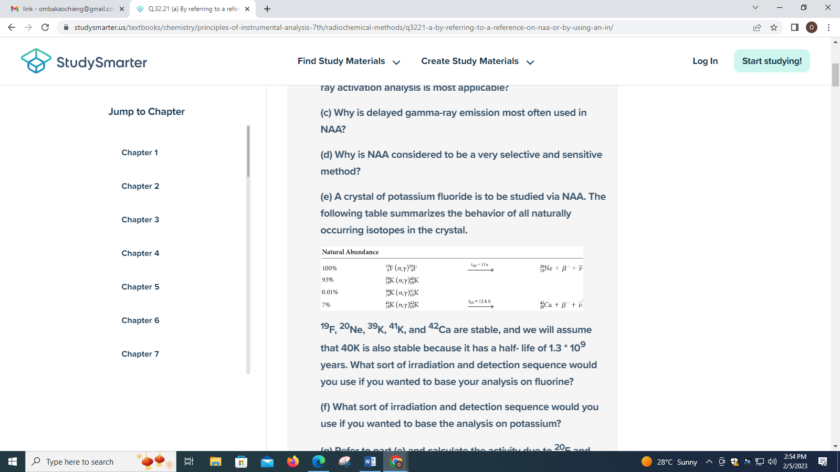

(1 mark)

(vi) Refer to part (v), calculate the activity due to ²⁰F and ⁴²K in a 58-mg (1.0-millimole) sample of pure potassium fluoride that has been irradiated for 60 s. The thermal neutron cross sections for ¹⁹F and ⁴¹K

are 0.0090 * 10⁻²⁴ cm² and 1.1 * 10⁻²⁴ cm² , respectively. Assume a flux density of 1.0 * 10⁻³ neutrons cm⁻² s⁻¹.

(2 marks)

(vii) State a method that describes the use of NAA for determining selenium in freshwater ecosystems and describe the method in detail. Include the neutron source, the irradiation time, and the calculations used. Give the advantages of the method over other analytical techniques.

(3 marks)

QUESTION THREE (20 MARKS)

(i)
(1 mark)
(ii)

(1.5 marks)
(iii)
(1 mark)
b (i)Explain the following statements “Vacuum chambers used in XPS are constructed out of stainless steel with MU-metal lining or MU-metal itself.”
(2.5 marks)
(ii)Describe if and how the work function of a sample of interest can be derived using X-ray photoelectron spectroscopy (XPS) or Ultraviolet Photoelectron Spectroscopy (UPS)
(1.5marks)
(iii) Describe what happens to all the photoelectron peaks observed in the spectra collected from an insulating sample when ineffective charge neutralization conditions are used.
- mark)
(iv)What could cause the spin orbit splitting value of photoelectrons from a specific level or a specific element to deviate from that typically observed?
(1 mark)
(v) The analysis of an unknown but homogeneous sample is carried out with photoelectrons collected at some off normal take off angle.On rotating the sample around its normal axis (azimuth rotation), reproduction periodic spikes are noted in various core level photoelectron signals.
(I)What are these variations indicative of?
(0.5 marks)
(II)How may they be useful?
(1 mark)
(vi)Quantification of sputter depth profiles of even the most stable metal oxides (e.g perovskites) with 0.5 keV Ar⁺ ions at an angle of 45º relative to the sample surface, using sensitivity factors defined from unsputtered surfaces ,tends to reveal less than stroichiometric amounts of oxides. Explain why this occurs? (1 mark)
(Vii)Compare Electron Spectroscopy for Chemical Analysis (ESCA) {X-Ray Photoelectron Spectroscopy (XPS)}, ultraviolet photoelectron spectroscopy (UPS) and Auger Spectroscopy (AES)
(2 marks)
c(i) Justify the following statement
“Secondary electrons are important for topographical and morphological imaging of samples”
- marks)

(ii)Describe the fundamental aspects of supputtering in secondary ion mass spectrometry (SIMS)
(4 marks)

QUESTION FOUR (20 MARKS)

a (i)Give four outstanding features of secondary ion mass spectrometry (SIMS) which distinguish this method from AES,XPS,RBS or other methods.
(2 marks)
(ii)Discuss the analytical potential of Atomic Force Microscopy (AFM)
(2 marks)
(iii)Write short notes on curve fitting as a technique in XPS.
(6 marks)
b (i) Distinguish between TEM and SEM microscopy.
- marks)
(ii)Describe how scanning microscope works.
(2 marks)
c) Answer the following questions with respect to SEM.
(i)List two types of electromagnetic lenses in the SEM and their functions .How are they controlled?
(3 marks)
(ii)Explain what you understand by edge effect and why it occurs?
(2 marks)

