CHUKA |  | UNIVERSITY
UNIVERSITY EXAMINATIONS

RESITS/SPECIAL EXAMINATIONS

THIRD YEAR EXAMINATION FOR THE AWARD OF DEGREE OF BACHELOR OF SCIENCE IN ACTUARIAL SCIENCE, BACHELOR OF SCIENCE GENERAL (MATHEMATICS)

MATH 321: CALCULUS III

STREAMS: TIME: 2 HOURS
DAY/DATE: TUESDAY 29/8/2023 8.30 A.M. – 10.30 A.M.
INSTRUCTIONS:
Answer Question ONE and any other TWO Questions

QUESTION ONE (COMPULSORY) (30MARKS)
- Find the second partial derivatives of the function 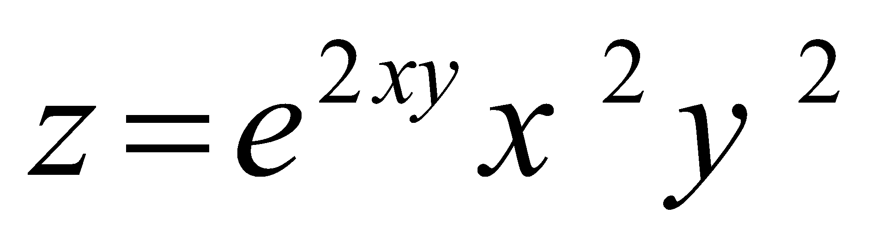 (5Marks)
- Evaluate the following integrals
- 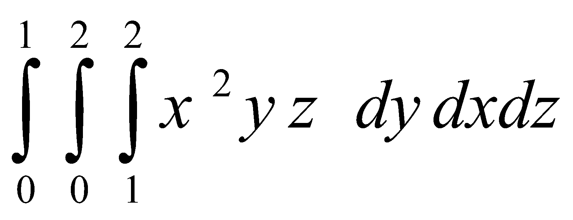 (4Marks)
- $∬_{R}^{} dx$ $dy$ where 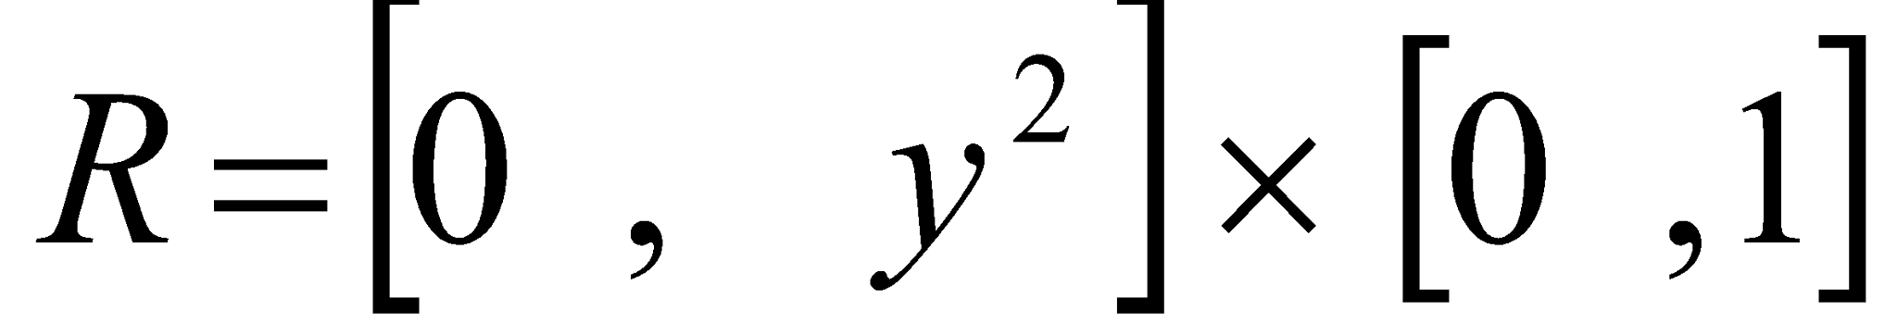 (3Marks)
- Use the Cosine series to evaluate 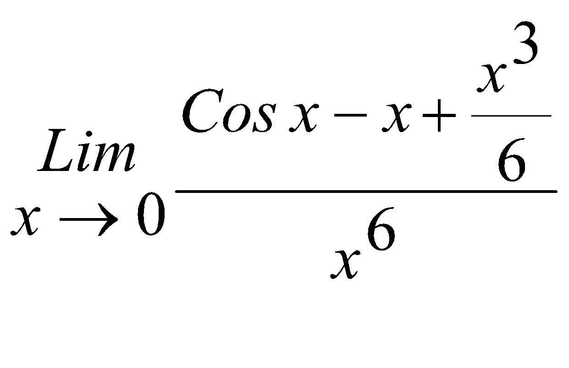 (3Marks)
- Verify the Mean Value Theorem for 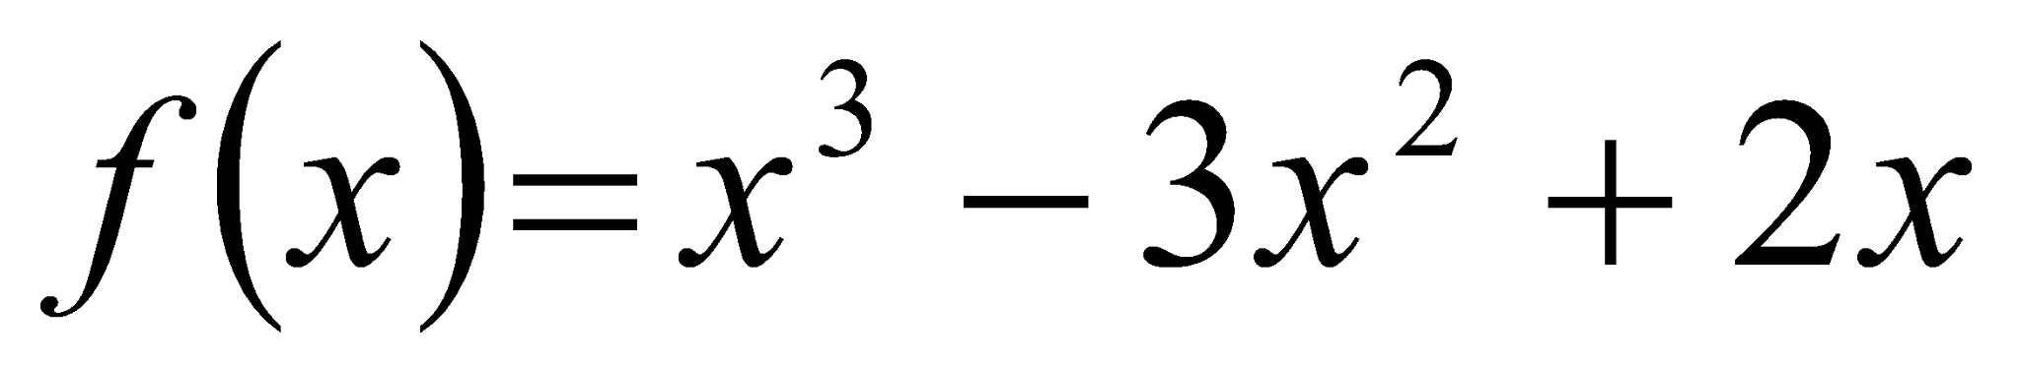 on the interval $\left[0 , \frac{1}{2}\right]$. (4Marks)
- Use the series of 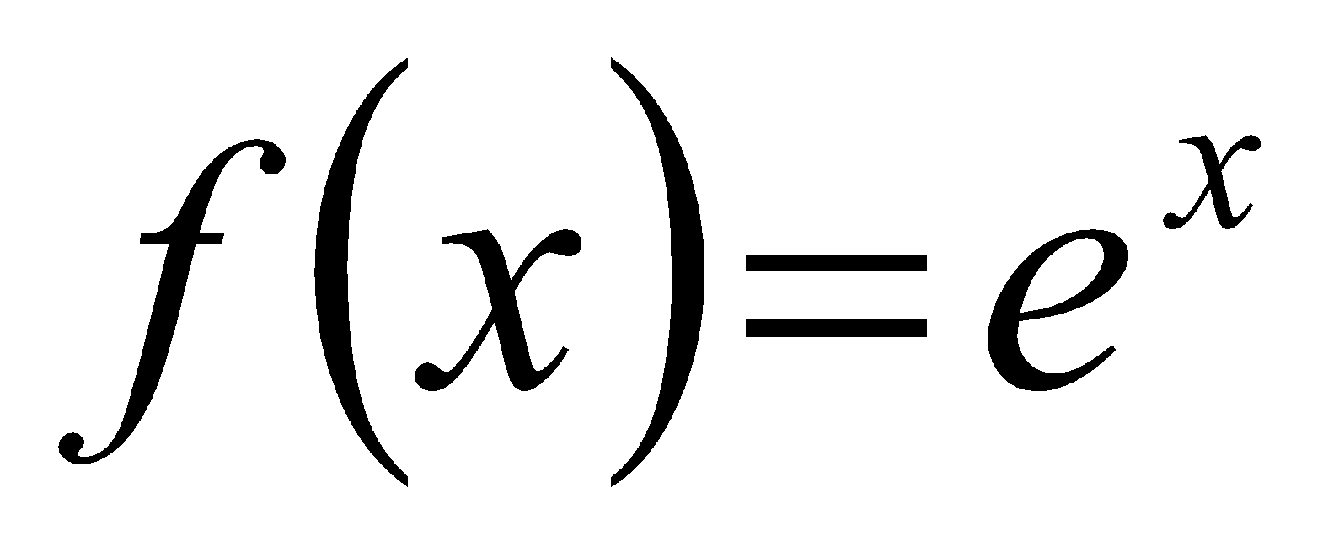and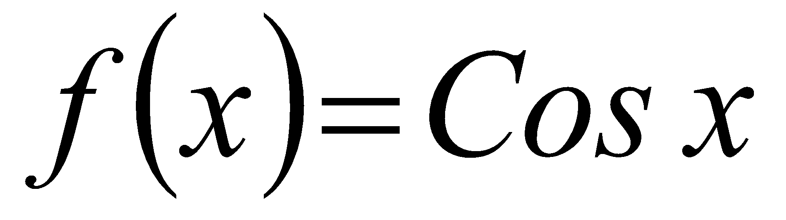 to find the first four non zero terms of the Maclaurin’s series for 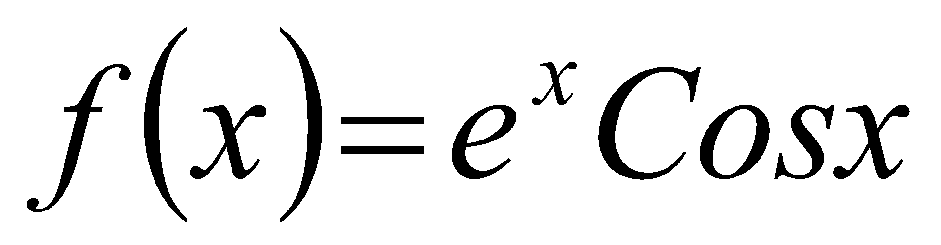 (3Marks)
- Find all the critical points of 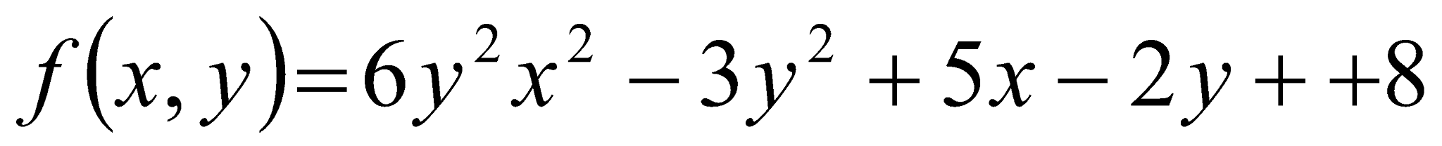 (4Marks)
- Use the integral test to determine the convergence of the series 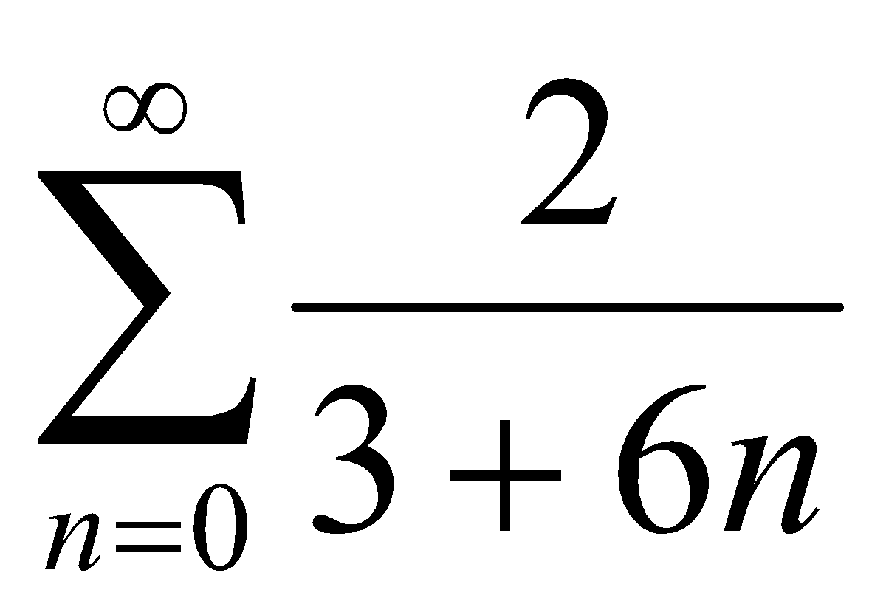 (4Marks)
QUESTION TWO (20MARKS)
- Use double integration to find the Area of the region bounded by the parabola 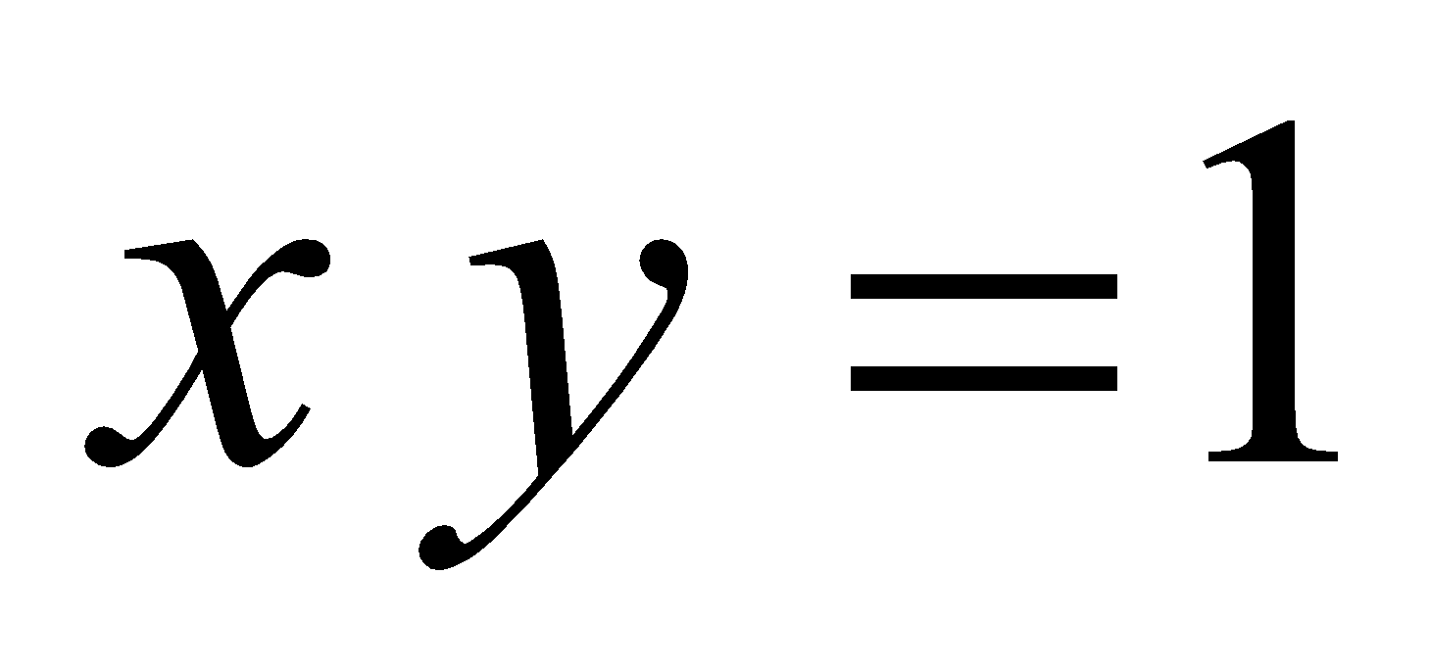and the line 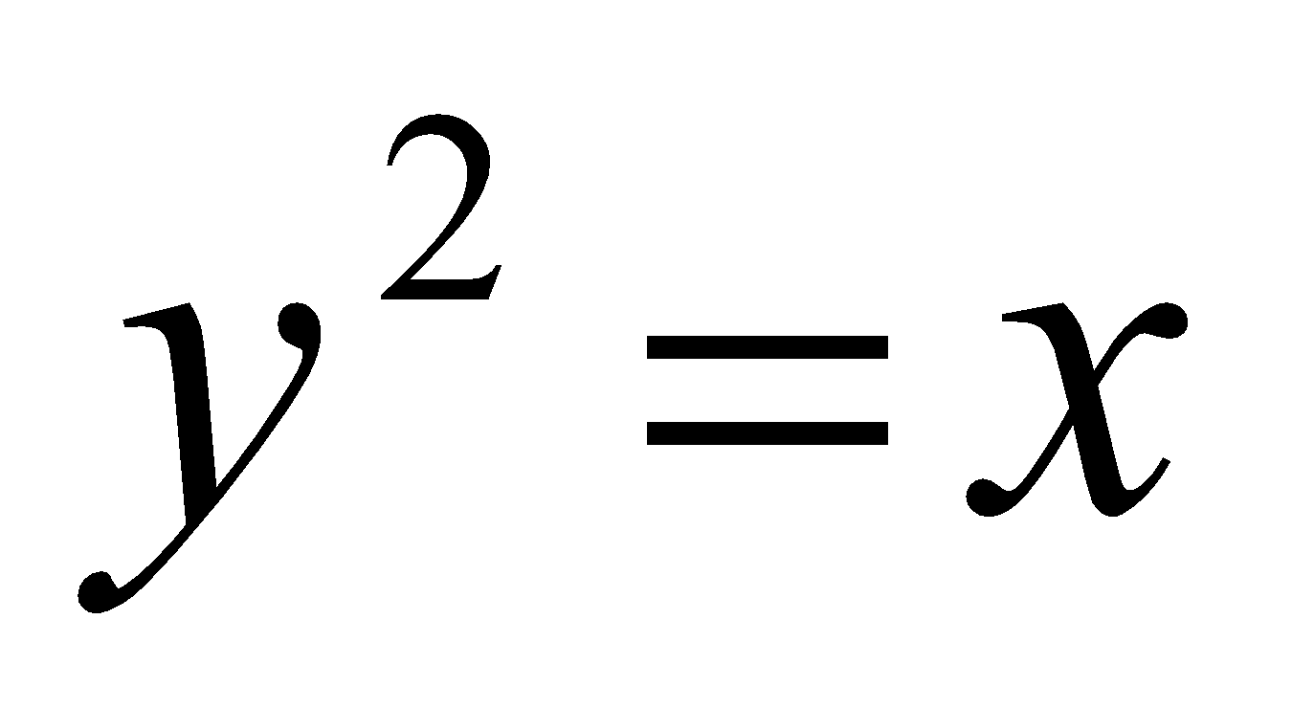 using double integration (5Marks)
- Determine the surface area of the plane 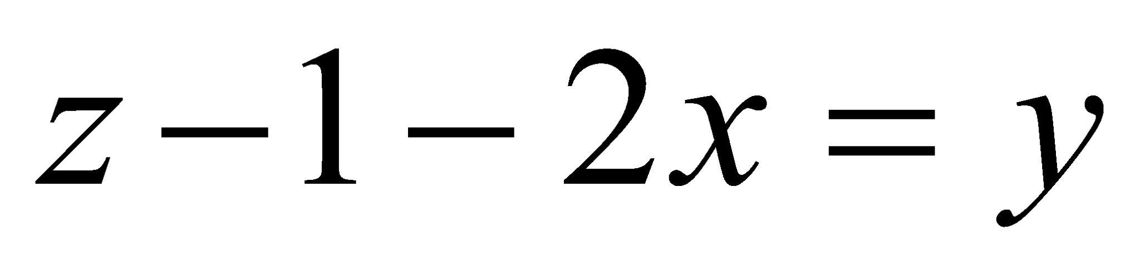 over the region (6Marks)
- Use power series up to the fourth term to evaluate 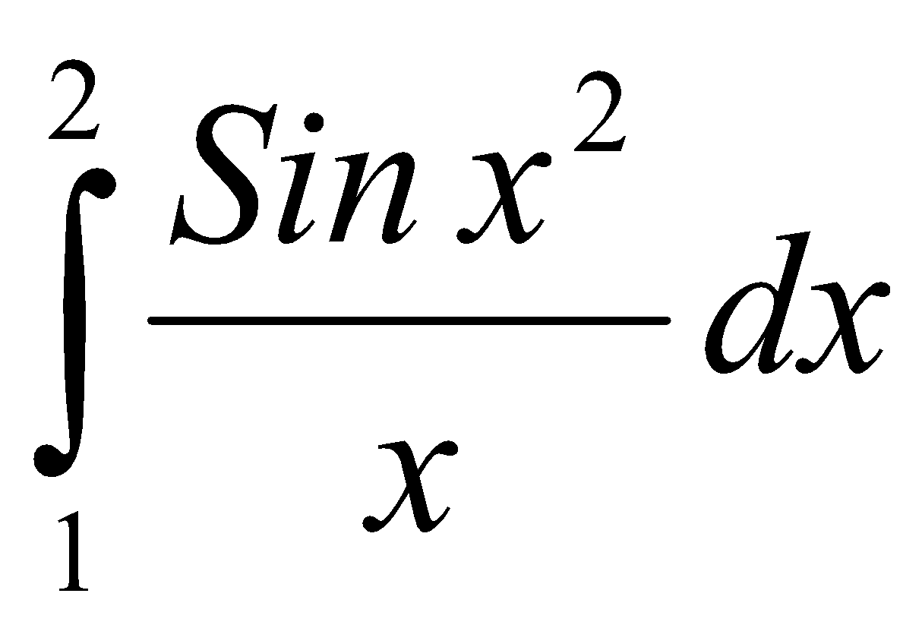 to 5 decimal places(9Marks) QUESTION THREE (20MARKS)
- Verify the mean value theorem (MVT) for 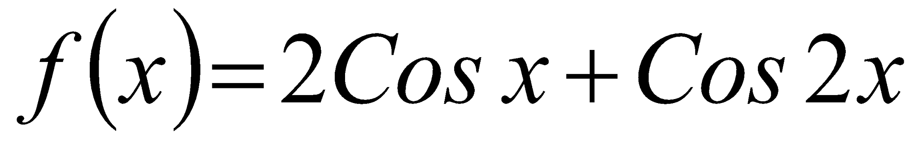 on 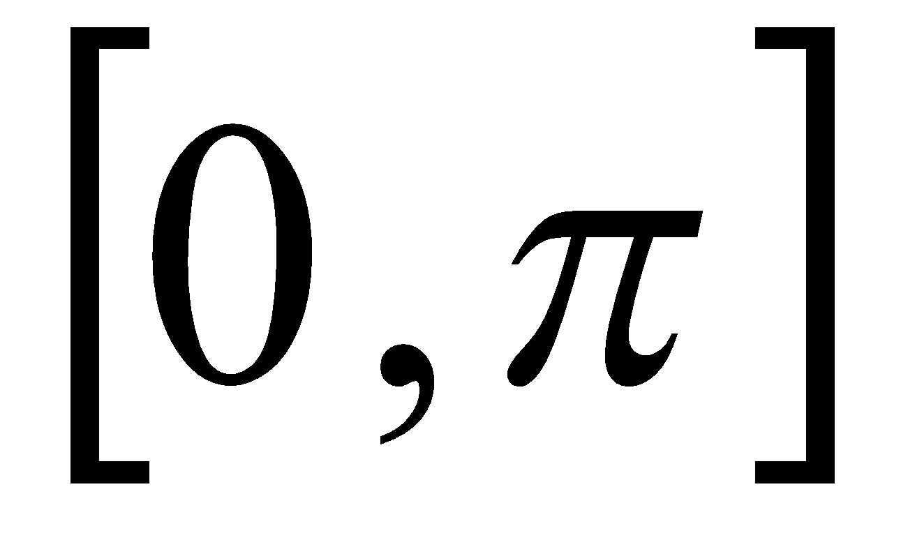 (7Marks)
- Calculate the volume of the solid below the surface 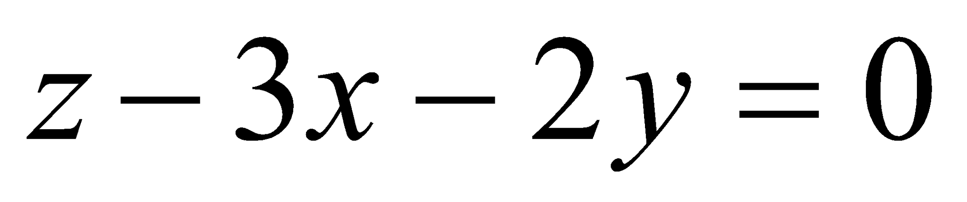over the region on the plane bounded by the curves 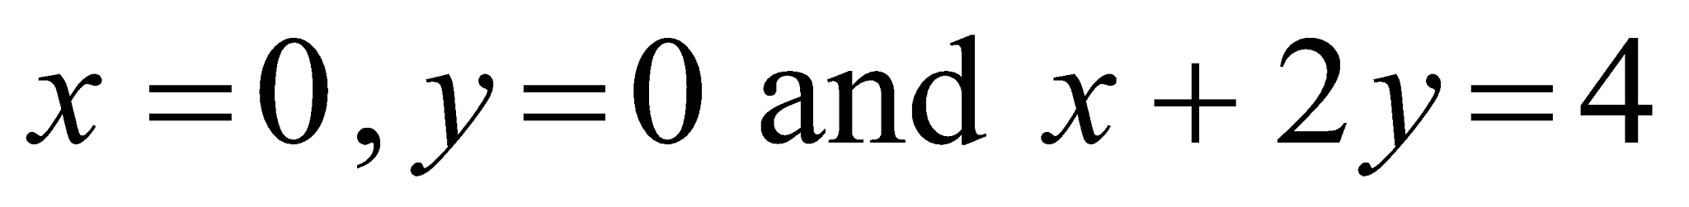 (5Marks)
- i. State the Ratio test for series convergence (3Marks)
ii.Hence determine the Convergence of the series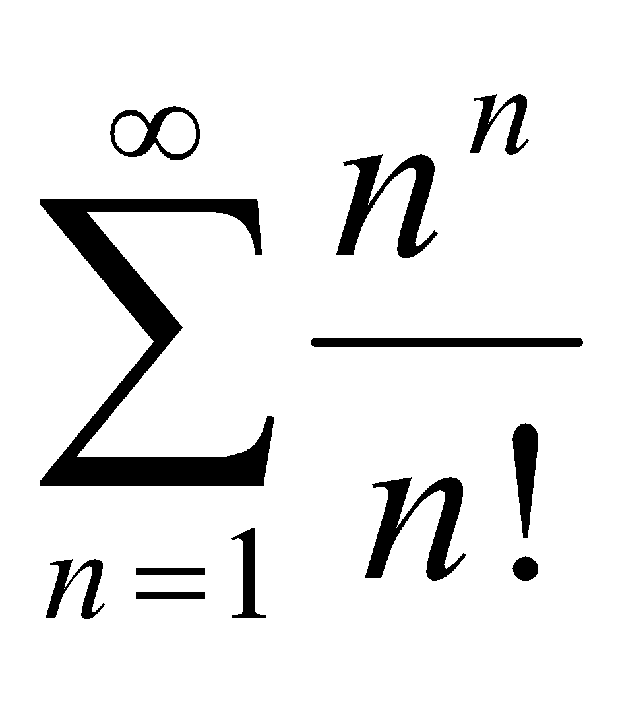by the Ratio test. (5marks) QUESTION FOUR (20MARKS)
- Consider the function 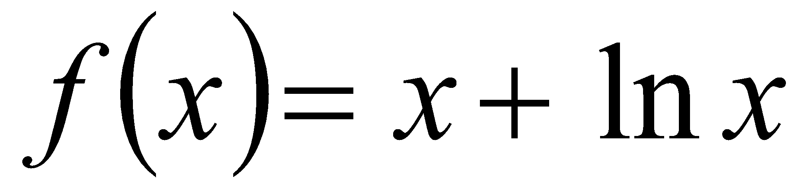.Find the Taylor’s polynomial of degree 3 (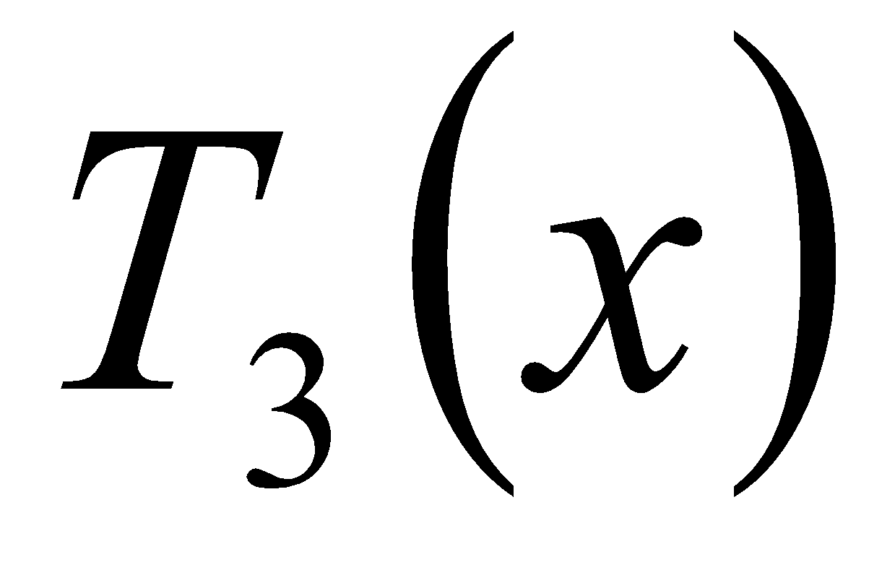)and hence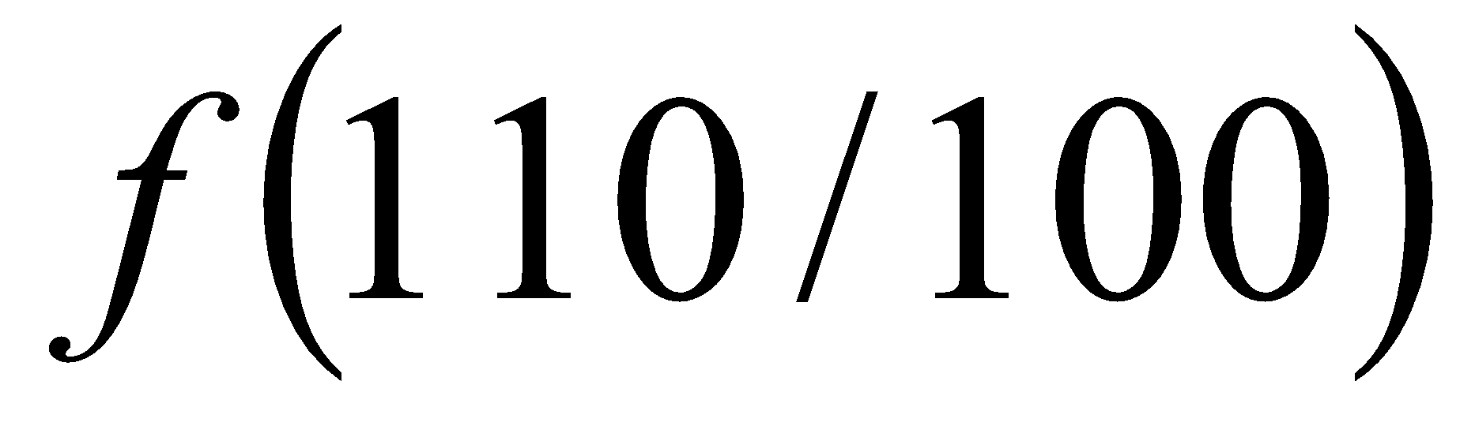 (8Marks)
- By changing into polar coordinates Determine the surface area of the saddle 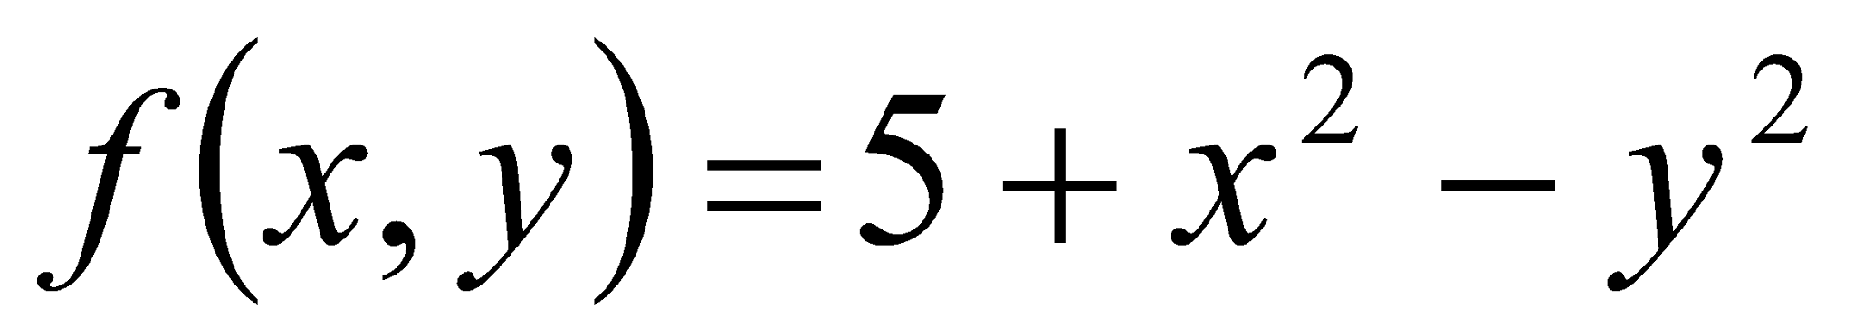 over the region 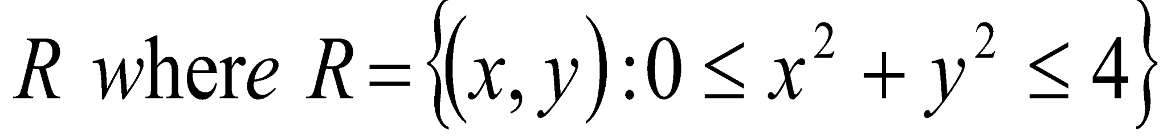 (8Marks)
- Use L’Hopital’s rule to evaluate 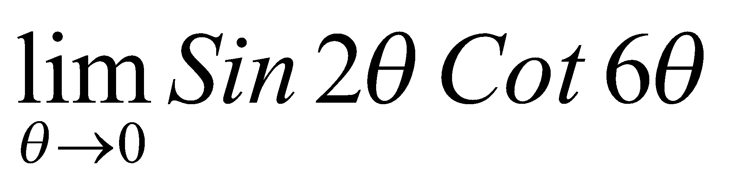 (4Marks)

QUESTION FIVE (20MARKS)
- Find the centre of mass of a square unit volume of the solid bounded above by the plane 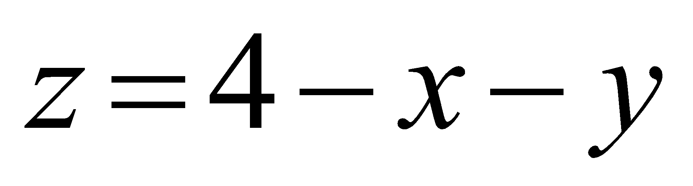 and below by the rectangle 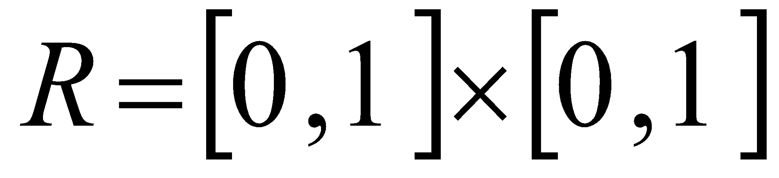given that 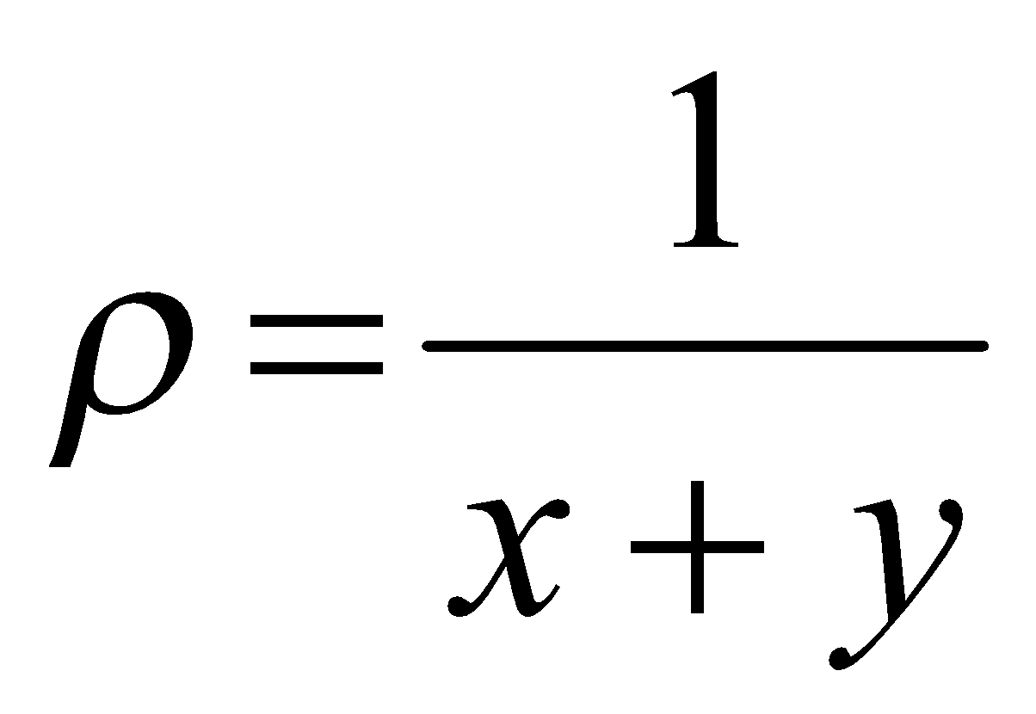 (10Marks)
- Verify the Rolle’s theorem for the function 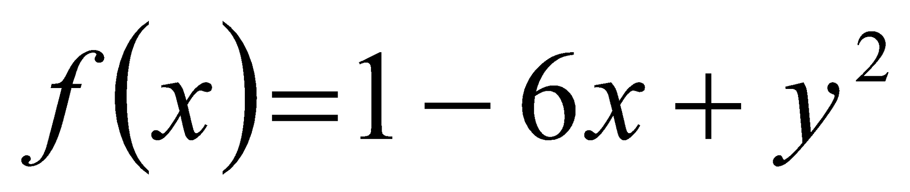 in the interval 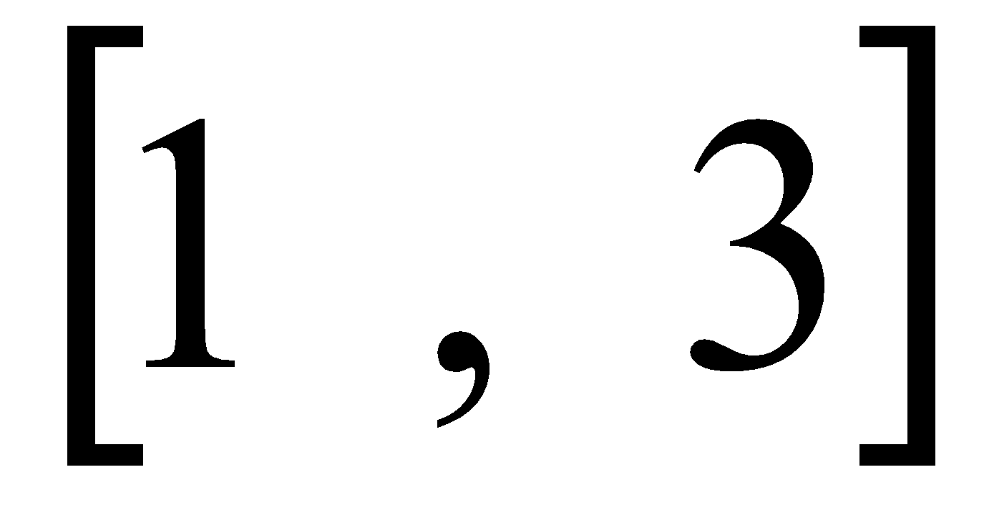( 5Marks)
- Use the Limit comparison test to determine the convergence of the series 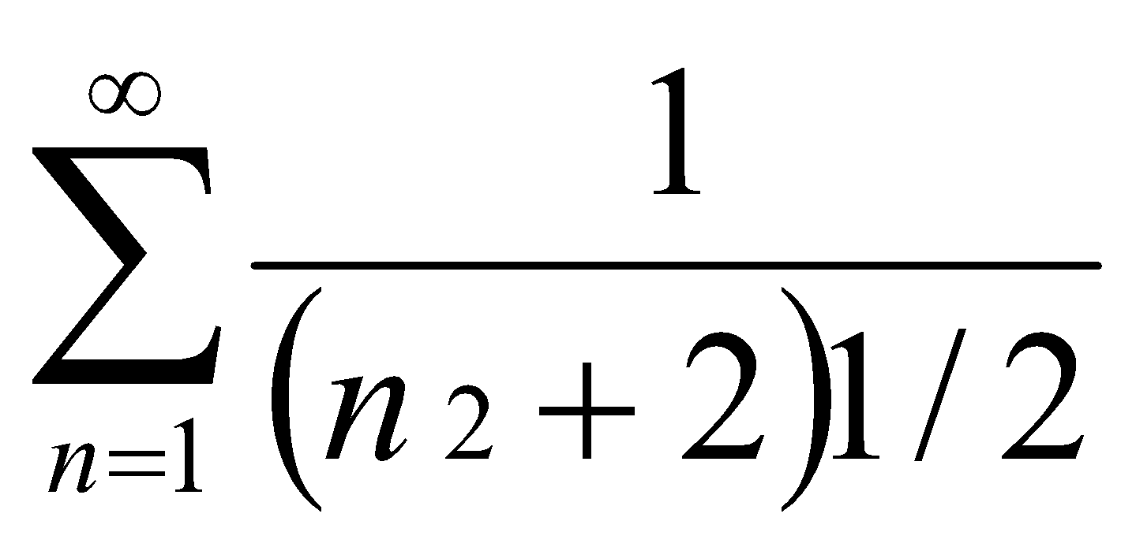 (5Marks)
