CHUKA | 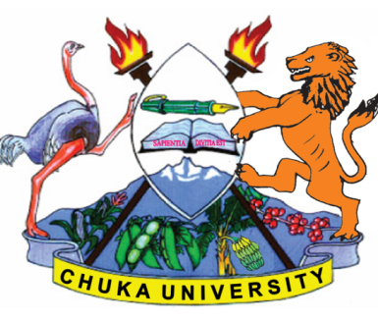 | UNIVERSITY
UNIVERSITY EXAMINATION
RESIT/SUPPLEMENTARY / SPECIAL EXAMINATIONS
EXAMINATION FOR THE AWARD OF DEGREE OF BACHELOR OF SCIENCE IN ECOTOURISM

BECO 241: INTERNATIOANL AND DOMESTIC TOURISM DEVELOPMENT

STREAMS: BECO (Y2S2) TIME: 2 HOURS

DAY/DATE: MONDAY 01/11/2021 8.30 A.M - 10.30 A.M.
INSTRUCTIONS:
- Answer all questions in Section A and any other two in section B
- Do No write Anything on the question paper.

SECTION A (30 MARKS)
- Briefly discuss six negative economic consequences of uncontrolled international tourism development in a country. (6 marks)
- Outline six benefits of undertaking national and regional tourism planning. (6 marks)
- Describe briefly six variables impacting on intradestination movements in international tourism. (6 marks)
- Explain briefly six ways in which the expansion of the Standard Gauge Railway (SGR) could revolutionise tourism in Kenya. (6 marks)
- Explain briefly six complexities of tourist accommodation business that may pose a challenge to local investors. (6 marks)

SECTION B: (40 MARKS)
- Justify why you would recommend domestic tourism as a strategy for socio- economic development in Kenya. (20 marks)
- Explain the factors that account for low levels of tourism development in Sub- Saharan Africa and the way forward. (20 marks)
- Discuss the appropriateness of the varied tourism development planning approaches. (20 marks)
………………………………………………………………………………………………………………………………………………

