CHUKA |  | UNIVERSITY
UNIVERSITY EXAMINATIONS
EXAMINATION FOR THE AWARD OF DEGREE OF BACHELOR OF SCIENCE IN MINERAL PHYSICS

GPHY 215: PETROLEUM GEOLOGY
STREAMS: TIME:2 HOURS
DAY/DATE: THURSDAY 13/04/2023 11.30 A.M. –1.30 P.M.
INSTRUCTIONS
Answer question one and any other two questions

QUESTION ONE (30 MARKS)
a) Explain the origin of oil in terms of geological and chemical occurrences [4 marks]
- List the regions with high production of petroleum [2 marks]
- Explain the distribution of productivity listed in (b) above [3 marks]
- What is the difference between primary and secondary migration [2 marks]
- Explain how primary migration occurs [5 marks]
- Explain the process that leads to over pressuring in primary migration [4 marks]
- State the difference between petroleum and hydrocarbon [2 marks]
- Discuss the four major groups of substances present in petroleum [4 marks]
- Explain any two different types of traps [4 marks]

QUESTION TWO (20 MARKS)
2 a) What type of trap is represented in the above model? Explain [2 marks]
b) Using the model diagram above, describe the characteristics of the seal rock and reservoirs [12 marks]
c) Based on the temperature differences, explain the splitting of crude oil into simpler mixtures by fractional distillation [6 marks]
QUESTION THREE (20 MARKS)
- a) Discuss the three processes that takes place in the conversion of Kerogen to oil and gas. [15 marks]
b) Explain the curve for Kerogen evolution shown below [5 marks]
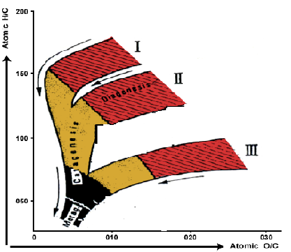
QUESTION FOUR (20 MARKS)
- a) Explain the formation of rift and passive margin basins [10 marks]
b) Give the structure of the following hydrocarbons
i) Ethene
ii) Methyl [4 marks]
c) Explain the following refinery processes
i) Separation process
ii) Primary distillation
iii) Secondary distillation [6 marks]
QUESTION FIVE (20 MARKS)
- a) Explain the application of the following geophysical methods in oil exploration
- Magnetic method [6 marks]
- Gravity method [6 marks]
- Seismic method [8 marks]

---------------------------------------------------------------------------------------------------------------------

