THIRD YEAR EXAMINATION FOR THE DEGREE OF BACHELOR OF SCIENCE IN ELECTRICAL ENGINEERING
EENG 395: ANALOGUE ELECTRONICS II
Time: 2 hours
Instructions.
- This paper consist four questions
- Attempt Question one and any other two.
- The following constants may be of importance;
    - Silicon n_{i} = 1.4 × 10¹⁶m⁻³
    - k = 1.38 × 10⁻²³
    - e = 1.6 × 10⁻¹⁹ _{C}

QUESTION ONE (30 MARKS)
b). i). Highlight two Differences between FM and AM Receivers (2 marks)

ii). Discuss Three limitations of Amplitude Modulation (6 marks)

c). i). Explain the terms Overdrive factor (ODF) and forced beta for a power transistor for switching applications. (4 marks)
ii). Explain the switching characteristics of power BJT. (4 marks)

c). i). Discuss three conditions that must be fulfilled in order to make oscillations in a tank circuit undamped. (3 marks)
ii). The tuned collector oscillator circuit used in the local oscillator of a radio receiver makes use of an LC tuned circuit with L₁ = 58.6 μH and C₁ = 300 pF. Calculate the frequency of oscillations. (4 marks)

d) i). Highlight three advantages of Superhetrodyne Circuit (3 marks)

ii). If the maximum and minimum voltage of an AM wave are Vmax and Vmin respectively, then show that modulation factor m is given by: (4 marks)
$m=\frac{V_{max} -V_{min} }{V_{max}+V_{min}}$

QUESTION TWO (20 MARKS)
a). with the aid of a block diagram, show the two stages in a typical isolation amplifier and discuss their need in the amplifier. (6 marks)

b). Determine the value of the external gain-setting resistor R_{G} for a certain IC instrumentation amplifier with R₁ = R₂ = 25 kΩ. The closed-loop voltage gain is to be 500. (3 marks)

c).Highlight two demerits of power BJT. (2 marks)

d). With a well labelled block diagram, describe the general principles of radio broadcasting, transmission and reception. (9 marks)

QUESTION THREE (20 MARKS)
a). Discuss the Comparison of PMOSFET with power BJT (6 marks)

b). A bipolar transistor shown in Fig. Q 3 (b) has current gain of β =40. The load resistance Rc = 10 Ω, d c supply voltage Vcc = 130 V and input voltage to base circuit, V_{B} =10 V. For V_{CES} =1.0 V and V_{BES} = 1.5 V, calculate;
- The value of R_{B} for operation in the saturated state (3 marks)
- The value of R_{B} for an over drive factor 5 (3 marks)
- Forced current gain (3 marks)
- Power loss in the transistor for both parts i) and ii) and give analysis of the results.
(5 marks)
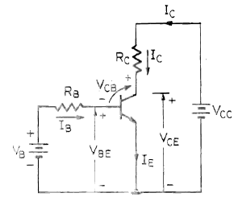
Fig. Q 3 (b)

QUESTION FOUR (20 MARKS)
a). Discuss the need for modulation in communication engineering. (4 marks)

b). Determine the total voltage gain of the 3656KG isolation amplifier in Fig Q 4 (a).
(4 marks)
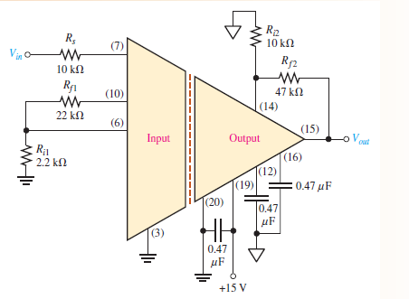
Fig Q 4 (a)

c). Design the capacitor required to build an LC oscillator that uses an inductance of L₁ = 1 mH to produce a sine wave of frequency 1 GHz. (4 marks)
Frequency of oscillations is given by;

d). An AM wave consists of the following components:
Carrier component = 5 V peak value
Lower sideband component = 2.5 V peak value
Upper sideband component = 2.5 V peak value
If the AM wave drives a 2 kΩ resistor, find the power delivered to the resistor by; (8 marks)
- carrier
- lower sideband component
- upper sideband component
- Determine the total power delivered

