

library@chuka.ac.ke; www.chuka.ac.ke

LOCAL COMMUNITY PERCEPTION OF THE BENEFITS AND COSTS OF CONSERVATION OF THE EASTERN MT. KENYA FOREST, KENYA

Njeru, J.M., Ngigi, W.M. and Soi, B.C.
¹Department of Wildlife Management, University of Eldoret, P. O. Box 1125-30100, Eldoret
²Department of Environmental Studies and Resources Development, P. O. Box 109-60400, Chuka
Email: jusmugendi@gmail.com
jnjeru@chuka.ac.ke, bsoi@chuka.ac.ke

Citation

Njeru, J. M., Ngigi, W. M. and Soi, B.C. (2014) Local community perception of the benefits and costs of conservation of the eastern Mt. Kenya forest, Kenya. In: Isutsa, D.K. and Githae, E.W. Proceedings of the Second Chuka University International Research Conference held in Chuka University, Chuka, Kenya from 28th to 30th October, 2015. 222-229pp.

ABSTRACT
Forests are crucial to a country’s health and development through soil and water conservation, wood and non-wood products production, carbon sequestration, biodiversity conservation and social benefits. Mount Kenya is a major water catchment area. Unfortunately, it is under serious pressure from local communities activities. It is necessary to seek active participation of the communities in the conservation of the forest. This study determined local community perception of the costs and benefits of conserving the Kiango’ndu forest East of Mt Kenya forest. Factors which influence communities’ attitudes towards forest conservation were investigated to enable forest and wildlife managers implement approaches that attract support of the communities. This was done using qualitative ethnographic questionnaires, interviews and observations. The target groups included the forest communities bordering Kiang’ondu forest and local level government forestry officials. Local community enjoys a diversity of economic, ecological, aesthetic and cultural benefits from the forest. However, they incur losses such as property and crop damage, loss of time spent chasing away wild animals, bodily injuries and fear of wild animals. Majority of the respondents feel frustrated but others were willing to participate in conserving the forest. Lack of effective communication between the local community and forest managers coupled with human-wildlife conflicts were major hindrances to participation in conservation. Initiatives should be set up to enlighten local residents and resolve the human-wildlife conflicts to create an environment conducive for community participation in conserving the forest.
Keywords: Forest, Benefits, Community, Participation, Conservation

INTRODUCTION
Protection of threatened critical ecosystems such as the Mt Kenya Forest Reserve is the vision of conservationists at local, national and global levels. Mount Kenya is a World Heritage Site as well as a Biosphere Reserve under the UNESCO’s Man and the Biosphere Programme (MAB). Like other forests, the forest is crucial to Kenya’s health and development, as it is important in soil and water conservation, production of wood and non-wood products, carbon sequestration, conservation of biodiversity and social benefits. In fact Mt Kenya Forest supports the largest and most ecologically diverse forests in the country (Bussmann, 1996), and has the highest priority for conservation (Emerton, 1999). Unfortunately, the forest reserve is under serious pressure from human activities such as illegal logging, cultivation, charcoal burning, overgrazing, encroachment, poaching, siltation, visitor impacts and increased human wildlife conflicts. These activities threaten the sustainability of the forest reserve.

Recent conservation initiatives have shown that success in conserving wildlife and their habitats depends on the attitude of local communities towards conservation, (Fredrick 2012; Okech, 2010; Esilaba et al, 2007; Moses, 2005). This concept in which the local communities act as partners in conserving natural resources is based on the bottom-up approach (Chambers, 1994). According to Chambers (1994), community participation is the key strategy to current biodiversity conservation and management whereby people are involved in deciding which direction and actions to take in managing natural resources in their areas. More recent models of community participation such as the People – Park Model (Oates, 1999; Stevens, 1997), and the Protected Areas Planning Framework (KWS, 2007) are aimed at ensuring that, communities (and other stakeholders) and their resources are more effectively mobilized, and empowered to participate in natural resource conservation by ensuring that their interests are taken care of. Based on these approaches a balance has to be struck between environmental protection and local community interests. Such a setup ensures harmonious co-existence between the communities and conservationist. In the light of this fact, it is imperative to understand factors which influence communities’ attitude towards wildlife so as to enable wildlife and forest managers implement approaches that attract support of the community and the general public.

Furthermore, it is important to recognise that within the traditional African setup, communities and wildlife coexisted in an environment where human activities and human-wildlife conflicts had minimal adverse effects to the survival of wildlife and their habitats . In Kenya, this situation began to change from 1898 when the colonial government enacted the first Wildlife Legislation that was used to control indiscriminate hunting (Chongwa, 2012). This was the beginning of the alienation of communities from managing a resource that they lived with. The ultimate result of this was a drastic change of the local communities’ attitude towards wildlife (Chongwa, 2012; Okech, 2010) mainly because they were evicted from their ancestral lands without any compensation and were denied access to resources that had been their inheritance for generations. One of the consequences of this is the seasonal and frequent human-wildlife conflicts around Kenya’s protected areas which mainly stem from the problem of resource utilization within and around the protected areas (Okech, 2010; Esilaba et al, 2007). Such conflicts do not solve this problem, however, but adversely affect the biodiversity for example through retaliatory killings of elephants.

The broad objective of this study was to find out the perceptions of the Kiang’ondu community on the costs and benefits of conservation of the Eastern Mt Kenya Forest reserve, so as to better understand mechanisms for integration of the local communities in conservation. The specific objectives were to: (i) determine the prevalence and causes of human-wildlife conflicts in Kiang’ondu, (ii) determine the benefits the community derives from the forest and (iii) to find mechanisms of community participation in forest and wildlife conservation. Such information is crucial in suggesting strategies and methodologies for achieving sustainable participatory conservation of eastern Mt Kenya forest reserve. This would be justifiable by enabling policy makers and managers better understand the conservation stand of the community, and adequately accommodate their aspirations during policy formulation process. Moreover, monitoring locals’ concerns related to conservation and wildlife resources can provide a foundation for effective decision making that mitigates wildlife impacts (Moses, 2005).

MATERIALS AND METHODS
Mt. Kenya is the second largest Mountain in Africa after Mt. Kilimanjaro of Tanzania. It is located at 00°10S and 37°20E, and lies between altitudes1600-5199m. Mt. Kenya is located on the eastern side of the Great Rift Valley and the northern slopes reach the equator. The study covered the lower slopes of the eastern part of Mount Kenya Forest Reserve (figure 1). The Kiang’ondu forest area has an approximate population of about 500 households living in villages that are contiguous to the forest buffer zone.

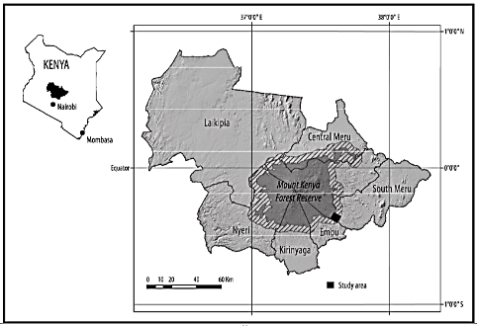

Figure 1: Map showing the location of the study area (box) in the Kiang’ondu sublocation. Kiang’ondu sublocation occurs within the 5km buffer zone that surrounds Mount Kenya Forest Reserve. (Source: Kaburi and Medley, 2011)

Sampling procedure
Community livelihoods in Kiango’ndu area are based on smallholder mixed crop and livestock production. Data was collected using a sample size of 116. Stratified sampling procedure was used to select the respondents who were issued with self- administered questionnaires.

Data analysis
Content analysis, which is, defined as any technique for making inferences by systematically and objectively identifying specified characters of messages was employed in analysing all the qualitative data collected. The IBM SPSS version 20 was used to analyse the data using descriptive statistics.

RESULTS
Prevalence of human wildlife conflicts
Of the 116 respondents, 72(62.93%) revealed that they were experiencing problems with wild animals in the Kiang’ondu forest. As shown in figure 2, 43(37.07%) of the respondents had no problem with wild animals. In relation to these findings, most of the respondents claimed that incidences of human-wildlife conflicts in the area occurred throughout the year. Most of the incidences revolved around farm setups.

Figure 2: Proportion of respondents who had experienced conflict with wildlife

The informants revealed four main types of problems they experienced from wild animals in Kiang’ondu forest. 62(53.33%) of the respondents identified crop raiding as the most common type of problem. As shown in figure 3, killing of domestic animals, fence damage and even fear were other problems caused by the wildlife. Apparently, 43(37.07%) of the respondents had no problem with the wildlife in Kiang’ondu forest.

Figure 3: Types of conflicts experienced by respondents

Animal species causing conflicts
Most of the respondents (32.76%) claimed that elephants were the major causes of human-wildlife conflicts in Kiang’ondu area. Monkeys, especially the vervet monkeys were also a major cause of conflict with 25% of the respondents supporting this view. As depicted by figure 4 unidentified carnivores (9.48%) which were most probably leopards, black and white colobus monkeys (7.76%) and rodents especially squirrels (2.59%) were also causing human wildlife conflicts in the area.

Figure 4: Main species of wildlife responsible for conflicts with the local community
Methods used to resolve conflicts
The majority of the respondents (43.97%) said that dealt with problem wild animals by scaring them away. This was mainly accomplished by making noises, shouting and drumming, throwing stones and sticks at the animals, lightning fires and using dogs as alarms. As indicated in figure 5, 36 (31.03) reported to the forest rangers in addition to scaring the animals away. Apparently, 12(14.66%) revealed that they resolved conflicts with the wild animals by killing them.
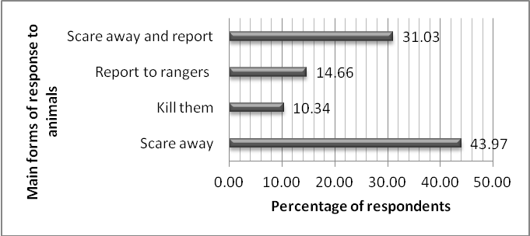
Figure 5: Main ways of responding to the problem wild animals used by the community

Benefits from forest conservation
Apparently, the most of the respondents 40.52% said that they enjoyed economic benefits from Mt Kenya conservation ventures. These benefits were in the form of employment and support through the community based organizations such as Rafiki Women Group. They also benefited by collecting firewood, fodder and tapped water from the forest. 37.07% of the informants said that they appreciated the ecological benefits such as climate moderation and conservation of water catchment area. Other benefits that the respondents enjoyed included socio-cultural, recreational, medicinal and aesthetic benefits as shown in table 1.

Table 1: Benefits received by the community from conservation of Mt Kenya forest
Form of benefits | Frequency | Percentage
Economic benefit | 47 | 40.52
Ecological | 43 | 37.07
Cultural | 11 | 9.48
Recreational | 7 | 6.03
Medicinal benefits | 5 | 4.31
Aesthetic value | 3 | 2.59
Total | 116 | 100.00

Participation in forest conservation
As indicated in figure 6 below 79(68.10%) of the respondents had ever participated in the conservation of Mt Kenya forest.
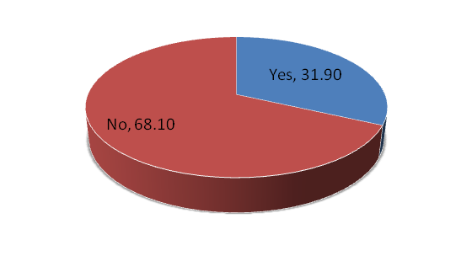
Figure 6: Respondents’ participation in the conservation of the Mt Kenya forest

Types of forest conservation activities
Tree planting was main type of forest conservation that the respondents were involved in. As shown in figure 7, 38(32.76%) of the respondents were planting trees though in their farms. Indeed it was established that some respondents had tree nurseries from which they were getting seedlings for planting in their farms as well for selling. It was also established that 16(13.79%) of the respondents were vigilant to ensure that wild animals did not cause conflicts with the local community and also collaborated with the security agents such the forest rangers to see that locals were not carrying out illegal activities in the forest. In addition other respondents cited that they have been involved in fire-fighting (11.21%), chasing away wild animals (12.07%) and creating public awareness about forest and wildlife conservation (10.34%). The remaining 23(19.83%) could not identify any forest conservation activity they had ever been involved in.

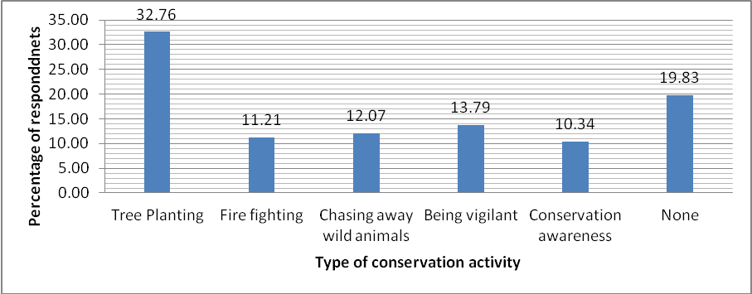
Figure 7: Types of forest conservation activities community had participated in.

Challenges facing forest conservation activities
It was found out that the community faced a number of challenges in participating in the conservation of Mt Kenya forest. Most of them, (comprising 26.72%) felt that financial constraint was the major problem that they were facing. In addition, 15.52% claimed that they did not have enough time to participate in forest conservation activities and 12.07% said that they lacked motivation to participate in the activities. As shown in figure 8, others cited lack of forest/wildlife conservation knowledge, (11.21%), lack of technical skills (7.76%) and lack of any community based organization (CBO) in the areas (6.90%) whereas 19.83% had no reason for not participating in any conservation activity.

DISCUSSION
Prevalence of Human Wildlife Conflicts
Our ﬁnding that the local community living adjacent to the Eastern Mt Kenya forest was experiencing conflicts with wildlife concurs with previous research on the topic. For example Bett (2005), conducted a socio-ecological survey on the role of community in the conservation of the Mt Kenya Biosphere Reserve and found out that human wildlife conflict was a major problem facing communities around the forest reserve. It can also be rightly argued that this scenario is not unique to the Mt Kenya conservation area, but instead, it represents one of the greatest threats facing forests and wildlife conservation in Kenya (Fredrick 2012; Okech, 2010; Esilaba, Maara, and Tangus, 2007; Moses, 2005), with negative consequences for both humans and wildlife. The origin of human-wildlife conflict can be attributed to the establishment of parks and reserves as wildlife protected areas, with communities settling next to them (Ngene and Omondi 2009).

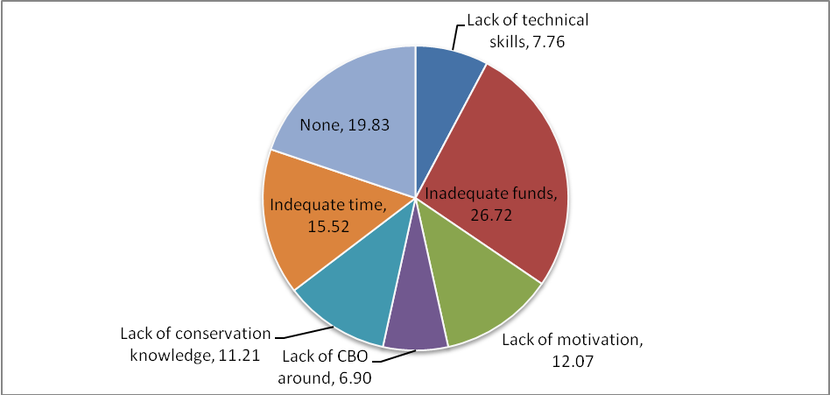
Figure 8: Challenges facing community participation in forest conservation

Based on the findings from this study, most of the conflicts stem from crop raiding by elephants. Elephants are known to cause severe damage to crops within the affected areas. They can destroy entire fields of crops (Naughton-Treves,1998). A study by Ngene and Omondi (2009) on the costs of living with elephants in areas adjacent to Marsabit National Park and Reserve showed that farmers were losing crops running into millions of dollars. Though not ascertained by the current study, it can be hypothesized that crop raiding has severe socio-economic cost to the Kiang’ondu community. It is important to note that although crop raiding is perhaps the most common form of human-elephant conflict (Sitati et al. 2003), elephants can also be quite damaging to local economies through destruction of food stores, water installations, fences, or barriers and occasionally have been known to injure or kill people (Kangwana, 1995). In addition, vervet and colobus monkeys were also reported to be causing conflicts with the community. This finding was in consent with Bett (2005) who observed that a number of primate species including baboons were a major cause of human-wildlife conflicts around the Mt Kenya Biosphere Reserve. Though the species of carnivores reported to have killed livestock in the area could not be ascertained, leopards are the top predators that roam the eastern parts of the Mt Kenya Forest Reserve and in addition to mongoose, are likely to be responsible for the losses.

Our findings mesh with other studies that look at the challenge of human-wildlife conflicts in Kenya (for example Moses, 2005; Esilaba, Maara, and Tangus, 2007; Ngene and Omondi 2009; Okech, 2010; Colonna, 2011; Fredrick 2012). The bottom line in the discussions is that with reduction of natural habitats steadily on the rise and agricultural activities close to the wildlife areas on the increase, it is obvious that wildlife is forced to encounter humans with increasing frequency. Besides, as Kaswamila et al., (2007) laments, wild animals raid crops or kill livestock simply to survive which unfortunately leads to conflicts between local communities and wildlife conservationists.

Findings of this study also show that the community responds to the animals mostly by scaring them away by shouting and drumming, throwing stones and sticks at the animals, lightning fires and using dogs as alarms. They also reported the cases to the reserve officials but a few cases of retaliatory killings were also revealed by the informants. These findings concur with observations by Bett (2005). Fences such as the electric fence can be very effective for deterring wildlife from crops and livestock. The ongoing project byRhino Ark, Kenya Wildlife Services and Kenya Forest Services to encircle the whole of Mount Kenya forest reserve with an electric fence is meant to realize benefits for the wildlife and the local communities (Madeleine, 2015). However, such a fence has high installation and maintenance cost, is ineffective for keeping out small animals that can go under the wires or dig under the fence, and it may cause negative ecological impacts such as habitat fragmentation or blocking traditional wildlife migratory routes (Hayward and Kerley, 2009). A combination of deterrents for crop raiding such as the use of bees to scare aware elephants (King, et al, 2011) as well as compensation for wildlife damages may help solve some of the human-wildlife conflicts in Kiang’ondu area.

Benefits from Forest Conservation
Our informants showed a great appreciation of benefits that accrue from conservation of Mt Kenya forest reserve with economic benefits being the most recognized conservation benefit. It was noted that the Mt Kenya forest reserve and people’s farmlands are integrated places and numerous benefits are expected to accrue from individuals in the area. Such benefits include increased access to forest products such as fuel wood, herbal medicine, honey, tree seedlings and fodder. They also recognized the forest reserve provides them with ecological benefits such as climate moderation and conservation of the water catchment area. Other benefits that the community enjoyed included socio-cultural, recreational, medicinal and aesthetic benefits. This appreciation could give the community the impetus to participate in conservation of the Mt Kenya forests against the frustrations they get after incurring losses they incur from the human-wildlife conflicts.

Community Participation in Forest Conservation
Results revealed that the greatest majority of the respondents in this study had participated in forest conservation activities. In Kenya, participation in forest conservation is open to all households (RoK, 2014; RoK, 2005). However, the community sampled was heterogeneous in terms of levels of gender, age, education, occupation, social status and according to Agrawal and Gupta (2005) such attributes could make some people not participate in forest conservation even when they were willing to. Most of the respondents had participated in activities such as tree planting, fire-fighting, creating conservation awareness and forest protection. This trend needs to be encouraged by initiating and strengthening of community forestry associations, and introduction of sound benefit-sharing arrangements. It is also important to note that challenges such as financial constraints, lack of time, motivation, technical, forest/wildlife conservation knowledge and lack of community based organization (CBO) in the area need to be addressed in order to deepen community participation in conserving Mt Kenya Forest Reserve. Similar concerns had been raised earlier by Bett (2005).

CONCLUSIONS
Our study showed that the community faces various types of human-wildlife conflicts. Crop raiding was the most significant type of conflict and was mainly associated with elephants and monkeys. The community was however not compensated for the losses which could be precipitating negative attitude towards wildlife/forest conservation in the area. This substantiates the need to address the causes of the conflicts in addition to enlightening the community on how aggrieved members can seek compensation for the losses or damages incurred. In addition, the community appreciates a wide variety of benefits that accrue from conserving the eastern Mt Kenya Forest Reserve especially economic and ecological benefits. Appreciation was a great driving force for the willingness of the community to participate in conserving the forest and its wildlife despite the many constraints and challenges they enumerated.

REFERENCES
Agrawal, A. and Gupta, K. 2005. Decentralization and participation: the governance of common pool re-sources in Nepal’s Terai. World Development 33: 7, 1101–1114.
Bett, A. 2005. Role of community in the conservation of Mt. Kenya biosphere reserve. KWS
Bussmann, R. 1996. Destruction and management of Mount Kenya’s forests. Ambio 25:315–317.
Chambers, R. 1994. The Origins and Practice of Participatory Rural Appraisal. World Development, 22(7):953-969.
Chongwa, N.B. 2012. The History and Evolution of National Parks in Kenya. The George Wright Forum 29 (1):39–42.
Colonna, C.B. 2011. Human-Wildlife Conflict on Small, Subsistence Farms in Kenya.
Emerton, L. 1999. Mt Kenya Forest: Economics of Community conservation. Evaluating Eden Discussion Paper No. 4.
Esilaba, M., Maara, N. and Tangus, J. 2007. Impact of human-wildlife conflict resolution on wildlife conservation and socioeconomic welfare of pastoral communities: A case study of Samburu pastoralists, Samburu District, Kenya. E. Africa Social Science Research Review, 23(2):41-54.
Fredrick, O. 2012. Options to stem human-wildlife conflicts. Swara July -September 2012 8-9. https://eawildlife.org/swaraonline/swaras/Owino2012_03_01.pdf
Hayward, M.W. and Kerley, G.I. 2009. Fencing for conservation: Restriction of evolutionary potential or a riposte to threatening processes? Biological Conservation, 142(1):1-13.
Kaburi, S.M. and Medley, K.E. 2011. Community Perspectives on Fuelwood Resources in East Africa: Enrichment and Extraction along the Eastern Slopes of Mount Kenya. Mountain Research and Development, 31(4), 315-324.
Kangwana, K. F. 1995. Human-elephant conflict: the challenge ahead. Pachyderm. 19:11-14.
Kaswamila, A., Russell S. and McGibbon, M. 2007. Impacts of wildlife on household food security and income in northeastern Tanzania. Human Dimensions of Wildlife. 12:391-404.
King, L.E., Douglas‐Hamilton, I. and Vollrath, F. 2011. Beehive fences as effective deterrents for crop‐raiding elephants: field trials in northern Kenya. African Journal of Ecology, 49(4):431-439.
KWS. 2007. Protected Areas Planning Framework: The Planning Manual. 2nd Edition, Nairobi, Kenya.
Okello, M.M. 2005. Land Use Changes and Human–Wildlife Conflicts in the Amboseli Area, Kenya. Human Dimensions of Wildlife, 10:1:19-28
Ngene, S.M. and Omondi, P.O. 2009. The costs of living with elephants in the areas adjacent to Marsabit National Park and Reserve. Pachyderm, (45):77-87.
Nyongesa-Kassilly, F., Tsingalia, H.M. and Gossow, H. 2008. Mitigating human-wildlife conflicts through wildlife fencing: A Kenyan case study. Wildlife Biology in Practice, 4(1):30-38.
Oates, J.F. 1999. Myth and Reality in the Rain Forest. How Conservation Strategies Are Failing In West Africa. Berkeley, CA, USA: university of California press.
Okech, R.N. 2010. Wildlife-community conflicts in conservation areas in Kenya. African Journal on Conflict Resolution, 10(2):65-80
RoK. 2014. Forest Policy. Ministry of Environment, Water and Natural Resources. http://www. kenyaforestservice.org/documents/Forest%20Policy,%202014%20(Revised%2020-2-2014).pdf
RoK. 2005. The Forest Act, Kenya Gazette Supplement, No. 7 of 2005. Nairobi, Kenya.
Sitati, N.W., Walpole, M.J. and Leader-Williams, N. 2005. Factors affecting susceptibility of farms to crop raiding by African elephants: using a predictive model to mitigate conflict. Journal of Applied Ecology. 42:1175-1182.
Stevens, S. 1997. The Legacy of Yellowstone. Conservation through Cultural Survival: Indigenous People and Protected Areas. Island press. Washington DC, USA.

