CHUKA UNIVERSITY

UNIVERSITY EXAMINATIONS

EXAMINATION FOR THE AWARD OF DEGREE OF BACHELOR OF SCIENCE IN HUMAN NUTRITION AND DIETETICS & BACHELOR OF SCIENCE IN HEALTH RECORDS AND INFORMATION MANAGEMENT

HNDS 213/ PUHE 344: BIOSTATISTICS/MEDICAL STATISTICS
STREAMS: B.Sc. (HUMAN NUTRITION & HEALTH RECORDS) - TIME: 2 HOURS DAY/DATE: …………………………… ………………………..

INSTRUCTIONS:
- Answer ALL questions
- Do not write anything on the question paper
- No use of mobile phones or any other unauthorized materials
- Write your answers legibly and use your time wisely
- Show all your working

SECTION A: MULTIPLE CHOICE QUESTIONS [ONE MARK EACH] [20 MARKS]

- What is the geometric mean of: 1, 2, 8, and 16?
  - 4
  - 5
  - 6
  - 7
- Which statistical test is used to compare group means in a sample?
  - Correlation
  - ANOVA
  - Regression
  - Correlation
- If a distribution is skewed to the left, then it is __________.
  - Negatively skewed
  - Positively skewed
  - Symmetrically skewed
  - Symmetrical
- Given the values in a series, the geometric mean is
  - The third root of the product of values
  - The square root of the product of values
  - The fourth root of the product of values
  - The Nth root of the product of values
- Which of the following measures of central tendency can have more than one value in a single sample?
  - Mean
  - Median
  - Mode
  - None of the above
- The upper and lower boundaries of interval confidence are classified as:
  - Error based limits
  - Marginal limits
  - Estimate limits
  - Confidence limits
- To which of the following options do individual respondents, focus groups, and panels of respondents belong?
  - Primary data sources
  - Secondary data sources
  - Itemised data sources
  - Pointed data sources
- Normal Distribution is symmetric about its___________
- Mean
- Variance
- Standard deviation
- Covariance
- Which of the following is NOT a measure of variability?
  - Median
  - Variance
  - Standard deviation
  - Range
- The measurement scale which allows the ranking of numbers rather than arithmetic operations on data is classified as?
  - Valid scale
  - Discrete scale
  - Ordinal scale
  - Continuous scale
- If two populations are different on their population means and the inferential statistical test leads you to conclude that the populations are equivalent, you have
  - Made a Type I error.
  - Made a Type II error.
  - Drawn a correct inference.
  - Inflated your alpha.
- If the null hypothesis is rejected when it should have been accepted, what type of error have we made?
  - Type II error
  - Type III error
  - Type I error
  - We have not made an error
- Given classes 1-5, 6-10,….. class interval size is:
  - 3
  - 4
  - 5
  - 5.5
- The denominator (bottom) of the z-score formula is
  - The standard deviation
  - The difference between a score and the mean
  - The range
  - The mean
- The ---------------- sum of squares measures the variability of the observed values around their respective treatment.
- Treatment
- Error
- Total
- Interaction
- In a study, subjects are randomly assigned to one of three groups: control, experimental A, or experimental B. After treatment, the mean scores for the three groups are compared. The appropriate statistical test for comparing these means is:
  - The Analysis Of Variance
  - The Correlation Coefficient
  - Chi Square
  - The T-Test
- For the chi-square test to be effective, the expected value for each cell in the contingency table has to be at least
  - 3
  - 5
  - 10
  - 20
- In quartiles, central tendency median to be measured must lie in?
- First quartile
- Second quartile
- Third quartile
- Fourth quartile
- The following are percentages of fat found in 5 samples of each of two brands of baby food:
- 5.7, 4.5, 6.2, 6.3, 7.3
- 6.3, 5.7, 5.9, 6.4, 5.1
Which of the following procedures is appropriate to test the hypothesis of equal average fat content in the two types of food?
  - Paired t-test with 5 d.f
  - Two samples t-test with 8 d.f
  - Paired t-test with 4 d.f
  - Two samples t-test with 9 d.f
- Which of these distributions is used for a testing hypothesis?
  - Normal Distribution
  - Chi-Squared Distribution
  - Gamma Distribution
  - Poisson Distribution

SECTION B: [20 MARKS]
- Explain the following concepts as used in biostatistics [6 marks]
- Gaussian curve
- Hypothesis
- Inferential statistics

- The mean fasting blood glucose of a country was found to be 90mg//dl. Research was done among 12 patients from one randomly selected county within the country. The results revealed a mean fasting blood glucose of 102 mg/dl with a standard deviation of 4.8. Determine if there was a significant difference between the mean for the country and the mean for the research county. Use α = 0.1. [4 marks]

- State four (4) assumptions that underlie the utilization of the Chi-square Test. [4 marks]

- The analysis of variance to test for significance difference in the efficacy of some treatment programs produced an ANOVA table entry as shown below;
Source | df | SS | MS | F
Treatments | 3 | 73.9
Residue | 20 |  | 1.84
Total
(i) Complete the ANOVA table [2 marks]
(ii) Determine if the data provide sufficient evidence to indicate that there are statistically significant differences in the effectiveness of the treatment programs [4 marks]

SECTION C: [30 MARKS]

- Two independent random samples were taken from two different populations. The results of the samples were summarized as follows
Sample 1 Sample 2
n₁= 20 n₂=16
$\underline{X}$₁=10.8 $\underline{X}$₂= 7.6
S₁= 1.2 S₂= 2.1
Determine if the difference between the means is significant at 95% and confidence level? [12 marks]
- Explain four (4) methods of data collection that can be used in population health research. [4 marks]

- A 24- hour recall was used to analyze the amount of nutrient consumed by 10 Chuka
university students. The data was analyzed using nutri-survey and the results shown
KCAL | BMI
2450 | 23.4
1920 | 22.7
2330 | 23.6
2050 | 19.4
2400 | 24.7
2110 | 22.5
2270 | 20.0
1880 | 21.6
2464 | 24.3
2600 | 26.8
- Calculate the product-moment correlation coefficient (r) [8 marks]
- Describe the direction and magnitude of the relationship [2 marks]
- Find the equation of the regression line and use it to estimate the BMI of a student who consumes 2500 kcal. [4 marks]
---------------------------------------------------------------------------------------------------------------------

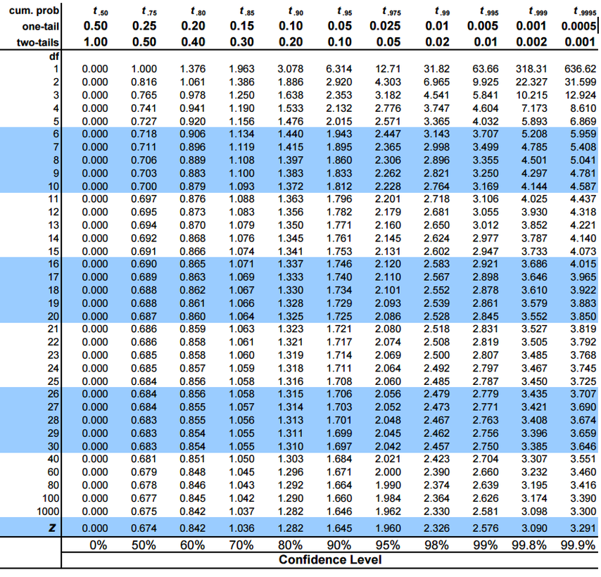
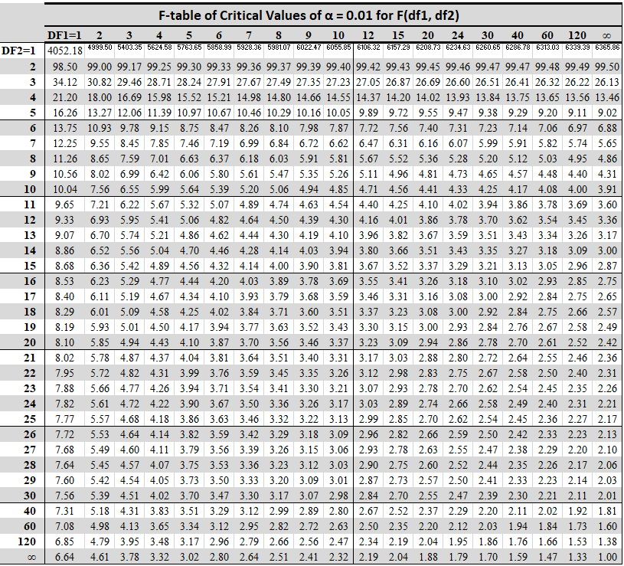

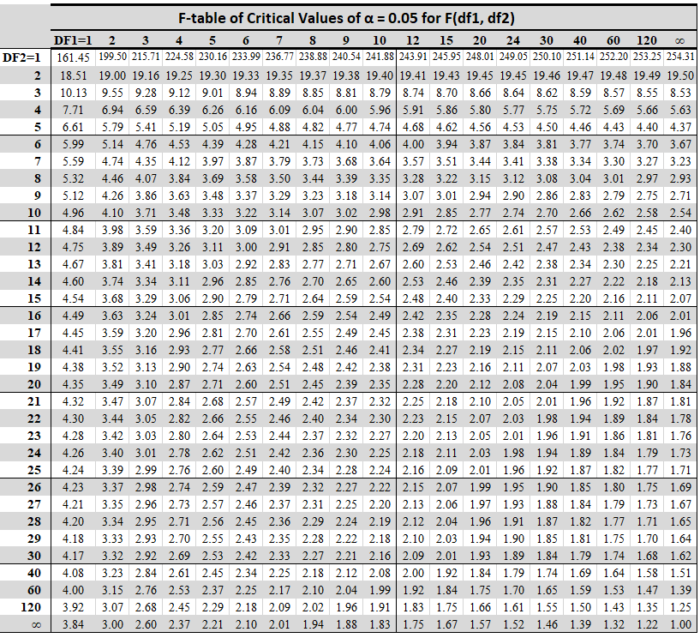

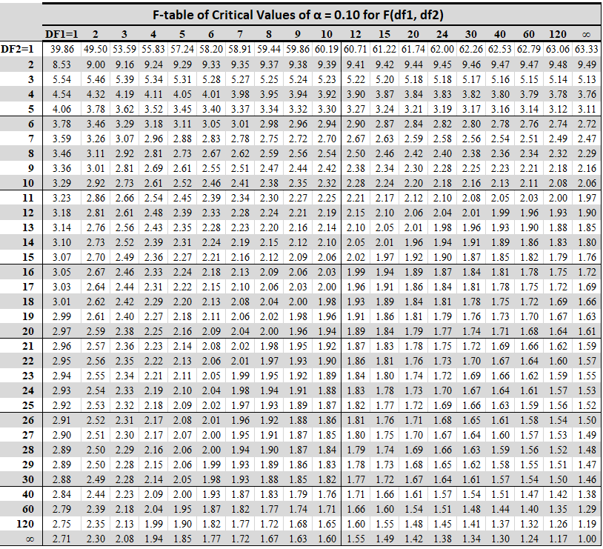

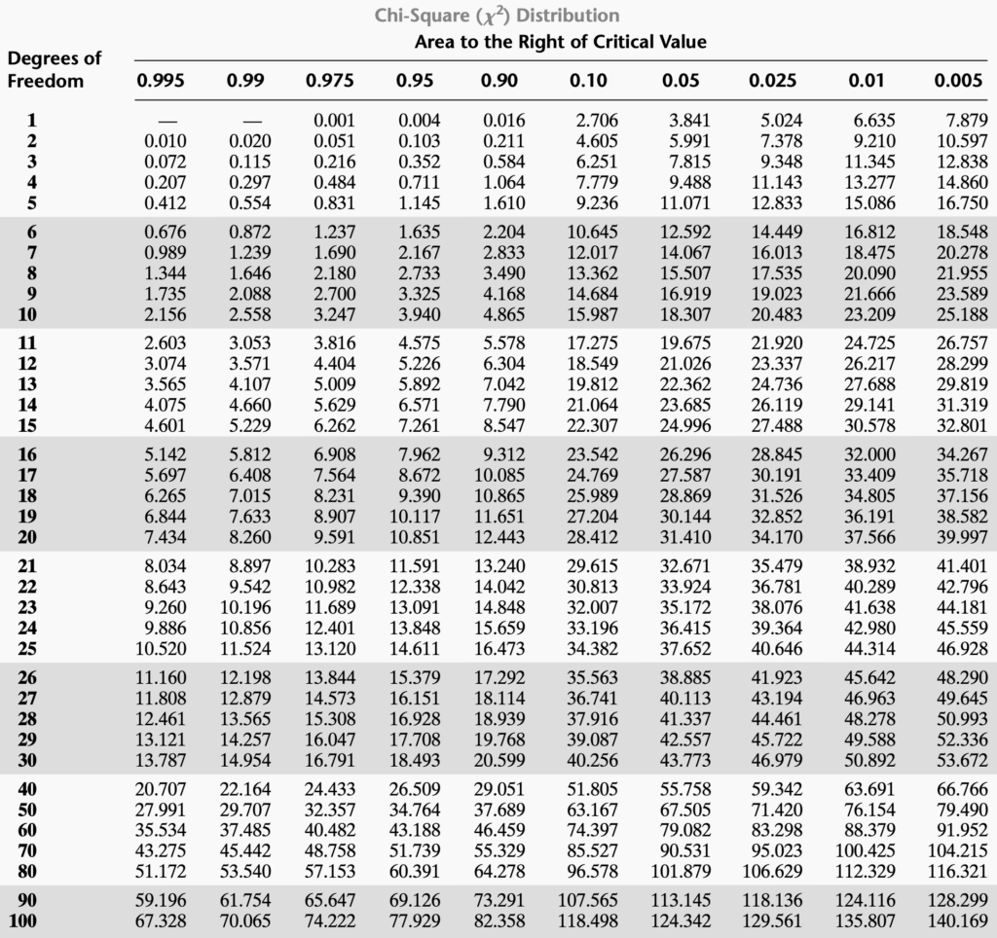

Critical Values of Expanded Dixon Outlier Test (Q -Test)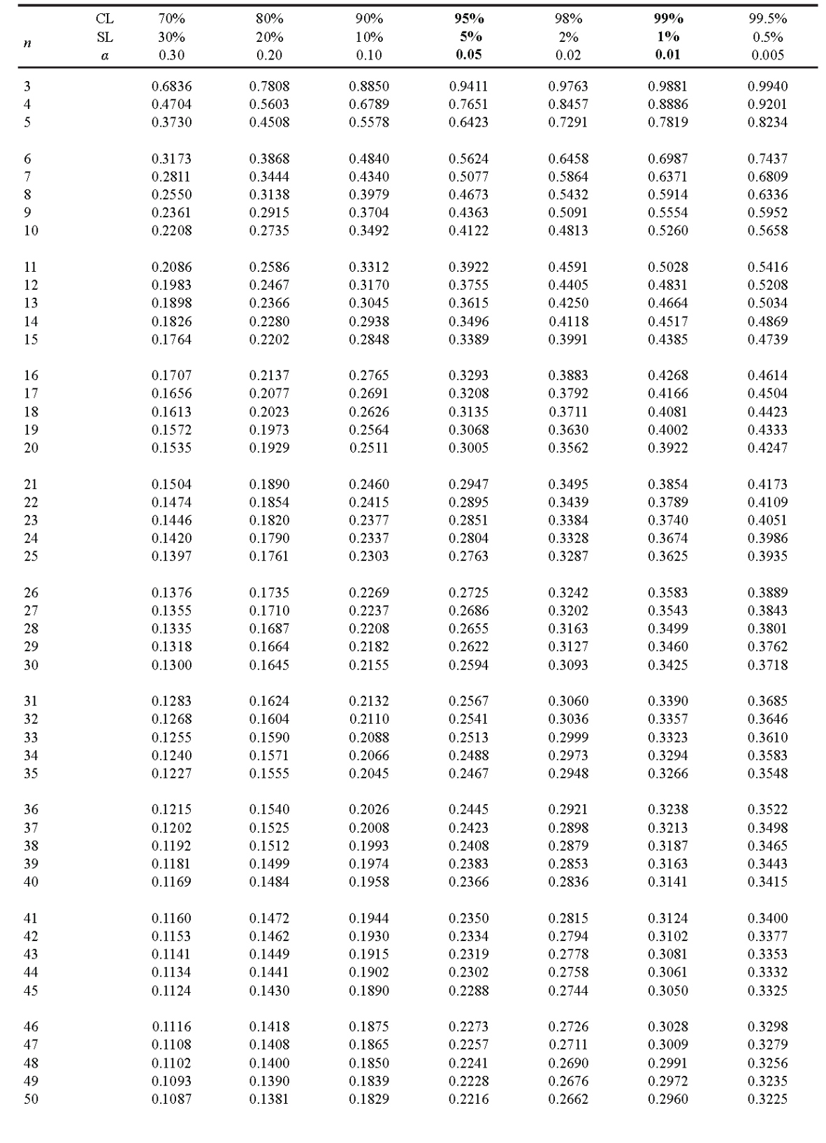

Standard Normal Distribution Tables

z | 0.00 | 0.01 | 0.02 | 0.03 | 0.04 | 0.05 | 0.06 | 0.07 | 0.08 | 0.09
0.0 | 0.0000 | 0.0040 | 0.0080 | 0.0120 | 0.0160 | 0.0199 | 0.0239 | 0.0279 | 0.0319 | 0.0359
0.1 | 0.0398 | 0.0438 | 0.0478 | 0.0517 | 0.0557 | 0.0596 | 0.0636 | 0.0675 | 0.0714 | 0.0753
0.2 | 0.0793 | 0.0832 | 0.0871 | 0.0910 | 0.0948 | 0.0987 | 0.1026 | 0.1064 | 0.1103 | 0.1141
0.3 | 0.1179 | 0.1217 | 0.1255 | 0.1293 | 0.1331 | 0.1368 | 0.1406 | 0.1443 | 0.1480 | 0.1517
0.4 | 0.1554 | 0.1591 | 0.1628 | 0.1664 | 0.1700 | 0.1736 | 0.1772 | 0.1808 | 0.1844 | 0.1879
0.5 | 0.1915 | 0.1950 | 0.1985 | 0.2019 | 0.2054 | 0.2088 | 0.2123 | 0.2157 | 0.2190 | 0.2224
0.6 | 0.2257 | 0.2291 | 0.2324 | 0.2357 | 0.2389 | 0.2422 | 0.2454 | 0.2486 | 0.2517 | 0.2549
0.7 | 0.2580 | 0.2611 | 0.2642 | 0.2673 | 0.2704 | 0.2734 | 0.2764 | 0.2794 | 0.2823 | 0.2852
0.8 | 0.2881 | 0.2910 | 0.2939 | 0.2967 | 0.2995 | 0.3023 | 0.3051 | 0.3078 | 0.3106 | 0.3133
0.9 | 0.3159 | 0.3186 | 0.3212 | 0.3238 | 0.3264 | 0.3289 | 0.3315 | 0.3340 | 0.3365 | 0.3389
1.0 | 0.3413 | 0.3438 | 0.3461 | 0.3485 | 0.3508 | 0.3531 | 0.3554 | 0.3577 | 0.3599 | 0.3621
1.1 | 0.3643 | 0.3665 | 0.3686 | 0.3708 | 0.3729 | 0.3749 | 0.3770 | 0.3790 | 0.3810 | 0.3830
1.2 | 0.3849 | 0.3869 | 0.3888 | 0.3907 | 0.3925 | 0.3944 | 0.3962 | 0.3980 | 0.3997 | 0.4015
1.3 | 0.4032 | 0.4049 | 0.4066 | 0.4082 | 0.4099 | 0.4115 | 0.4131 | 0.4147 | 0.4162 | 0.4177
1.4 | 0.4192 | 0.4207 | 0.4222 | 0.4236 | 0.4251 | 0.4265 | 0.4279 | 0.4292 | 0.4306 | 0.4319
1.5 | 0.4332 | 0.4345 | 0.4357 | 0.4370 | 0.4382 | 0.4394 | 0.4406 | 0.4418 | 0.4429 | 0.4441
1.6 | 0.4452 | 0.4463 | 0.4474 | 0.4484 | 0.4495 | 0.4505 | 0.4515 | 0.4525 | 0.4535 | 0.4545
1.7 | 0.4554 | 0.4564 | 0.4573 | 0.4582 | 0.4591 | 0.4599 | 0.4608 | 0.4616 | 0.4625 | 0.4633
1.8 | 0.4641 | 0.4649 | 0.4656 | 0.4664 | 0.4671 | 0.4678 | 0.4686 | 0.4693 | 0.4699 | 0.4706
1.9 | 0.4713 | 0.4719 | 0.4726 | 0.4732 | 0.4738 | 0.4744 | 0.4750 | 0.4756 | 0.4761 | 0.4767
2.0 | 0.4772 | 0.4778 | 0.4783 | 0.4788 | 0.4793 | 0.4798 | 0.4803 | 0.4808 | 0.4812 | 0.4817
2.1 | 0.4821 | 0.4826 | 0.4830 | 0.4834 | 0.4838 | 0.4842 | 0.4846 | 0.4850 | 0.4854 | 0.4857
2.2 | 0.4861 | 0.4864 | 0.4868 | 0.4871 | 0.4875 | 0.4878 | 0.4881 | 0.4884 | 0.4887 | 0.4890
2.3 | 0.4893 | 0.4896 | 0.4898 | 0.4901 | 0.4904 | 0.4906 | 0.4909 | 0.4911 | 0.4913 | 0.4916
2.4 | 0.4918 | 0.4920 | 0.4922 | 0.4925 | 0.4927 | 0.4929 | 0.4931 | 0.4932 | 0.4934 | 0.4936
2.5 | 0.4938 | 0.4940 | 0.4941 | 0.4943 | 0.4945 | 0.4946 | 0.4948 | 0.4949 | 0.4951 | 0.4952
2.6 | 0.4953 | 0.4955 | 0.4956 | 0.4957 | 0.4959 | 0.4960 | 0.4961 | 0.4962 | 0.4963 | 0.4964
2.7 | 0.4965 | 0.4966 | 0.4967 | 0.4968 | 0.4969 | 0.4970 | 0.4971 | 0.4972 | 0.4973 | 0.4974
2.8 | 0.4974 | 0.4975 | 0.4976 | 0.4977 | 0.4977 | 0.4978 | 0.4979 | 0.4979 | 0.4980 | 0.4981
2.9 | 0.4981 | 0.4982 | 0.4982 | 0.4983 | 0.4984 | 0.4984 | 0.4985 | 0.4985 | 0.4986 | 0.4986
3.0 | 0.4987 | 0.4987 | 0.4987 | 0.4988 | 0.4988 | 0.4989 | 0.4989 | 0.4989 | 0.4990 | 0.4990
3.1 | 0.4990 | 0.4991 | 0.4991 | 0.4991 | 0.4992 | 0.4992 | 0.4992 | 0.4992 | 0.4993 | 0.4993
3.2 | 0.4993 | 0.4993 | 0.4994 | 0.4994 | 0.4994 | 0.4994 | 0.4994 | 0.4995 | 0.4995 | 0.4995
3.3 | 0.4995 | 0.4995 | 0.4995 | 0.4996 | 0.4996 | 0.4996 | 0.4996 | 0.4996 | 0.4996 | 0.4997
3.4 | 0.4997 | 0.4997 | 0.4997 | 0.4997 | 0.4997 | 0.4997 | 0.4997 | 0.4997 | 0.4997 | 0.4998
3.5 | 0.4998 | 0.4998 | 0.4998 | 0.4998 | 0.4998 | 0.4998 | 0.4998 | 0.4998 | 0.4998 | 0.4998
3.6 | 0.4998 | 0.4998 | 0.4999 | 0.4999 | 0.4999 | 0.4999 | 0.4999 | 0.4999 | 0.4999 | 0.4999
3.7 | 0.4999 | 0.4999 | 0.4999 | 0.4999 | 0.4999 | 0.4999 | 0.4999 | 0.4999 | 0.4999 | 0.4999
3.8 | 0.4999 | 0.4999 | 0.4999 | 0.4999 | 0.4999 | 0.4999 | 0.4999 | 0.4999 | 0.4999 | 0.4999

