CHUKA UNIVERSITY

UNIVERSITY EXAMINATIONS

EXAMINATION FOR THE AWARD OF DIPLOMA IN HUMAN NUTRITION AND DIETETICS

HNDS 0292: INTRODUCTION TO BIOSTATISTICS
STREAMS: B.SC(HNDS) Y2S2 TIME: 2 HOURS
DAY/DATE: MONDAY 08/04/2024 8.30 A.M. – 10.30 A.M.

INSTRUCTIONS:
•ANSWER ALL QUESTIONS

SECTION A: MULTIPLE CHOICE QUESTIONS [ONE MARK EACH] [20 MARKS]
- The purpose of descriptive statistics is to
  - Determine if the sample data accurately describe the population.
  - Simplify and organize large sets of data.
  - Help us decide whether population means are equal.
  - All of the above

- Which of the following is a measure of central tendency?
  - Standard deviation
  - Variance
  - Median
  - Range

- What does the standard deviation measure in a dataset?
  - The spread or dispersion of data points around the mean
  - The central value of the dataset
  - The total range of the dataset
  - The frequency of each data point in the dataset

- Which of the measures given here are based on every item of the series (uses all observations)?
  - Standard Deviation
  - Quartile Deviation
  - Range
  - All of the above

- Which of the following types of variables have a true zero point
  - Nominal
  - Ordinal
  - Interval
  - Ratio

- What is a variable?
  - A characteristic or attribute that can take on different values
  - A constant value that does not change
  - The process of collecting data
  - A measure of central tendency

- Data collected by the investigator personally from the informants are called -------------- data?
- Primary
- Secondary
- Group
- Official

- The number of degrees of freedom (df) is the:
- Number of factors in the experiment.
- Number of participants who had contributed non-outlier data when computing a statistic.
- Number of values that are free to vary when computing a statistic.
- Number of data points that were free from systematic error when computing a statistic.

- Which of the following are assumptions underlying the use of parametric tests (based on the normal distribution)?
  - Some features of the data should be normally distributed.
  - The samples being tested should have approximately equal variances.
  - The data should be at least interval level
  - All of the options are true

- If Pearson’s correlation coefficient between stress level and workload is 0.8, how much variance in stress level is not accounted for by workload?
  - 20%
  - 2%
  - 8%
  - 36%

- What does the term 'outlier' mean?
  - A score that is left out of the analysis because of missing data
  - The arithmetic mean
  - A type of variable that cannot be quantified
  - An extreme value at either end of a distribution

- A t-test is a significance test that assesses
  - The means of two independent groups
  - The medians of two dependent groups
  - The modes of two independent variables
  - The standard deviation of three independent variables

- Variables with values that cannot be expressed numerically are referred to as
  - Quantitative variables
  - Qualitative variables
  - Absolute variables
  - Continuous variables

- Average birth weight of children in the last 8 months is an example of a:
  - Discrete variable
  - Continuous variable
  - Qualitative variable
  - Independent variable

- The stages of a malignant disease (cancer) is recorded using the symbols 0, I, II, III, IV. We say that the scale used is:
  - Alphanumeric
  - Ordinal
  - Numerical
  - Nominal

For questions 16-20 indicate if the statement provided is True or False
- Cross-tabulation is a useful way to describe the relationship between two nominal variables.
  - True
  - False

- The mean is the score at the 50th percentile.
  - True
  - False

- The variance, unlike the range, uses all the scores in its computation.
  - True
  - False

- If we are using a t-test and we reject the null hypothesis, we can be sure that the population means are different.
  - True
  - False

- A sample is a subset of the people or objects in a population.
  - True
  - False

SECTION B: [30MARKS]
- Explain thefollowing statistical concepts [4marks]
- Variance
- Hypothesis

- Outline four (4) characteristics of statistical data [4 marks]

- Discuss the meaning of the following results derived from data analysis to establish the relationship between the amount of kilocalories consumed and the weight gain among pregnant mothers.
a) r = 0.82; p value=0.026 [3 marks]
b) r² = 0.61 [2 marks]

- The population mean for hb levels is 12.8 g/dl. An experiment was conducted for 10 subjects and the results are shown below
Mean = 11.6 g/dl
Standard deviation = 0.08
Determine if there is a significant difference between the population means and the experimental mean at a 99 % confidence level [4 marks]

- Plot a stem leaf of the following data set and determine if the largest value is an outlier; 34, 58, 25, 59, 37, 67, 49, 42, 36, 71, 39, 53, 46, 59, 62, 21, 68, 74, 45, 42, 64, 20, 35, 65, 36, 63, 58, 29, 43, 58, 42, 64, 20. [8 marks]

- State whether each of the following observations is discrete or continuous data [5 marks]
- Number of suicides in Nairobi County in 2018.
- Blood sugar level in pre-surgical patients.
- Length of time an AIDS patient survives after diagnosis.
- Number of miscarriages an expectant mother has had.
- Dose of chlorine in a sample of water.

SECTION C: [20 MARKS]

- The ages of people who sought medical treatment in a given hospital were recorded as follows;44,11,31,24,36,23,12,28,26,13,42,35,37,16,36,17,39,24,21,25,27,14,46,18,25,43,47,37,40,33,28,34,38,47,33,20,27,30,47,29.

- Using 7 classes, draw a frequency distribution table. [3 marks]
- Calculate
- Mean [3 marks]
- Median [4 marks]
- Standard deviation [4 marks]

- Discuss the levels of measurements and their importance in statistics [6 marks]

---------------------------------------------------------------------------------------------------------------------

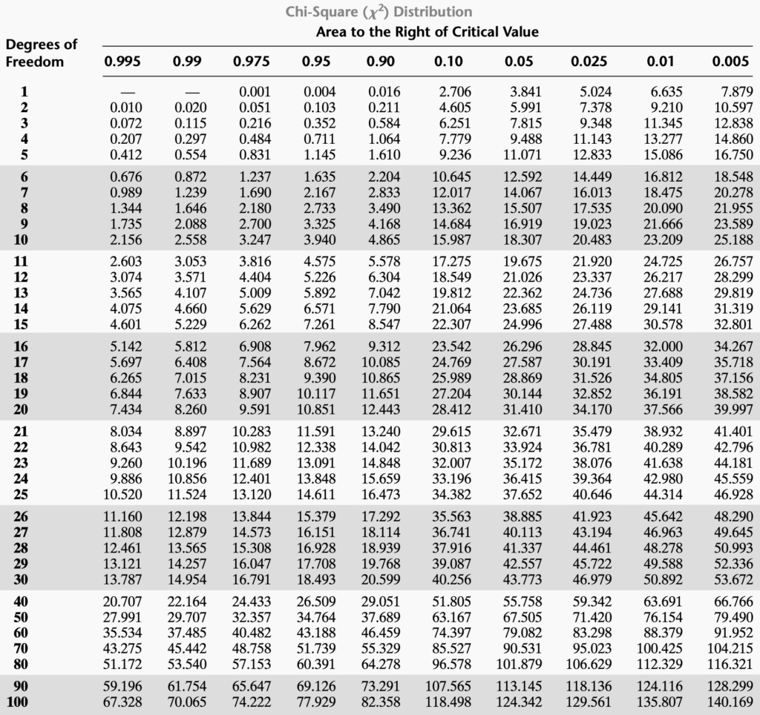

CriticalValues of Expanded Dixon OutlierTest (Q -Test)