CHUKA UNIVERSITY
UNIVERSITY EXAMINATIONS 2022/2023

FOURTH YEAR SECOND SEMESTER EXAMINATION FOR THE DEGREE OF BACHELOR OF SCIENCE IN ELECTRICAL AND ELECTRONIC ENGINEERING

EENG 445: ELECTRICAL MOTORS II

DATE: APRIL 2023 TIME: 2 HOURS

INSTRUCTIONS • Answer question one and any other two questions • Do not write on the question paper

QUESTION ONE (30 MARKS)
- Give three types of inverters used in synchronous motor drives (3 Marks)
- Briefly discuss four types of electric braking used in traction (8 Marks)
- A dc chopper in figure Q1 (c) below has a resistive load of R = 10 ohm and input voltage of V = 200V. When chopper is ON, its voltage drop is 2 V and the chopping frequency is 1 kHz. If the duty cycle is 60%, determine
(7 Marks)
  - Average output voltage
  - RMS value of output voltage

  - Effective input resistance of chopper (iv) Chopper output power.
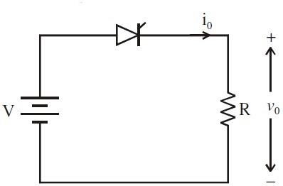
Figure Q1(c)
- Two three-phase induction motors are to be speed control by cumulative cascade arrangement as shown in Figure Q1 (d). The main motor has four poles whereas the auxiliary motor has six poles. The supply voltage is 400 V, 50 Hz for the main motor while the frequency in the rotor of the auxiliary motor is 1.0 Hz. Calculate the slip of each motor and the combined speed of the whole set. (8 Marks)
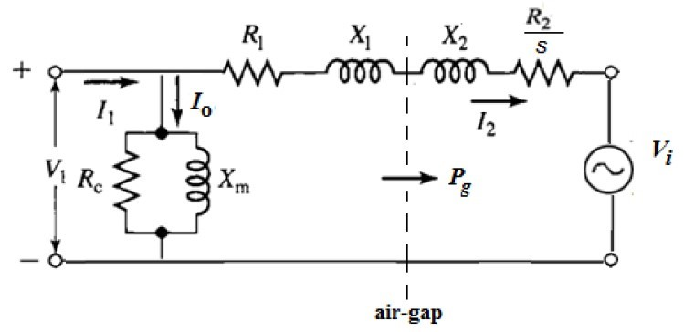
Figure Q1 (d)
- An inverter supplies a 4-pole, three phase induction motor rated at 220 V, 50 Hz. Determine the approximate output require of the inverter for motor speeds of (i) 900, (ii) 1200, (iii) 1500, (iv) 1800 rpm (8 Marks)

QUESTION TWO (20 MARKS)
- Define chopper (1 Mark)
- Give four advantages of Ward Leonard method of DC motor control

(4 Marks)
- Highlight for requirements of an ideal traction system. (4 Marks)
- The figure Q2 (d) below is a sketch for current source inverter (CSI) fed induction motor drives. Briefly explain its operation (3 Marks)

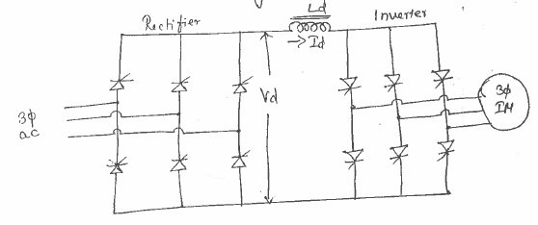
Figure Q2 (d)
- The speed of 10 hp, 230 V, 1200 rpm separately-excited d.c. motor is controlled by single-phase fully-controlled full-wave rectifier bridge. The rated armature current is 38 A, Ra = 0.3 Ω, the a.c. supply voltage is 260V. The motor voltage constant is KeΦ = 0.182V/rpm. Assume sufficient inductance is present in the armature circuit to make Ia continuous and ripple-free: (8 Marks)
  - For α = 30° and rated motor current calculate the Motor torque,
Motor speed and Supply power factor
  - The polarity of the armature emf is reversed say by reversing the field excitation; calculate the firing angle to keep the motor current at its rated value and the power fed back to the supply.

QUESTION THREE (20 MARKS) a) Mention the speed control method employed in electric traction (1 Mark)
- (i) State the principle of regenerative braking. (1 Mark)
(ii) Explain regenerative braking in respect of DC motors. (2 Marks)
- Briefly discuss the disadvantage of VSI fed synchronous motor drive
(2 Marks)
- Briefly explain the four quadrant motor operations (2 Marks)
- Discuss three Rectifier Fed DC Drives Problems and they possible methods of their mitigation (6 Marks)
- A separately excited DC motor with an armature resistance of 0.01Ω works on a DC supply of 220 V. It draws an armature current of 100A and its rated speed is 1000 RPM. It is fed from a chopper controller for its motoring and braking operations. Assuming continuous conduction, calculate the duty ratio of chopper at rated torque with a speed of
500RPM during (6 Marks)
  - motoring
  - braking

QUESTION FOUR (20 MARKS)
- Give the advantage of operating choppers at high frequency (1 Mark)
- (i) Sketch the diagram of a voltage source inverter and briefly explain it
(2 Marks)
(ii) Give the application of CSI fed synchronous motor. (1 Mark)
- Give two advantages and one disadvantage of D.C. motor drives(3 Marks)
- Discuss in detail about series parallel control of electric traction motor.
Use diagrams where necessary (5 Marks)
- A series d.c. motor is to be controlled by a single-phase, half-controlled, full-wave rectifier bridge as shown in Figure 4 (d). The a.c. input voltage has an rms value of 240V at 50Hz. The combined armature and field resistance is 2.5Ω and = 300 mH. If the load torque is 30 Nm and damping is neglected, calculate the average current and the speed for α =
60˚. (4 Marks)
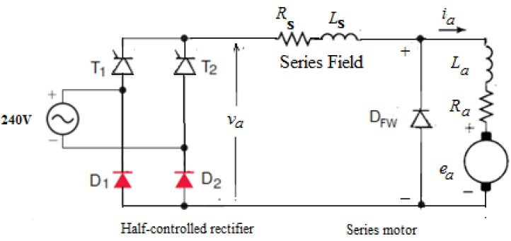

Figure Q4 (d)

- A variable speed d.c. drive has rated power of 10 kW, rated speed of 1500 rpm drives a load that comprises a constant load of T_{L} = 30 Nm. The inertia of the drive system is 0.10 kg.m². Calculate the time taken to accelerate the load from zero to 800 rpm, assuming the drive develops rated torque during the acceleration phase. (4 Marks)

