CHUKA | 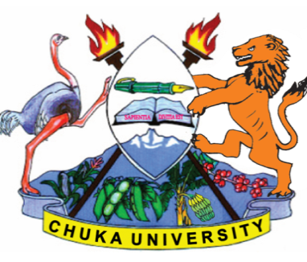 | UNIVERSITY
UNIVERSITY EXAMINATIONS
CHUKA / EMBU
EXAMINATION FOR THE AWARD OF
DIPLOMA IN HUMAN RESOURCE MANAGEMENT

DIBM 0112: PRINCIPLES OF MANAGEMENT

STREAMS: DIBM / DHRM/ DTHM/ DIAC
TIME: 2 HOURS

DAY/DATE: TUESDAY 6 /07/ 2021 2.30 PM – 4.30 PM

INSTRUCTIONS:
- Answer question ONE (Compulsory) and any other TWO questions.
- Do not write on the question paper

QUESTION ONE
You have currently been appointed as the County Chief Management Officer with the key mandate of improving the efficiency of the County’s operations. Explain to the County Management Board the below management issues:
i. The importance of conducting environmental analysis of the county in decision making.
[10 Marks]
ii. The benefits of planning county activities. [10 Marks]
iii. The role of the County Management Board in running the activities of the county.
[10 Marks]
QUESTION TWO
a) Discuss the contributions of the Bureaucratic theory in management of organizations in Kenya today. [10 Marks]
b) Explain any five determinants of organization structure. [10 Marks]

QUESTION THREE
a) Discuss any five components of staffing in organization. [10 Marks]
b) Explain the importance of carrying out performance appraisal to the employees.
[10 Marks]
QUESTION FOUR
a) Social responsibility refers to the manager’s duty or obligations to make decisions that nurture, protect, enhance, and promote the welfare and well-being of stakeholders and society as a whole. Discuss the arguments for Sociable responsible organizations. [12 Marks]
b) Explain the levels of planning. [8 Marks]
……………………………………………………………………………………………………

