CHUKA |  | UNIVERSITY
UNIVERSITY EXAMINATIONS

EXAMINATION FOR THE AWARD OF BACHELOR OF SCIENCE IN ELECTRICAL AND ELECTRONIC ENGINEERING

EENG 542: ROBOTICS II

STREAMS: BSC (EENG) TIME: 2 HOURS

DAY/DATE: TUESDAY 11/04/2023 11.30 A.M. – 1.30 P.M.
INSTRUCTIONS:
- Answer question ONE and any other TWO questions
- Do not write on the question paper

QUESTION ONE (30 MARKS)
a) How many links does the following robot configuration have? (2 marks)
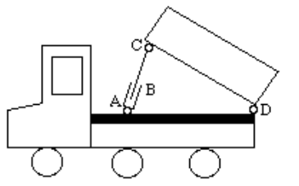
b) What is an actuator? (2 marks)
c) What would the degrees of freedom be for the mechanism shown (4 marks)
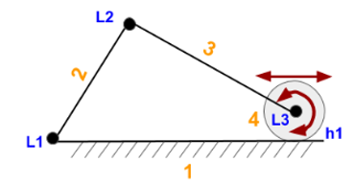
. (4 marks)
d) Define inverse kinematics of a robot? (2 marks)
e) Discuss the D-H notations (4 marks)
f) The following diagram show as door hinged to a frame. How many constraints does the configuration introduce? (2 marks)
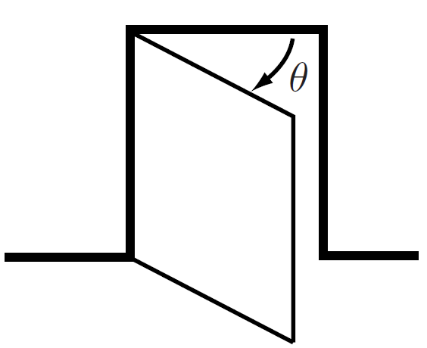

g) Define DOF of a rigid body. (2 marks)
h) Assign link frames to the RPR planar robot shown below, and give the linkage parameters. (5 marks)
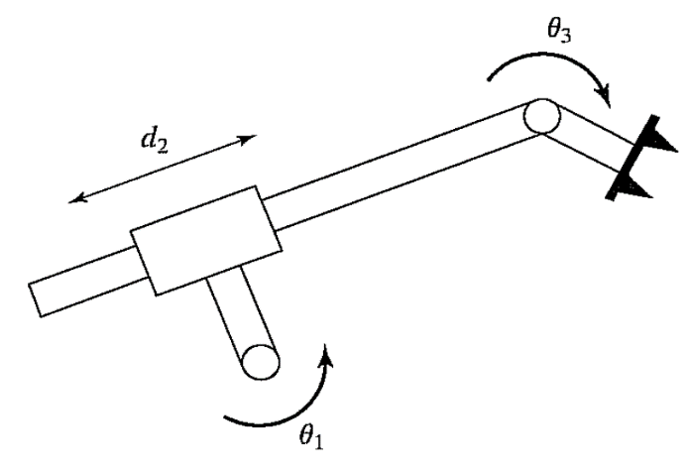

- Define open and closed kinematic chains and give diagrammatic illustrations. (4 marks)
j) What are the names given to the robots below. (2 marks)

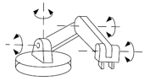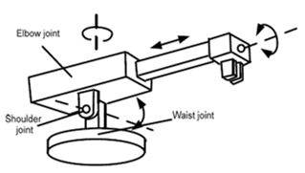

QUESTION TWO (20 MARKS)
- Figure A.5 shows a machine screw. As it advances into a tapped hole, it moves 5 mm linearly for every radian of rotation. A frame {a} has its $\hat{z}$_{a}-axis along the axis of the screw and its $\hat{x}$_{a}--axis out of the page. The frame {b} has its origin at p_{a} = (0, 3,−2) mm and its orientation is shown in the figure ($\hat{z}$_{b}- is out of the page). Use mm as your linear units and radians as your angular units.
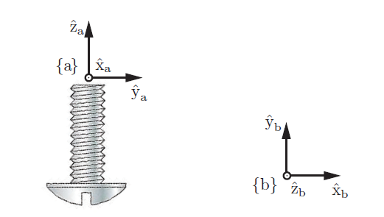
Fig. A5 A machine screw. Notice the direction of the threads.

(i) What is the screw axis $S_{a}$ corresponding to advancing into a tapped hole? Give a numerical 6- vector. (3 marks)
(ii) What is the screw axis S_{b}? Give a numerical 6-vector. (4 marks)
(iii) What is [$S_{b}$]? (4 marks)
(iv) From the initial configuration $T_{ab}$ shown in the figure, the {b} frame follows the screw an angle θ , ending at the final configuration $T_{ab'}$. If we write $T_{ab'}$ = ${TT}_{ab}$ what is $T$? Express this symbolically (don’t write numbers), using any of $S_{a}$, $S_{b}$, θ, and any math operations you need. (2 marks)
(v) Referring to the previous question, if we instead write$T_{ab'}$ = ${TT}_{ab}$, what Is $T$ ? Again, express this symbolically (don’t write numbers), using any of $S_{a}$, $S_{b}$, θ and any math operations you need. (2 marks)

- A unicycle is controlled moving on a rigid balance beam as shown in Figure A.4. Suppose the wheel is always touching the beam with no sliding, answer the following questions in terms of R, S, T, and I (a one-dimensional closed interval).
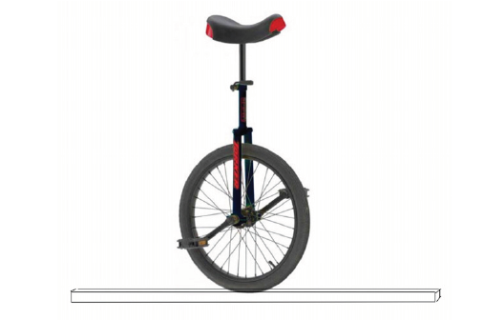
Fig A.4 A unicycle on a rigid balance beam.
i) Give a mathematical description of the C-space of the unicycle when it remains upright and is constrained to move in the 2-dimensional plane of the page. (2 marks)
(ii) Give a mathematical description of the C-space of the unicycle when it remains upright, it moves in a 3-dimensional space, and the beam has nonzero width. (3 marks)
QUESTION THREE (20 MARKS)

- Figure A.2 shows a simplified pick-and-place robotic arm at its home configuration. Let’s apply velocity kinematics and statics to this arm.

(i) Find M = $T_{sb}$(0), the configuration of {b} relative to {s} when the robot is at its zero (home) configuration. (3 marks)
(ii) Find the space-frame screw axis for each joint when the robot is at its home configuration. (4 marks)

(iii) To resist a wrench $ӻ_{s}$ = (0, 0, 0, 5, 10, 0) (linear components are in Newton’s) applied to the last link of the robot when the robot is at the home configuration, what torques $τ$ must be generated by the joints? (3 marks)
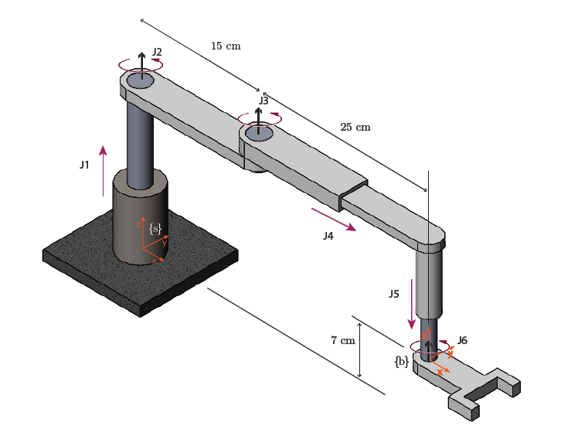

Fig A.2 A pick-and-place robot shown in its home configuration. The end-effector
{b} frame is aligned with the {s} frame and is 7 cm above the {s} frame (in the + ${\hat{z}}_{s}$ direction).

- Consider the satellite and Earth shown in Figure below


!_{b}
y

z x
z
{e}
y
x {b}
(i) If the given rotational velocity $w_{b}=(0,1,1)$ is the exponential coordinates for a rotation, solve for the axis-angle representation and the corresponding rotation matrix. (5 marks)
(ii) After rotating and orbiting the Earth for some time, the relative orientation of the Earth and satellite is given as (5 marks)
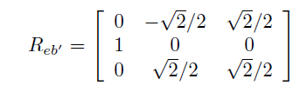
Find the axis-angle representation that describes the rotation from the initial body frame {b} to the new body frame {b’}.

QUESTION FOUR (20 MARKS)
a) Consider the scene in Figure below of a once peaceful park overrun by robots. Frames are shown attached to the tree {t}, robot chassis {c}, manipulator {m}, and quadcopter {q}. The distances shown in the figure are d1 = 4 m, d2 = 3 m, d3 = 6 m, d4 = 5 m, d5 = 3 m. The manipulator is at a position $p_{cm}$= (0, 2, 1) m relative to the chassis frame {c}, and {m} is rotated from {c} by 45 degrees about the $x_{c}$ axis.

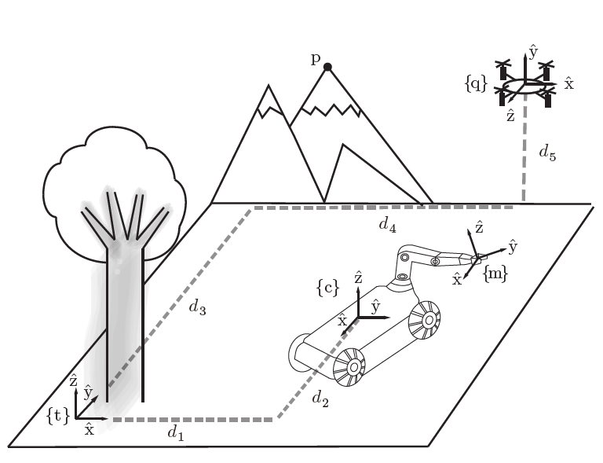
A tree, mobile manipulator, and flying robot in a park and the corresponding
reference frames.
(i) Give the transformation matrices representing the quadcopter frame {q}, chassis frame {c}, and manipulator frame {m} in the tree frame {t}. (7 marks)
(ii) Assume that the position controller for the manipulator on the mobile robot is referenced to the chassis frame {c}. What position should you command the gripper to go to if you would like to snatch the quadcopter out of the sky? (2 marks)

(iii) You are tasked to move the mobile robot so that the chassis origin is directly underneath the quadcopter and its frame is aligned with the tree frame. Assume the mobile robot chassis controller takes transformation matrices in the chassis frame as inputs. What transformation should you command the robot to follow? (4 marks)

- Consider the parallel SCARA robot shown in Figure A.6. The robot is controlled by two rotational motors located in the base, and one rotational and one prismatic motor at the end effector. Assume each of the links of the parallel mechanism are length 1 m, the prismatic joint has a maximum travel of 1 m, and the separation distance of the base motors is 0.5 m.
Assume no collisions between the links, and that the end effector y-coordinate is constrained to be greater than zero.
(i) Sketch the workspace of the end effector. (5 marks)
(ii) What are some benefits and drawbacks of making a parallel rather than a serial SCARA robot? (2 marks)
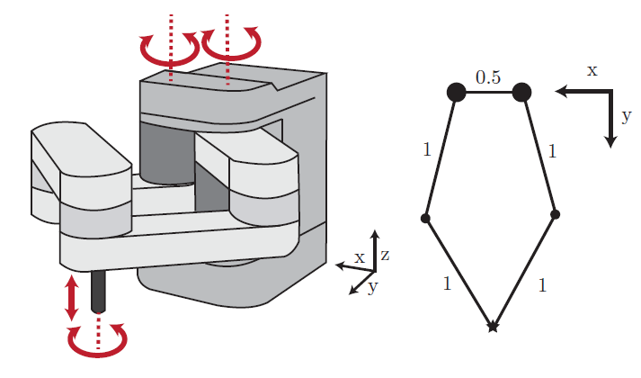
Figure A.6 Parallel SCARA robot and a skeleton top view.

----------------------------------------------------------------------------------------------------------------------

